The Social/Cultural World Three Column Notes
Section Titles | Visual | Answers
Social Organization  Customs and Traditions  Religion  Language  Arts and Literature  Government Systems  Economic Systems | What do you see?  List three things you see in the images. Try to find one you think others won’t find.
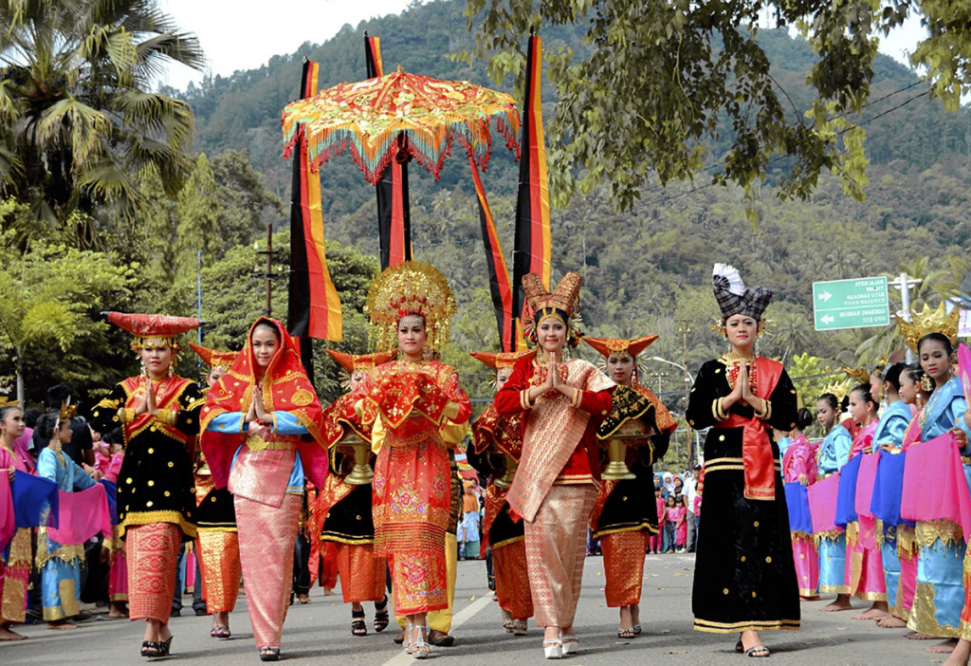
Source: worldtravelling.com

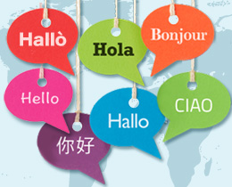
Source: educationscotland.gov.uk

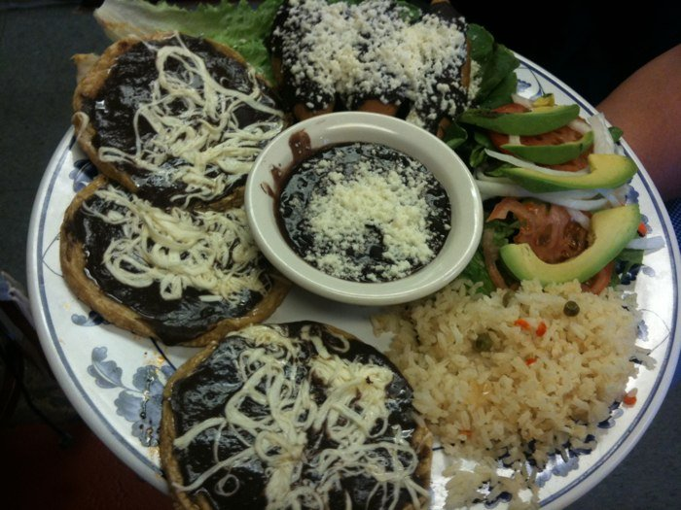
Sources: yelp.com

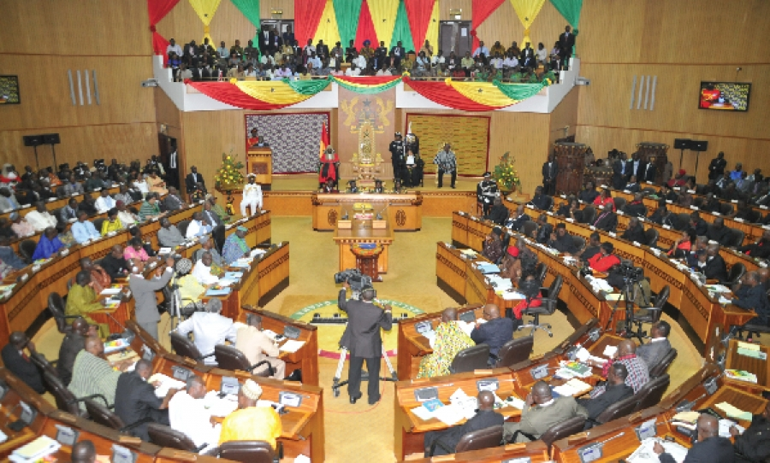
Source: gbcghana.com

Source: huffingtonpost.com

Source: currencyguide.eu

