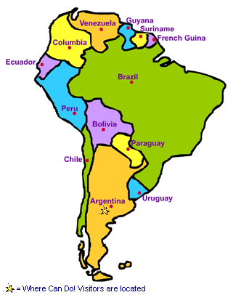
The Setting of South America

South America’s physical features are diverse. The continent contains the Andes Mountains, the Amazon River Basin, and grasslands and plains.
The people of South America must change their economic activities for the different elevations and climates of the region. Life is very different from one part of South America to another.
1. Political Map: South America
The Andes Mountains
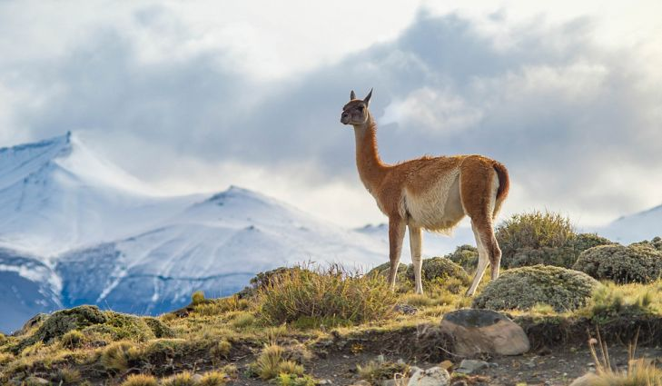
The Andes Mountains are mountain ranges that stretch about 5,500 miles along the western side of South America. Many of the mountains in the Andes rise higher than 20,000 feet above sea level. The climate in the Andes is generally cool and dry. Because of low temperatures and high elevation, few types of vegetation, or plants, grow here.
Elevation and climate determine how people use the land. Rain is scarce at high elevations in the mountains and highlands of the continent. For example, some farmers in the Andes Mountains herd animals and grow only enough food for their families. This is called subsistence farming. However, others have become part of the global economy, selling wool to European and other manufacturers.
2. A Guanaco on top of the mountain in Torres del Paine, Chile.

Basin, River and Rainforest
The Amazon River Basin is the largest river basin on Earth. It covers nearly 2,700,000 square miles in the north-central part of South America—nearly the width of the continent. The Amazon River drains this basin, flowing from the Andes Mountains to the Atlantic Ocean. The climate is warm and wet. Many different species of plants and animals thrive in the Amazon Basin.
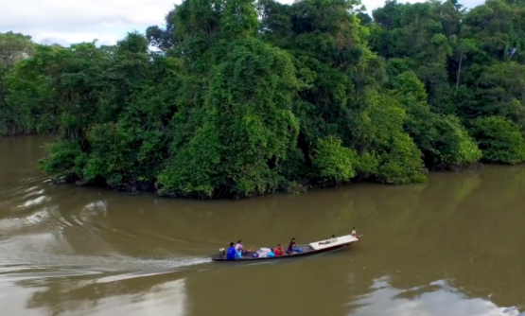
The Amazon River begins high in the Andes Mountains of Peru. It flows east for 4,000 miles across the continent and empties into the Atlantic. Though the Amazon River is the world’s second largest river, it is the world’s largest river by volume and includes the largest tropical rainforest, the Amazon Rainforest. The Amazon Rainforest is home to thousands of plant and animal species and millions of insect species. The variety of species in an ecosystem is called its biodiversity.
3. Group traveling on the Amazon River by boat.
Yearly flooding of the Amazon River from melting snow and rain in the Andes usually happens between June and October. The floodwaters deposit rich nutrients, or substances that support life, in the lowland forest soils. These nutrients support the biodiversity of the rainforest.
Today, a growing population puts pressure on rainforest lands through mining, logging, farming, and land development. Conservationists suggest that setting limits on development will help protect the Amazon rain forest.
Northern Grasslands
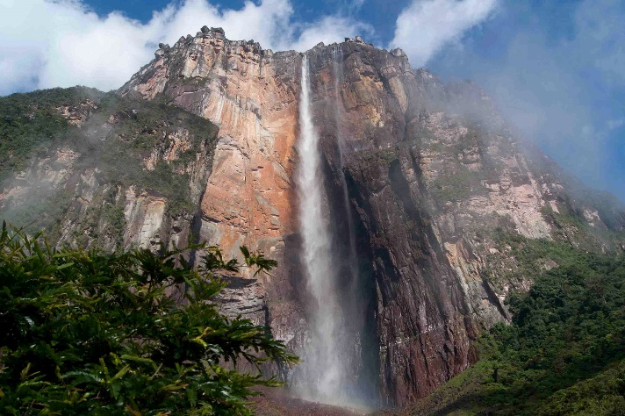
The northern part of South America has a warm climate and contains both high and low elevations. Cattle ranching dominates the Llanos, or grasslands—wide open areas used for grazing and crops. The highest waterfall in the world—Angel Falls—is located in Venezuela.
Pampas Plains
The southern part of South America has a mild climate and the elevation is low. The rich soil of the grassy plain in Argentina called the Pampas is ideal for growing alfalfa, corn, and wheat.
4. Angel Falls

Reading adapted from “Physical Geography,” “Life at Different Elevations,” and “The Amazon River.” National Geographic World Cultures and Geography (Texas Ed.) Cengage Learning, 2015.
Images:
http://www.worldfortravel.com/2015/11/17/worlds-largest-angel-falls-salto-angel-venezuela/
http://www.worldatlas.com/articles/what-animals-live-in-the-andes-mountains-of-south-america.html
https://www.explorama.com/the-amazon-river.html

