The Setting of North Africa and Southwest Asia

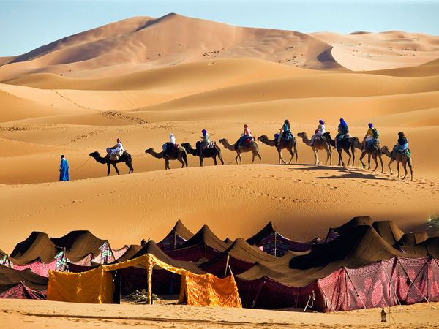
Physical Features and Climate
Many parts of North Africa and Southwest Asia are covered by large, infertile deserts. The region is extremely dry and daytime temperatures are very high. For example, in the Sahara Desert, daytime temperatures can climb to 130˚F and the area receives less than four inches of rain per year.
Several different mountain ranges are located in the region. The Atlas Mountains are located at the tip of northwest Africa. The Zagros Mountains in Iran stretch along the Persian Gulf, and the Taurus Mountains in Turkey border the Mediterranean Sea.
1 Camel riders crossing the Sahara Desert
Fresh water is scarce in most of the region, however, there are three important rivers that have historically supported life in the region. The Nile River flows through Egypt, and the Tigris and Euphrates rivers flow through Syria and Iraq. Cultures have developed and grown along these waterways and many of the world’s oldest cities are located here.
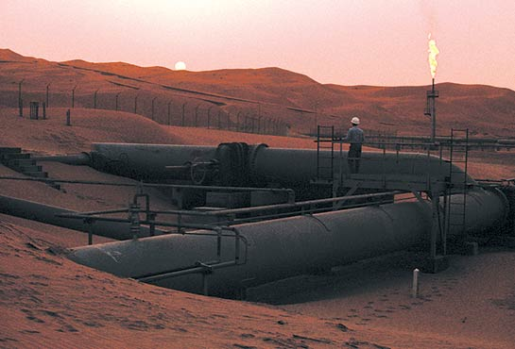
Natural Resources
Most of the world’s known petroleum, or oil, deposits can be found in North Africa and Southwest Asia. Saudi Arabia, Iran, Iraq, Kuwait, and the United Arab Emirates possess more than half of the world’s known petroleum reserves, or future supply. Around 20 percent of the world’s known oil reserves are located in Saudi Arabia and petroleum production—which involves removing oil from the ground and refining it into gasoline and other products—is the most important industry in the region.
2 Oil field in Saudi Arabia

Images:
http://travel.nationalgeographic.com/travel/countries/morocco-photos/
http://ngm.nationalgeographic.com/ngm/0310/feature1/zoom1.html
Reading adapted from “Physical Geography” and “Oil and Wealth.” National Geographic World Cultures and Geography. Washington, DC: 2015

