OIL RESERVES/PRODUCTION,
TOP FIVE OIL-PRODUCING COUNTRIES
 | Saudi Arabia | Iran | Iraq | Kuwait | United Arab Emirates
Barrels of Reserves | 266.7  Billion | 137.6  Billion | 115  Billion | 104  Billion | 97.8  Billion
Barrels Produced Per Day | 9.764  Million | 4.172  Million | 2.399  Million | 2.494  Million | 2.798  Million
Source: CIA World Factbook, 2009 Estimates

Data chart adapted from “Oil and Wealth.” National Geographic World Cultures and Geography. Washington, DC: 2015

North Africa and Southwest Asia: Political
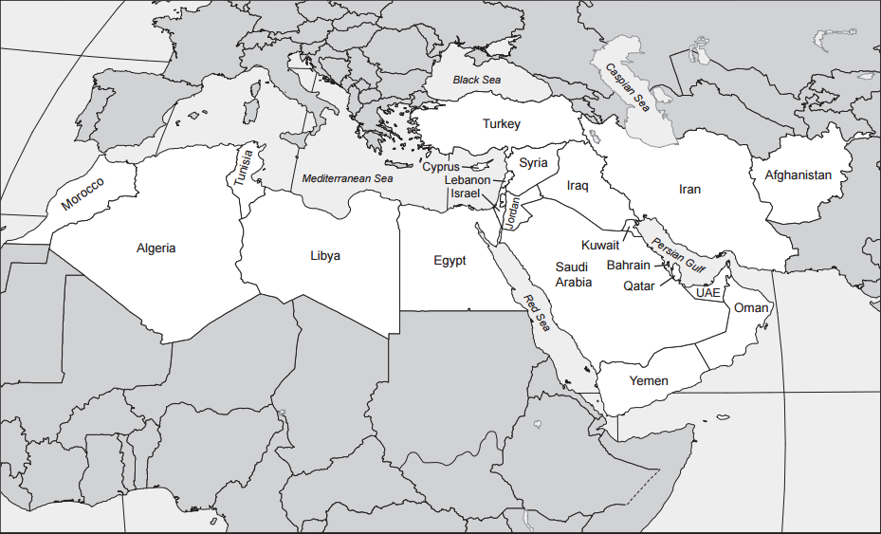

Source: https://geoalliance.asu.edu/sites/default/files/maps/MidEast_Labeled.pdf

North Africa and Southwest Asia: Physical
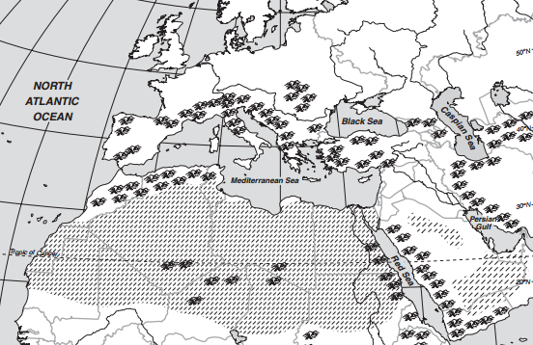

Arabian
Peninsula

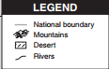

Source: https://www.eduplace.com/ss/maps/pdf/afr_asia_phys.pdf
North Africa and Southwest Asia: Economic Activity
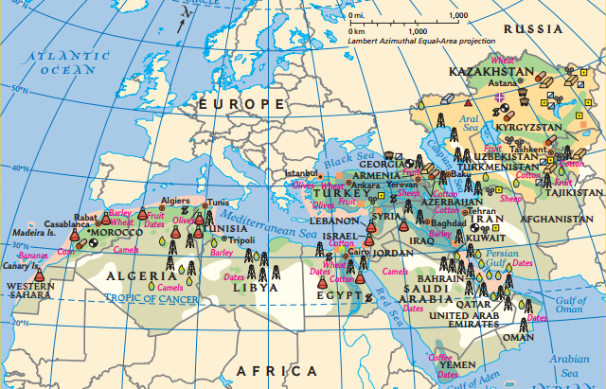

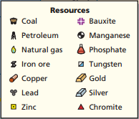

Source: “North Africa, Southwest Asia, and Central Asia.” World Geography and Cultures. McGraw-Hill Global Education Holdings: 2012.

