COUNTRY PROFILE: BRAZIL

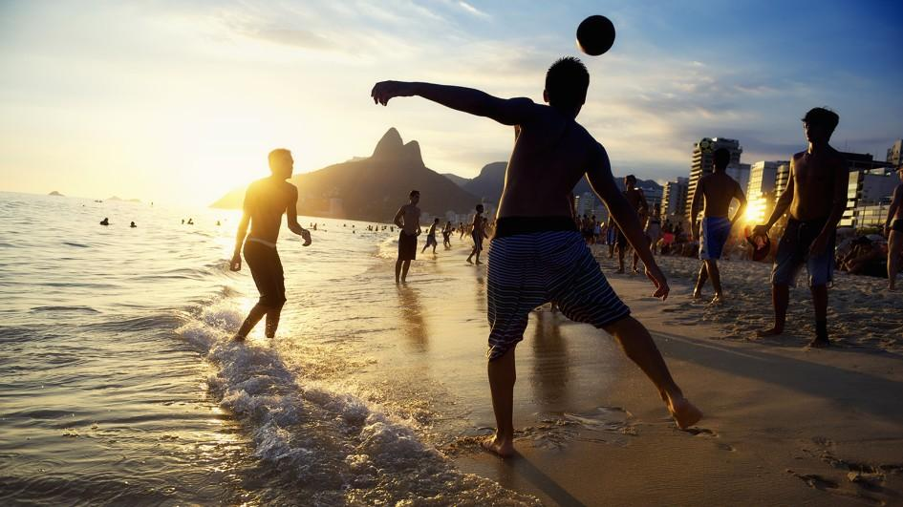
OFFICIAL NAME: Federal Republic of Brazil
FORM OF GOVERNMENT: Democratic federal republic
CAPITAL CITY: Brasilia
POPULATION: 183,888,841
OFFICIAL LANGUAGE: Portuguese

Brazil is the largest country in South America and the fifth largest nation in the world.
Most Brazilians are descended from three ethnic groups: Amerindians, European settlers (mainly from Portugal), and Africans. Starting in the 19th century, waves of immigrants from Europe, the Middle East, and even Japan added to this mix. This diversity of cultures has created a rich religious, musical, and culinary culture.
1. Brazilian children playing soccer
Soccer, or football, is the most popular sport in Brazil, and the country has produced some of the best players. The most famous of all is Edson Arantes do Nascimento, better known as Pelé. Brazil has won the World Cup soccer finals five times, more than any other nation.
The country's most celebrated festival is Carnival, which takes place just before the start of Lent, a Roman Catholic holiday that traditionally involves abstaining from the consumption of meat.
Samba, an old Brazilian style of dance with many variations, is African in origin. It has been performed as a street dance at Carnival and is also performed by many dancers around the world. Characteristics of the Samba include quick steps and a noticeable rocking motion and sway of the dancing couple.

Figure 2. Samba performance

Reading and image 1 adapted from http://kids.nationalgeographic.com/explore/countries/brazil/#brazil-soccer.jpg . https://www.kids-world-travel-guide.com/brazil-facts.html, http://www.dancelovers.com/samba_history.html, and http://www.aboutbrasil.com/modules/brazil-brasil/carnival_carnaval.php?hoofd=8&sub=44&art=475
Images:
https://www.smithsonianmag.com/arts-culture/Celebrate-Brazil-with-Emerils-Feijoada-180951699/
http://mydanceproductions.com/history-dance-samba/

COUNTRY PROFILE: PERU

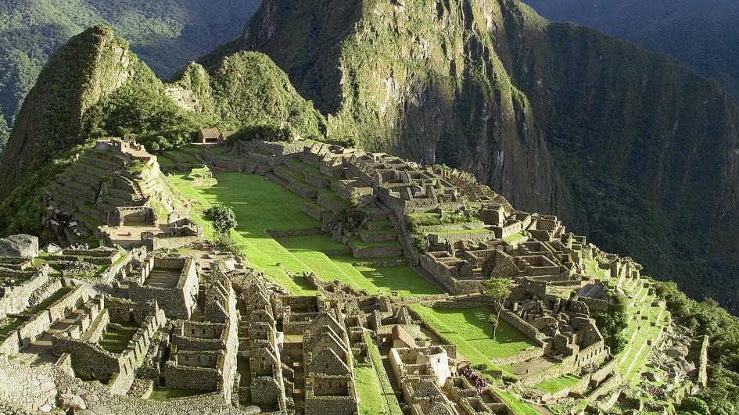

OFFICIAL NAME: Republic of Peru
FORM OF GOVERNMENT: Constitutional republic
CAPITAL CITY: Lima
POPULATION: 30,147,935
OFFICIAL LANGUAGES: Spanish, Quechua

Peru is the third largest country in South America, after Brazil and Argentina.

The people of Peru are a mix of many different cultures, including Indians, Spaniards and other Europeans, descendants of African slaves, and Asians. Until recently, most people lived in the countryside. But now, more than 70 percent live in cities. Most Peruvians follow the Catholic religion introduced by the Spanish.

Peruvians enjoy sports and participate in various sporting events. The most popular sports in Peru are soccer, or football (futbol in Spanish) and volleyball.

One of the most important Peruvian cultures was the Inca, who lived in Peru around 600 years ago. Their capital, Cusco, is still a major city today. The Inca also built Machu Picchu (pictured above), a famous and mysterious ancient city in the Andes.
Reading and image adapted from http://kids.nationalgeographic.com/explore/countries/peru/#peru-lima.jpg and http://www.topendsports.com/world/countries/peru.htm

COUNTRY PROFILE: ARGENTINA
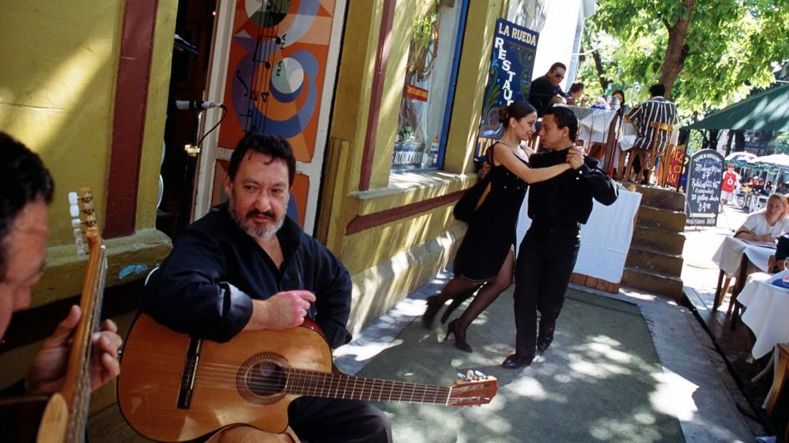
OFFICIAL NAME: Argentine Republic
FORM OF GOVERNMENT: Republic
CAPITAL CITY: Buenos Aires
POPULATION: 43,024,374
OFFICIAL LANGUAGE: Spanish

Unlike Mexico and South American countries such as Peru and Ecuador, Argentina has fewer native people and a large population, which came from Europe. The population is comprised as much as 95% of people of European descent, mostly from Italy, Spain, and Germany. Much of the native population died from diseases brought in by Europeans.

Soccer, or football (futbol in Spanish), is the most popular sport in Argentina. The Argentine national soccer teams the 1978 and 1986 were the World Cup champions and were runner-ups in 1930 and 1990.

The tango is the most famous of all Argentinian dances. Although it was created in Buenos Aires, the Argentine tango is now known throughout the world. The tango is a flexible dance performed by couples, and is open to spontaneous creativity which means the leader can lead in any direction.
Reading adapted from http://kids.nationalgeographic.com/explore/countries/argentina/#argentina-street-dancing.jpg, http://www.topendsports.com/world/countries/argentina.htm, and http://www.donquijote.org/culture/argentina/tango/tango-origins.

COUNTRY PROFILE: URUGUAY
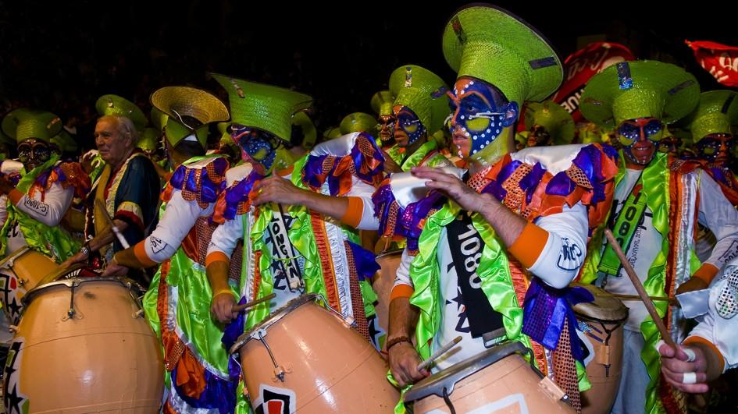
OFFICIAL NAME: Oriental Republic of Uruguay
FORM OF GOVERNMENT: Constitutional republic
CAPITAL: Montevideo
POPULATION: 3,332,972
OFFICIAL LANGUAGE: Spanish

As with neighboring Argentina, most Uruguayans have European ancestors from Spain and Italy who immigrated to the country in the 19th and 20th centuries. In terms of religion, the majority of the population is Roman Catholic, though a small community of Jews—one of the largest in South America—lives in the capital of Montevideo.

The country's most celebrated festival is Carnival, which takes place just before the start of Lent, a Roman Catholic holiday that traditionally involves abstaining from the consumption of meat. The main festivities take place in Montevideo and include costumes, drumming parades, and outdoor theater.

The people of Uruguay enjoy many different sports. Soccer, or football (futbol in Spanish), is the most popular sport in Uruguay, however, Uruguayans also enjoy other sports and outdoor activities such as kayaking, cycling, windsurfing, and rock-climbing.

Reading and image adapted from http://kids.nationalgeographic.com/explore/countries/uruguay/#uruguay-carnival-drummers.jpg and https://theculturetrip.com/south-america/uruguay/articles/uruguays-most-popular-sports-and-where-to-try-them/

