DOCUMENT A
Charts/Tables

Charts/tables are used to represent factual and/or statistical data to present information in an organized way to make comparisons, analysis, summarizations, inferences and conclusions easier and more concise than expository text. Data is arranged in rows and columns with descriptive labels. Numerical data from charts/tables can be transferred to graph form using traditional methods (graph paper, sketch graphs) or computer programs.

Use the chart below to discuss and respond to questions 1-2.
Economic Indicators of Selected Countries
Country | Population | GDP (in U.S. dollars) | GDP Per Capita (in U.S. dollars) | Life Expectancy | Literacy Rate (percent)
Afghanistan | 31.1 million | 33.5 billion | 1,000 | 50 | 28.0
Brazil | 201.0 million | 2.3 trillion | 12,000 | 73 | 88.6
China | 1.3 billion | 12.3 trillion | 9,100 | 75 | 92.2
Ethiopia | 90.8 million | 103.1 billion | 1,200 | 60 | 42.7
Germany | 81.1 million | 3.1 trillion | 39,100 | 80 | 99.0
Haiti | 9.9 million | 12.9 billion | 1,300 | 63 | 52.9
Mexico | 116.2 million | 1.17 trillion | 15,300 | 77 | 86.1
Singapore | 5.4 million | 325.1 billion | 60,900 | 85 | 92.5
United States | 316.6 million | 15.6 trillion | 49,800 | 79 | 99.0
Sources: The World Bank, United Nations; CIA World Factbook; 2012, 2013 (est.)

Gross Domestic Product (GDP) is defined as the total value of all products manufactured and goods provided within that territory during a specified period (most commonly, per year). GDP Per Capita is an estimate of the value of goods produced per person in a country, equal to the country's GDP divided by the country’s population. The term literacy rate is refers to the percentage of a population of a country that can read and write.

- Carefully analyze the chart above. Which country has the highest population? Which country has the highest GDP per capita? How are the two related?

Use the quote below to answer question 2.
“If you want to try and figure out how to market (sell) your product in a new area you should first know the GDP per capita. “

- Why would a high GDP per capita attract new industries or businesses to an area?

DOCUMENT B
Bar Graphs

A bar graph displays data visually and is sometimes called a bar chart or a bar graph. Data is displayed either horizontally or vertically and allows viewers to compare items displayed. Data displayed will relate to amounts, characteristics, times and frequency etc. A bar graph displays information in a way that helps us to make generalizations (assumptions) and conclusions quickly and easily. A typical bar graph will have a label, axis, scales and bars. Bar graphs are used to display information such as, numbers of females versus males in a school, sales of items during particular times of a year. Bar graphs are ideal for comparing two or more values.

Use the bar graph below to discuss and respond to questions 1-3.
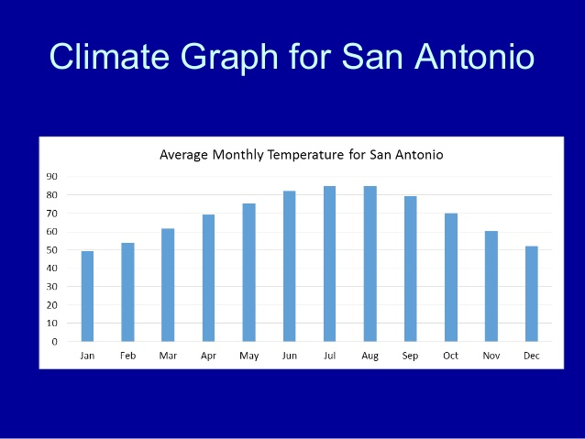

Climate is defined as the weather conditions prevailing in an area or over a long period. The average monthly temperatures for San Antonio presented in the bar graph are in degrees Fahrenheit.

- Carefully analyze the bar graph above. How would you describe the temperatures in San Antonio between the months of January and December?

- Based on the information provided in the bar graph, what can you tell about human activity in the summer months (June-August)?

- How could the information in the bar graph be useful to future tourists?

DOCUMENT C
Line Graphs

A line graph is commonly used to display change over time as a series of data points connected by straight line segments on two axes (the horizontal x-axis and vertical y-axis respectively). The line graph helps to determine the relationship between two sets of values, with one data set always being dependent on the other set.

Use the line graph below to discuss and respond to questions 1-3.
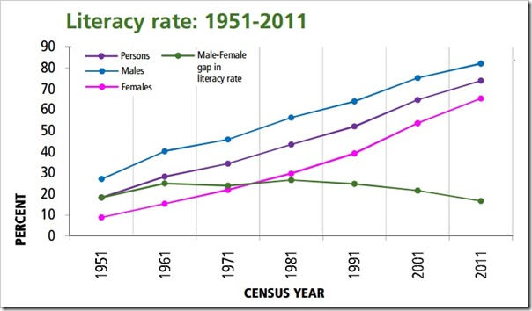

The term literacy rate is defined as the percentage of a population of a country that can read and write. The line graph above shows the literacy rate in India from 1951 to 2011. A trend is defined as change that occurs over time.

- Carefully analyze the line graph. What is the highest literacy rate shown on the line graph and for what year? Gender (male or female)?

- What do you notice about the literacy rate for men versus the literacy rate for women?

- Based on the rates shown, what conclusions can you draw about education in India?

DOCUMENT D

Pie Graph/Circle Graph

A pie graph, or circle graph, is a graph that is made by dividing a circle into sections or categories. It allows for comparison of the part to the whole.

Use the circle graph/pie graph below to discuss and respond to questions 1-2.
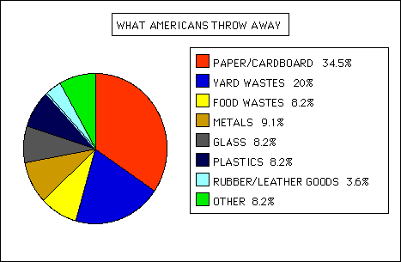

Waste is defined as eliminated or discarded materials that are no longer useful or required after the completion of a process. The pie graph above shows the percentage of certain items Americans dispose of everyday.

- Carefully analyze the pie graph. What material has the highest rate of disposal? Why do you think the percentage is so high?

- How could Americans decrease the amount of food disposed of per year? Plastics?

