Interpreting Maps Visual Notes

Part I: Types of Maps
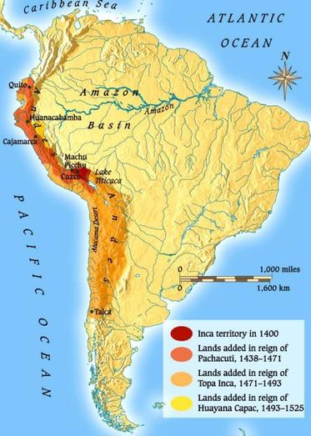
Type of Map:

Evidence/Clues:

What important information does this map offer?

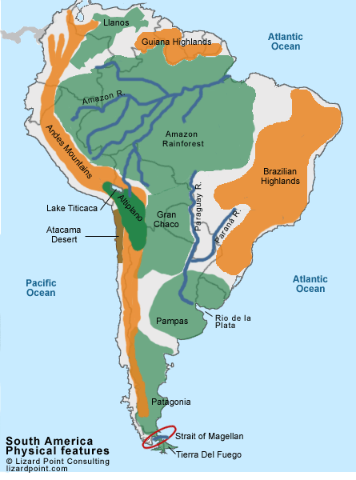
Type of Map:

Evidence/Clues:

What important information does this map offer?

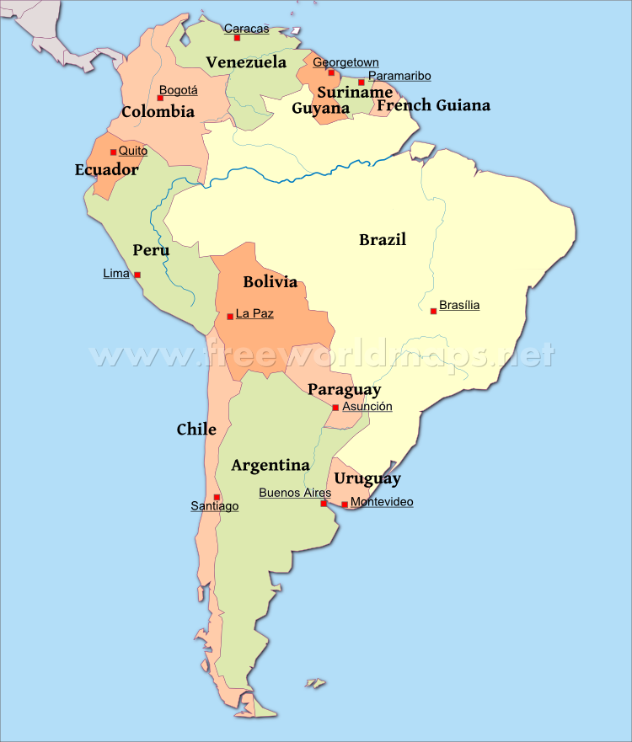
Type of Map:

Evidence/Clues:

What important information does this map offer?

Part II: Map Analysis

- The maps shown above are visual representations of 1 of the 7 continents. Which continent is represented? Where did you find this information?

- A geographer is a person who studies the earth, its physical features and human distribution of life on earth, including human life and the effects of human activity. How might the three maps shown above be useful to a geographer in learning about South America?

- The Inca Empire was an ancient civilization that existed in South America between the 1400s and 1500s. How might the three maps shown above be useful in helping us understand how the Inca lived?

