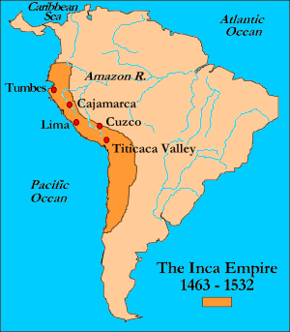
The Inca
The Inca Empire was the largest and most powerful native empire ever seen in the Americas. Southern Peru was the capital of the Incas and from there the Incas spread out in all different directions, quickly expanding the Empire of the Incas.
The Incas based their empire off of very old traditional cultural foundations, much like the Aztecs. The Incas believed in not one god but many.
They farmed on terraced fields, or flat fields cut into slopes or mountainsides of the Andes, built irrigation canals to water their crops, and built suspension bridges using vines and wood. Another example of the Inca’s engineering skills is Machu Picchu, built in the 1400s. The Inca built this complex city on a mountain by constructing giant walls, terraces, sloping ramps, and steep stairways.
By 1500 the Incan empire stretched 2,500 miles along the western coast of South America, it stretched from Ecuador to northern Chile and southern Argentina. By the 1530s, the Inca suffered from a weak economy and civil war. A much smaller but better Spanish Army conquered the Inca in 1532.
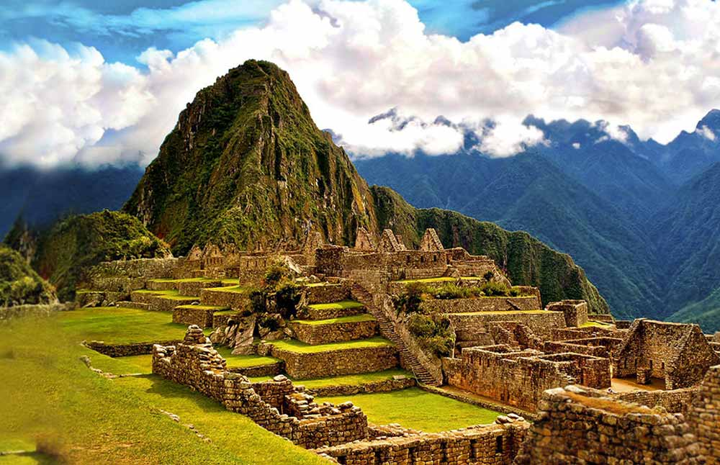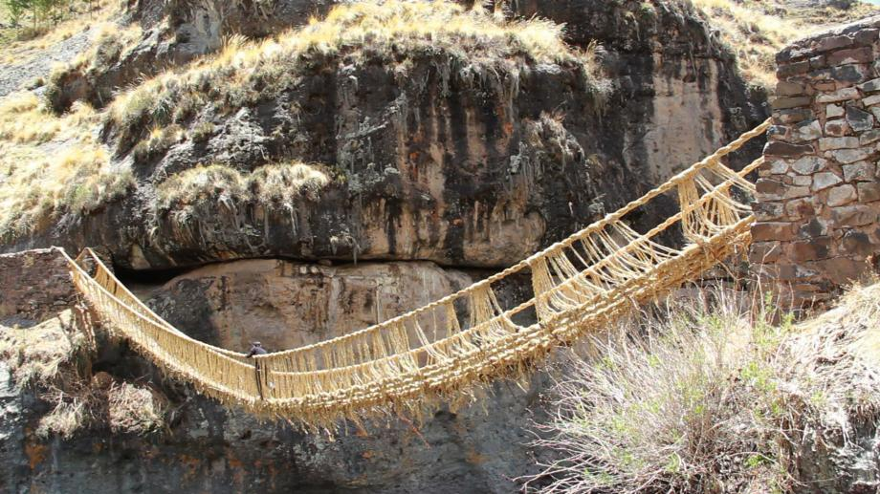
Machu Picchu; http://machupicchu.org Last Incan Suspension Bridge; http://www.slate.com

Reading adapted from “The Inca.” National Geographic: World Cultures and Geography (Texas Ed.). Cengage Learning, 2015. Print.
World History: Patterns of Interaction. 1st ed. 2003. Print.
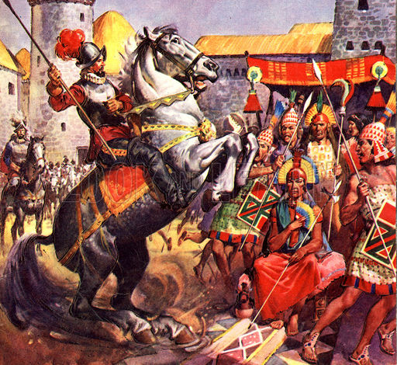
The Spanish in South America
As they did in Mexico, Spanish conquistadors arrived in South America wanting to expand Spain’s empire and search for resources like gold and silver. Francisco Pizzaro overthrew the Inca emperor, Atahualpa and established the city of Lima, Peru. The city became the center of the Spanish government and empire in South America.
The Spanish conquest of South America greatly changed much of the continent and its people. Deadly diseases from Europe killed entire villages and native populations. The Spanish also enslaved natives and forced them to work on plantations and ranches and in mines. Many natives died from the effects of harsh labor, or work, conditions.
1. Painting: The Spaniard and the Inca Chief
Missionaries sought to convert or persuade the native populations to change their religious beliefs and follow Christianity. Many native people began to practice the Catholic faith, and some blended the aspects of Christianity with their own religious practices.
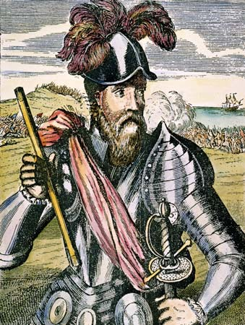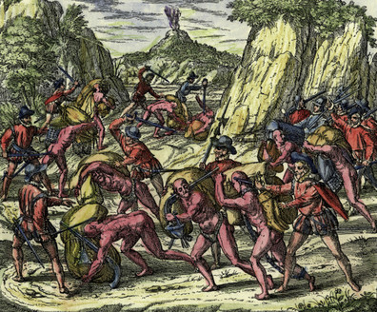
Francisco Pizzaro; kids.brittanica.com Painting of Inca slaves being attacked by Spanish soldiers; http://pizarrobrb.weebly.com
Reading adapted from “The Spanish in South America.” National Geographic: World Cultures and Geography (Texas Ed.). Cengage Learning, 2015. Print.
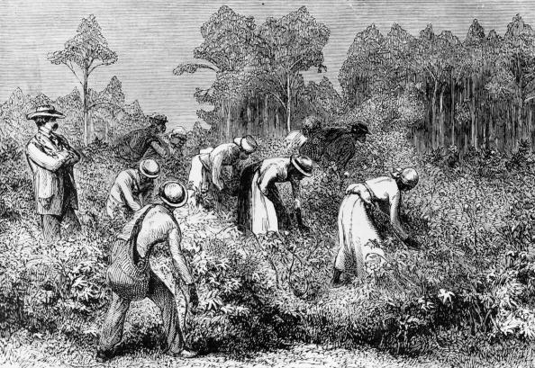
Brazil and the Slave Trade
Brazil was claimed (on the behalf of Portugal) by Portuguese navigator Pedro Alvares Cabral in 1500. Before the 1530s, the Portuguese did not have much interest in Brazil. It was not until Portuguese settlers discovered that these new lands contained valuable natural resources such as brazilwood and sugarcane. They built plantations and began exporting, or shipping, sugarcane and sugar products to Europe. These products then spread all over the world.
The Portuguese tried enslaving natives to work the sugar plantations, but overwork and disease killed many of them. The Portuguese then turned to another source of labor: Africa. By the mid-1500s, the Portuguese and other European countries were exporting African slaves across the Atlantic to South America and the Caribbean. As valuable natural resources like gold and diamonds were found, more slaves were brought in to work on sugar and coffee plantations and in gold and diamond mines. Portuguese slave traders imported more than 5 million slaves from Africa to Brazil. Brazil declared independence from Portugal in 1822, but not everyone was free. Even though the slave trade had ended in 1850, slavery continued in Brazil until it was abolished, or ended, in 1888. Brazil was the last country in the Americas to end slavery.
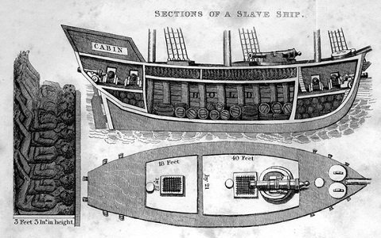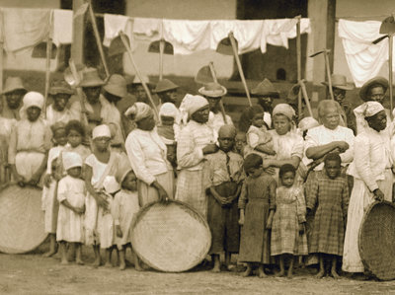
Portuguese slave ship; http://baltimoretimes-online.com Slaves going to coffee harvest in Sao Paulo, 1885; http://www.npr.org
Reading adapted from “Brazil and the Slave Trade.” National Geographic: World Cultures and Geography (Texas Ed.). Cengage Learning, 2015. Print.
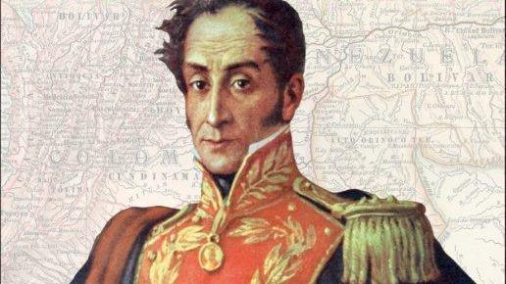
Simon Bolivar
Many people were unhappy with the social, racial, and political system that had developed during 300 years of Spanish rule in South America. Only certain Spanish-born people held social and political power in South America, as well as jobs in the government and the Church. Many European-descended Latin Americans, such as Simon Bolivar, bitterly disliked their second-class status.
In 1808, when Napoleon Bonaparte (French military and political leader) controlled Spain, Simon Bolivar saw the occupation as a signal to revolt, or start a revolution. In 1810, Bolivar led a revolution that established a republic in his native country, Venezuela. Bolivar's plan was not successful as civil war raged in the country and he was forced into exile on the island of Haiti. Though his first attempt towards freedom had failed, between the years of 1819 and 1830, Bolivar (or the "Liberator" as he was now called) successfully freed Venezuela, Colombia, Ecuador, Peru, and Bolivia from Spanish rule. Along with Jose de San Martin, he also fought against Napoleon’s army for several years, liberating Argentina and Chile.
2.Simon Bolivar; npr.org
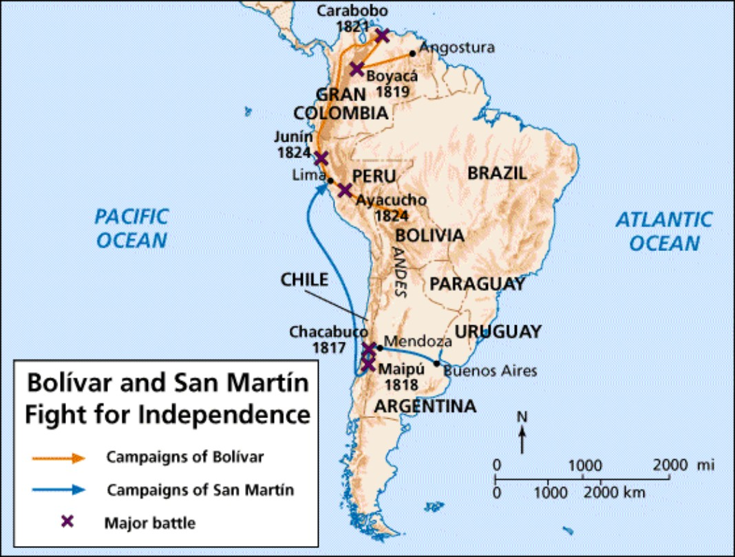
http://www.slidego.com/go/10489

