Pre-Columbian Civilizations—The Olmecs
The Olmecs represent one cultural hearth society that dates from approximately 1200 – 400 BCE and lived in central Mexico with developed urban areas (cities), carved obsidian tools, drainage systems for fields rich with maize (corn) and other agricultural products, and huge carved stone statues. The Olmecs were traders. They traded with groups that lived in present-day Mexico and Central America.
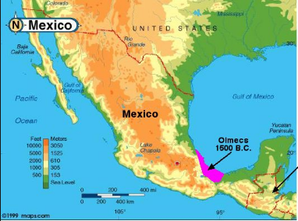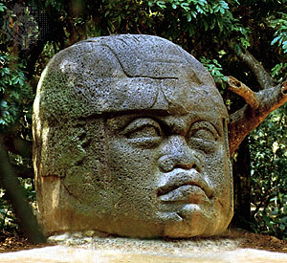
http://maps.com https://www.britannica.com/topic/Olmec

Pre-Columbian Civilizations—The Maya
The Mayas lived in the Yucután Peninsula (which is in southeastern Mexico) and nearby areas about 200 – 900 CE. This group had a 365 day calendar and built large cities for their people. The Maya used hieroglyphic writing and had extensive agriculture.
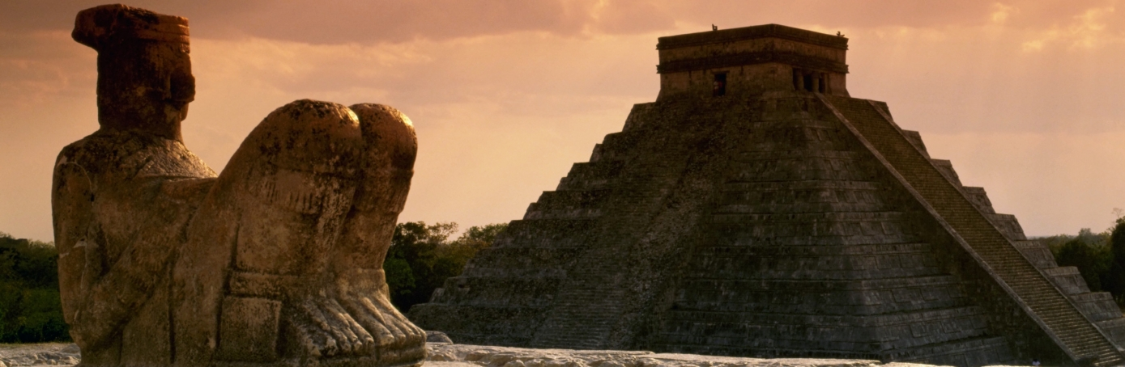
Chichen Itza, Mayan Empire, http://www.history.com/topics/maya

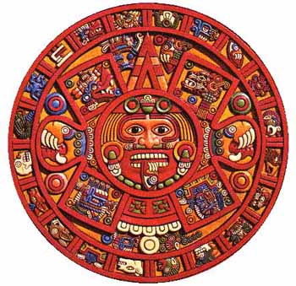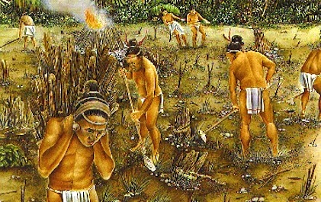
Mayan Calendar, http://www.crystalinks.com/mayancalendar.html http://www.cityfarmer.info/2013/03/29/how-mayan-civilization-can-inspire-contemporary-urban-food-security/
Pre-Columbian Civilizations—The Aztecs
The Aztecs (1300 – 1500) in central Mexico evolved into a technologically advanced society and conquered many neighboring groups while building large cities and impressive structures, agricultural areas, and systems of roads.
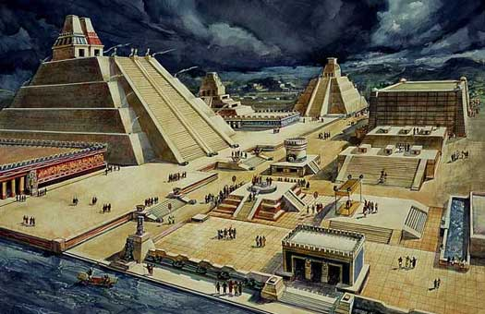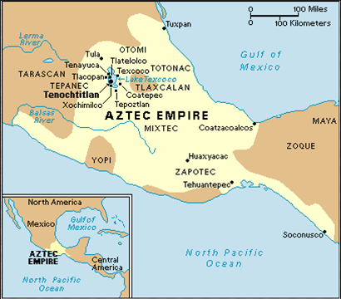
http://www.historyfiles.co.uk/KingListsAmericas/CentralAztecEmperors.htm https://aztecprojectempire.wordpress.com/maps/

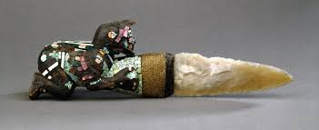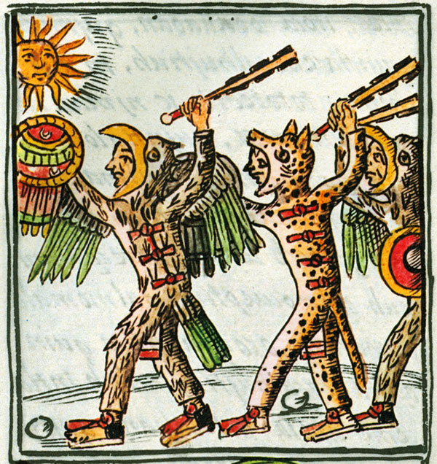
Aztec ceremonial knife Aztec eagle and jaguar warriors, http://www.mexicolore.co.uk/aztecs

The Columbian Exchange—The Arrival of Christopher Columbus

Columbus was an explorer. In 1492, he sailed from Europe to the Americas (or the New World). He and his sailors crossed the Atlantic Ocean, not knowing where they would land. It was a voyage into the unknown. After Columbus, other Europeans began to explore and settle in America.
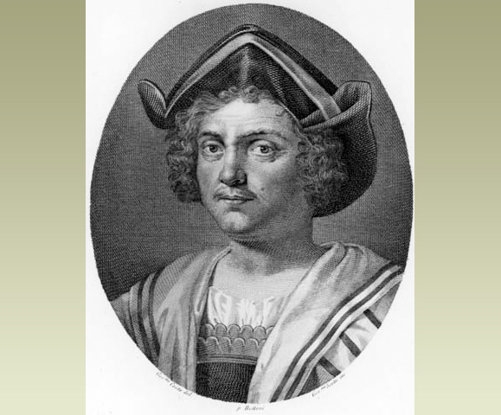
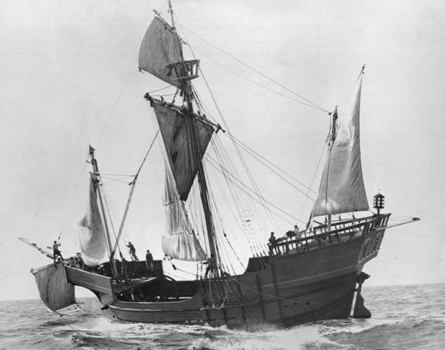
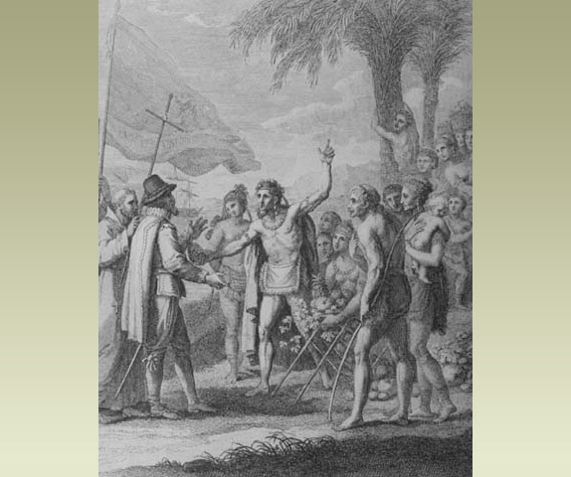
Images and reading adapted from http://www.bbc.co.uk/schools/primaryhistory/famouspeople/christopher_columbus/
The Columbian Exchange—Exchange of Goods, Ideas, and Diseases

When Europeans first touched the shores of the Americas, Old World crops such as wheat, barley, rice, and turnips had not traveled west across the Atlantic, and New World crops such as maize, white potatoes, and sweet potatoes had not traveled east to Europe. The New World did not have domesticated animals such as horses, cattle, sheep, or goats, nor did it have the germs associated with the Old World’s dense populations of humans and such associated creatures as chickens, cattle, black rats, and mosquitoes. Among these germs were those that carried smallpox, measles, chickenpox, influenza, malaria, and yellow fever.

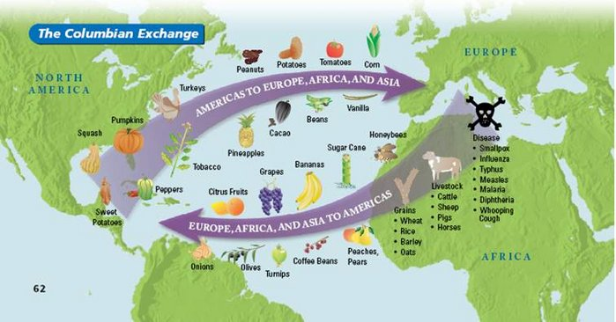
http://thecolumbianexchange.weebly.com/

Reading adapted from https://www.gilderlehrman.org/history-by-era/american-indians/essays/columbian-exchange
The Columbian Exchange—Effects on Indigenous (Native) Peoples
Indigenous peoples suffered from European brutality, alcoholism, the killing and driving off of game, and the seizing (taking away) of farmland. Smallpox was the worst of the infectious diseases that killed the Native Americans.
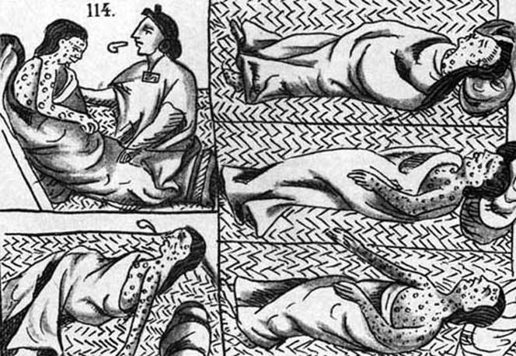
http://public.gettysburg.edu/~tshannon/hist106web/site19/diseases.htm

Reading adapted from https://www.gilderlehrman.org/history-by-era/american-indians/essays/columbian-exchange

