DOCUMENT A
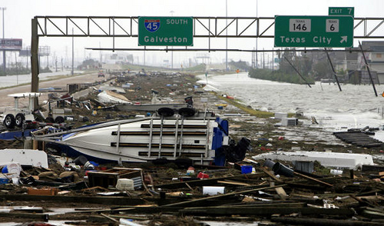
In 2008, Hurricane Ike was the third worst storm to ever hit the United States. The storm swallowed the Gulf of Mexico and was as big as Texas. Galveston location near the Gulf of Mexico made it an easy target. It came into Galveston Island as a Category 2 storm with winds of 110MPH. The National Weather Service in Houston/Galveston, TX issued a warning about the storm surge along the shoreline of Galveston Bay. Heavy flooding occurred in the area and many structures, including homes, were destroyed.
Excerpt and image adapted from http://www.local1259iaff.org/hurricaneike2008.html
DOCUMENT B
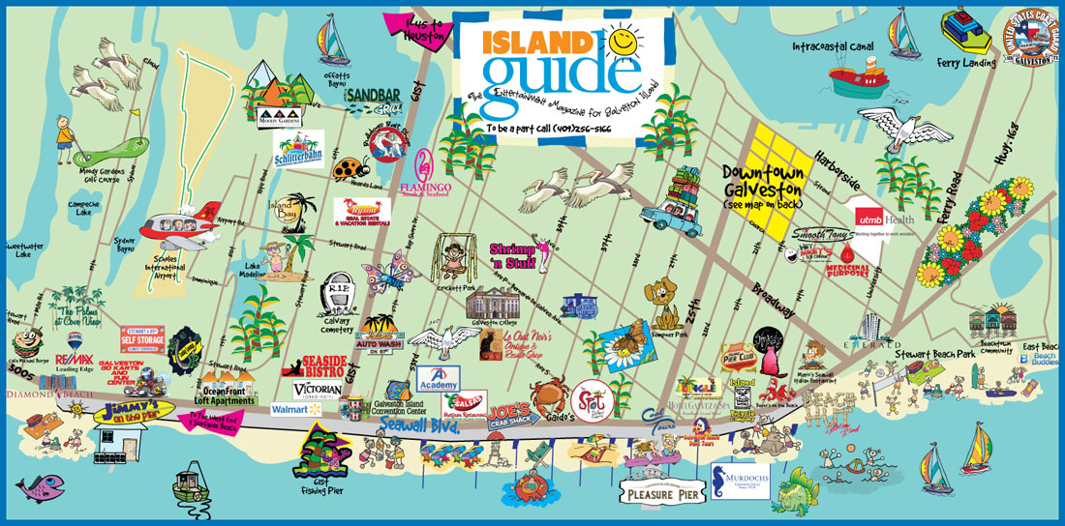

Galveston has more than 30 miles of beaches, 14 museums, 20 art galleries, plus several historic homes and mansions. Visits can enjoy a trip to the Lone Star Flight Museum, Texas Seaport Museum, and Moody Gardens which has a man-made tropical rain forest. It is a great tourist destination that many people enjoy.

Image: Galveston Fun Map, galvestonislandguide.com
Reading adapted from Tripadvisor: Galveston, Texas, https://www.tripadvisor.com/Tourism-g55879-Galveston_Galveston_Island_Texas-Vacations.html

DOCUMENT C
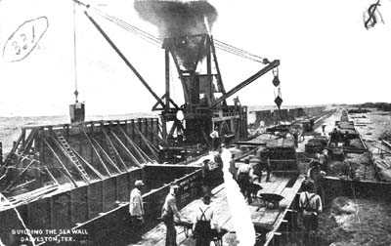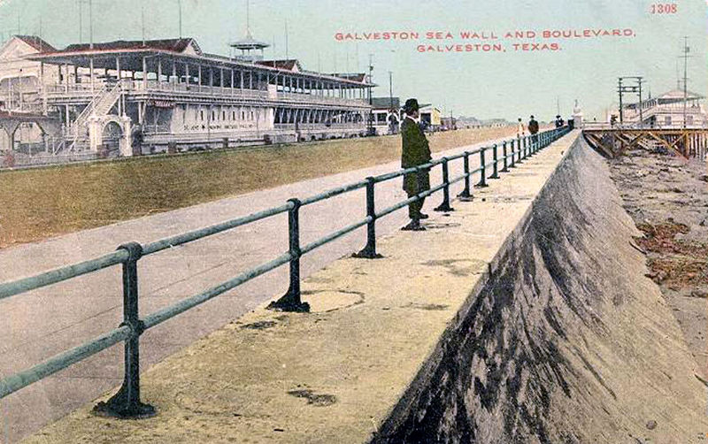
Source: Building the Sea Wall, Galveston, Tex; gthcenter.org
DOCUMENT D

The Galveston Hurricane of 1900 killed thousands of people and destroyed much of the city…by 1910 citizens…built a protective seawall. The Hotel Galvez was built in 1911… at the same time, Galveston became a port of entry…and the government created an immigration center. By 1915 Galveston was considered a "second Ellis Island" or immigrant center.
Today, the Port of Galveston serves as a passenger cruise ship terminal for cruise ships operating in the Caribbean. It also has facilities to handle all types of ship cargo.
Source: Galveston County, tsha.org

DOCUMENT E
Welcome from the Mayor

An island community rich in history and opportunity, Galveston is the ideal place to live, work, and raise a family.
We have one of the finest deep-water ports on the Gulf Coast, the Port of Galveston. Also, Galveston is the home of one of the largest insurance companies in the United States, the American National Insurance Company. In addition, we are proud to have the first medical school and complete health science center in Texas, the University of Texas Medical Branch - our largest employer. Last but not least, our successful tourist industry continues to grow and provide attractions that make Galveston a definite tourist destination.

Excerpt adapted from Welcome from the Mayor, cityofgalveston.org

