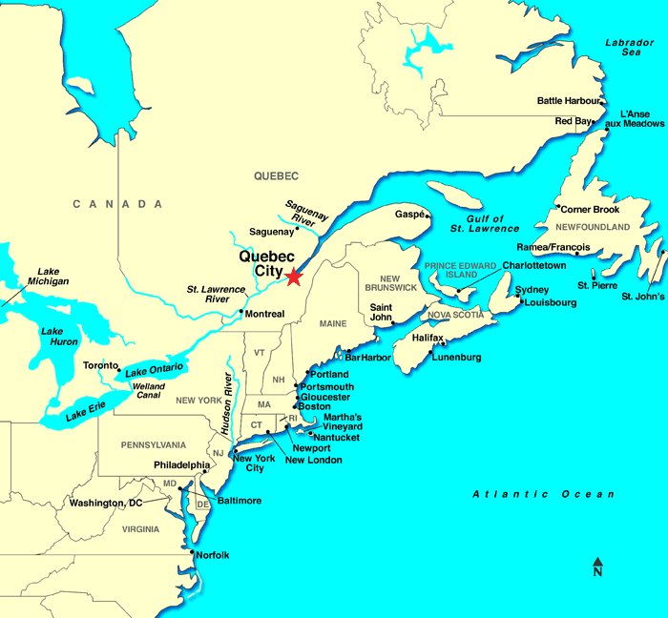
On Location: Quebec City, Quebec, Canada
Population: 516,625
Official Language(s): French
Quebec City is the capital of the Canadian province of Quebec. It is the oldest city in Canada. Thousands of years before the arrival of Europeans, Aboriginal hunters and fishermen lived in the area. In the 1530s, French explorer Jacques Cartier took possession of the land in the name of the king of France.

Featured Dish: Poutine
A Canadian dish consisting of French fries and fresh cheese curds topped with brown gravy. A curd is a soft, white substance formed when milk sours, used as the basis for cheese. (Interesting fact: the French fry actually originated in Belgium, not France!)

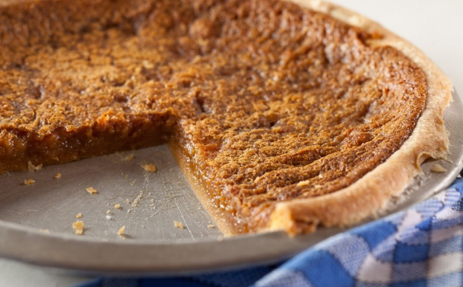
Featured Dish: Sugar Pie (tarte au sucre)
A French-Canadian specialty, sugar pie is a single-crust pie filled with a mixture of cream, flour, egg, and brown sugar, which is sometimes replaced with maple syrup. Such tarts are common in Northern France (and Belgium), from where so many of the original immigrants to la Nouvelle France, now Quebec, came from.

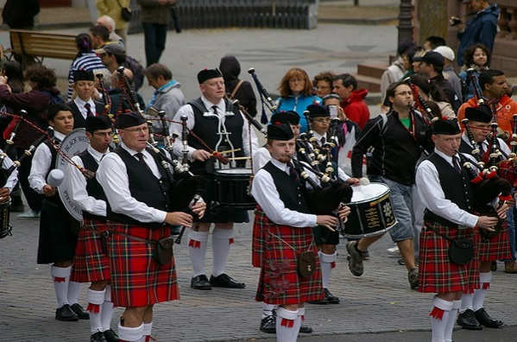
Featured Celebration: Quebec City Celtic Festival

For two weeks between August and September, Scotland and Ireland replace France as Québec City’s most dominant culture at this yearly Celtic festival. The festival celebrates its first weekend with a theme night and continues with a sports weekend filled with Gaelic football matches and other thrilling Celtic sporting activities. A Sunday afternoon Gaelic banquet is this festival’s delicious closing event.

https://whatscookingamerica.net/History/PieHistory/SugarCreamPie.htm
http://www.quebecregion.com/en/where-to-eat-restaurants/traditional-quebec-cuisine/
http://www.quebecregion.com/en/special-events/quebec-city-celtic-festival/
https://www.britannica.com/place/Quebec-province#toc271971
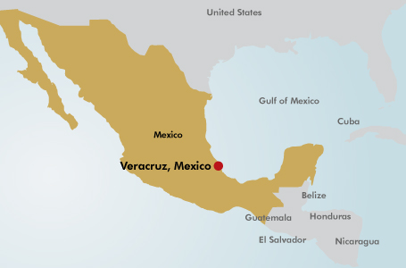
On Location: (City of) Veracruz, Veracruz, Mexico
Population: 428,323
Official Language(s): Spanish
Spanish conquistador (Spanish conqueror) Hernán Cortés founded the city of Veracruz in 1519 while searching for gold in the region. Like in most parts of Mexico, new European diseases and enslavement destroyed the native population in the first years after the Spanish arrived. As the population decreased, African slaves were brought over to work on the sugarcane plantations. Veracruz had the largest enslaved population in Mexico during this time.

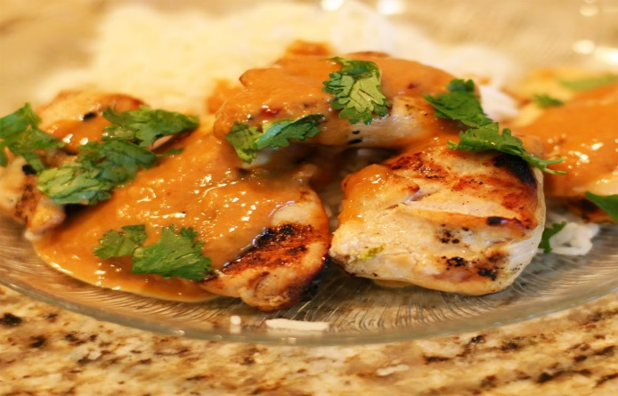
Featured Dish: Pollo Encacahuate

While peanuts are native to the Americas, West Africans took to them quickly, using cooking methods they used for their native groundnuts to these new ingredients. Peanuts, for example, likely weren't eaten before Africans arrived on the continent. Their influence can be found in dishes like pollo encacahuate, or chicken covered in a peanut sauce.

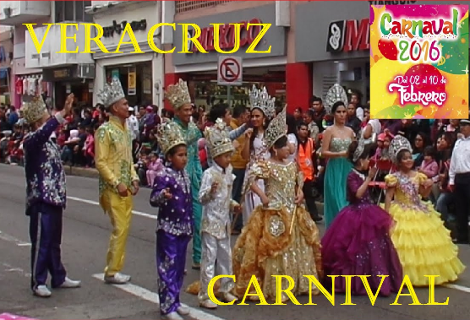
Featured Celebration: Carnival
This traditional celebration dates back to colonial times and has become the most important carnival in Mexico. During Carnival, there are artistic performances and six joyous parades. Dance troupes, batucadas, and cheerleaders participate in these parades. (Interesting Fact: Many countries in the Caribbean and South America celebrate Carnival.)

http://www.history.com/topics/mexico/veracruz
http://www.brederoshaw.com/plants/americas/veracruz.html
http://www.seriouseats.com/2014/08/regional-mexican-cuisine-veracruz.html
http://recetas-mexicanas.com.mx/pollo-salsa-cacahuate/pollo-salsa-cacahuate-2
https://www.youtube.com/watch?v=0NMX3EmOVZU

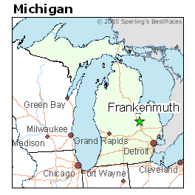
On Location: Frankenmuth, Michigan, United States
Population: 4,898
Primary Language(s): English
Frankenmuth was settled in 1845 by 15 Germans, led by Lutheran minister, August Craemer. The small band of settlers came to the area from Germany to convert Native Americans to Christianity. The first structure built was a church, and the second a school. Only seven years after their arrival, Frankenmuth had 80 cabins and farmhouses.

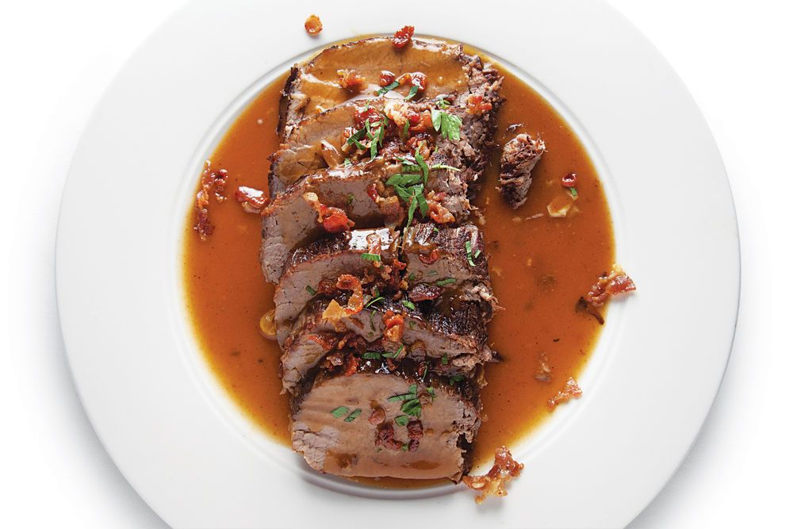
Featured Dish: Sauerbraten
Sauerbraten is a popular German dish that includes a large cut of beef that has been marinated in vinegar, wine, spices and seasonings for up to 5 days. This popular German dish can be found on the menus of restaurants, such as the Bavarian Inn Restaurant, and on the stoves of household cooks living in Frankenmuth, Michigan.

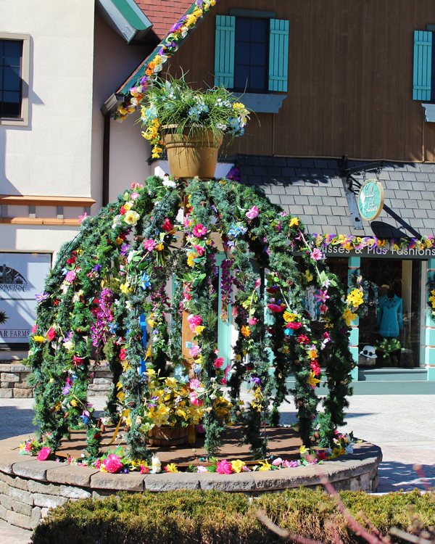
Featured Celebration: Bavarian Easter Celebration
The tradition of decorating Easter Fountains in Germany is over 200 years old and many cities and villages in Franconia, Germany still follow the tradition. Frankenmuth festively celebrates Easter with unique and colorful fountain and egg displays throughout town.

http://www.frankenmuth.org/grandgiveaway/
http://www.whats4eats.com/meats/sauerbraten-recipe
http://www.city-data.com/picfilesv/picv14591.php
http://www.frankenmuthcity.com/information/history

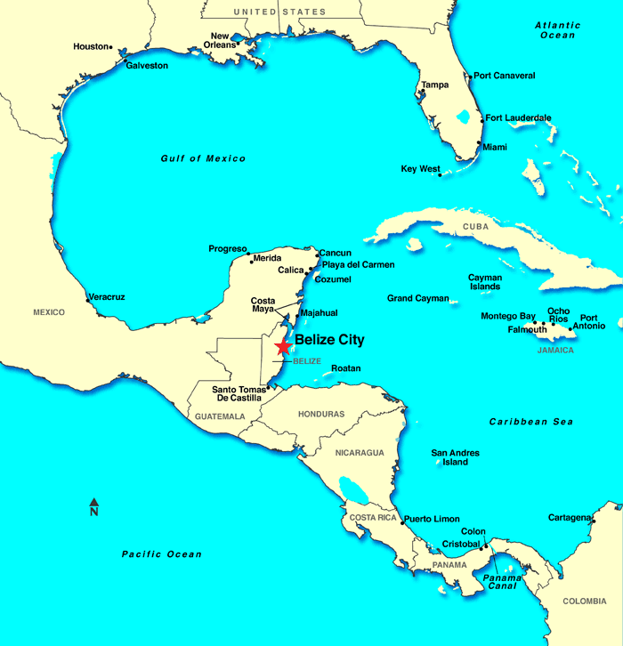
On Location: Belize City, Belize
Population: 57,169
Official Language(s): English
The first people to develop Belize were the Maya around 1500 B.C.E. The first European contact with Belize happened in 1502 when Christopher Columbus reached the area's coast. In 1638, the first European settlement was established by England and for 150 years, many more English settlements were set up. Belize was a representative government of England for many years but gained full independence in 1981.

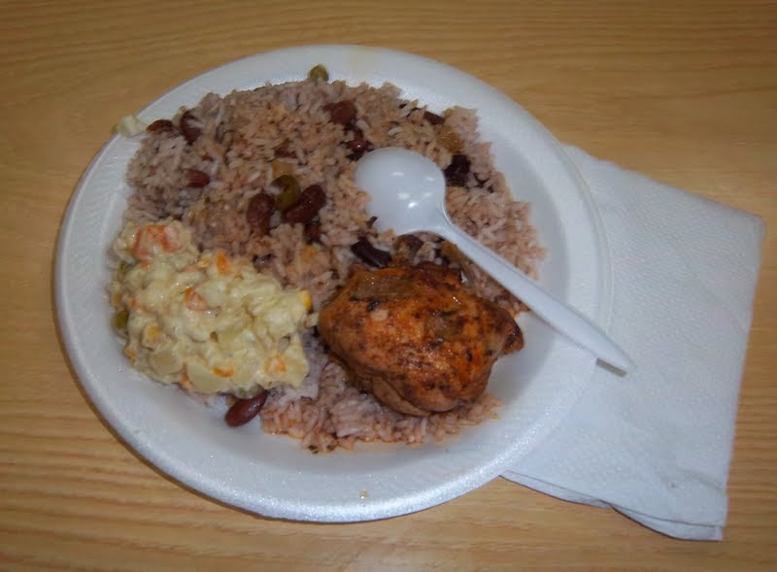
Featured Dish: Belizean Rice and Beans

Rice and beans is considered by many as the foundation of Belizean cooking. The dish consists of rice and beans cooked in coconut milk and served with meat and potato salad. Although originally considered a Creole dish, today it’s eaten daily by many people living in Belize City, Belize. (Interesting Fact: Creole is a term used to describe the people or foods of mixed French, African, and Eastern origin. Creole cooking is includes the use of fresh herbs, meats, poultry, fish, and shellfish that are cooked with various tropical fruits as well as vegetables, rice, tomatoes, sweet peppers, and onions.)

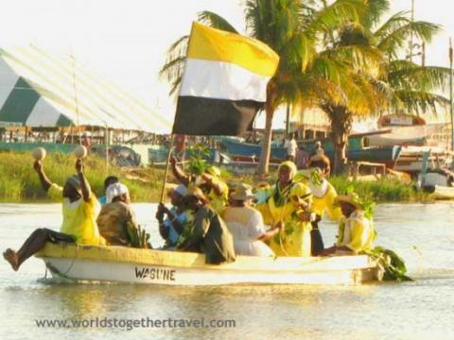
Featured Celebration: Garífuna Settlement Day
Belize consists of many cultural groups, Garifuna being one of the main groups of the country. In 1795, the Garifuna people fought against the British and were punished by being sent to the island near Honduras called Roatan. When this happened, the Garifuna people slowly began to settle along the coasts of southern Belize, Guatemala, and Honduras. On Garifuna Settlement Day, locals usually re-enact the Garifuna’s arrival in Belize by slipping out to sea in boats, and riding the surf onto the shore, waving palm and banana leaves to symbolize the cassava (a South American root vegetable) that fed their ancestors.
https://www.belize.com/belize-cuisine
http://www.travelbelize.org/facts-about-belize
http://www.centerforfoodsoftheamericas.org/research/the-caribbean/
http://aglobalworld.com/holidays-around-the-world/garifuna-settlement-day-belize/
http://south-centralamerica.worldstogethertravel.com/central-america/belize/dangriga/garifuna-settlement-day-belize-festival

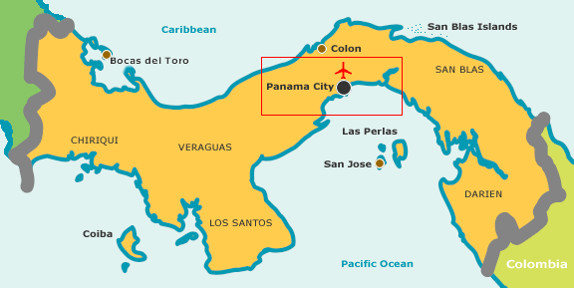
On Location: Panama City, Panama
Population: 880,691

Official Language(s): Spanish

Panama City was founded in 1519 by the Spanish governor Pedro Arias de Ávila. The Spanish settlement became an important center of government and church authority, but was destroyed in 1671 by the English pirate Sir Henry Morgan. It was once under Colombian rule but gained its independence in 1903. Since the Panama Canal was completed in 1914, the city has emerged as a center for international business and trade.
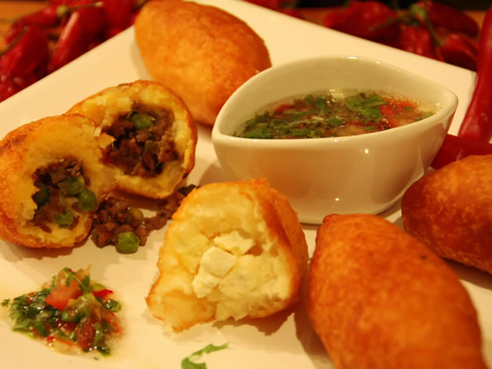
Featured Dish: Carimañola

Carimañola is a Panamanian meat-pie in a torpedo-shaped yuca fritter, stuffed with cheese, seasoned ground meat or shredded chicken and fried. It is similar to an empanada, except mashed yuca (cassava) is used as the wrapper. It is often served for breakfast, but also as a snack or appetizer. Carimañola is a very popular dish in Panama and can also be found in Colombia.

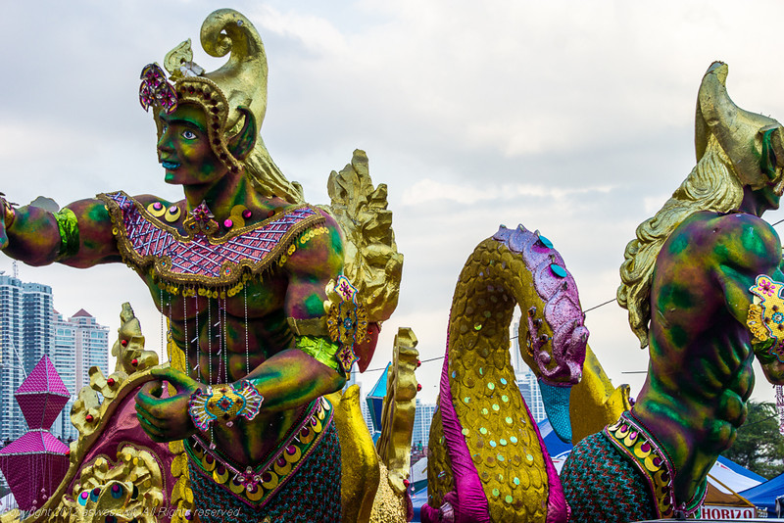
Featured Celebration: Carnival
Every year on the four days leading up to Ash Wednesday, the Panama Carnival takes place. It is the most celebrated Panamanian festival, and has been celebrated since the early part of the 1900's. During Carnival, you can experience colorful floats, live concerts, food booths, parades, games and fireworks. It's common to get soaked during the Panamanian Carnival, as large trucks are known to hit the streets spraying refreshingly clean water on all they pass. "Culecos", which are outdoor dance parties, typically involve getting sprayed quite a bit. (Interesting Fact: Many countries in the Caribbean and South America celebrate Carnival.)

http://www.tropicaldiscovery.com/accom_panama/el_panama/vacations.php
http://www.aswesawit.com/panama-carnival/
http://www.196flavors.com/2015/07/12/colombia-carimanolas-de-carne/
https://www.hablayapanama.com/blog/2014/07/what-do-panamanians-eat-traditionally-typical-meals-in-panama/
http://www.lonelyplanet.com/panama/panama-city/history#ixzz4VySvUoaa

