Determining Latitude and Longitude

Use the grid system on the map below to determine the city and state that can be found at the given latitude and longitude coordinates.

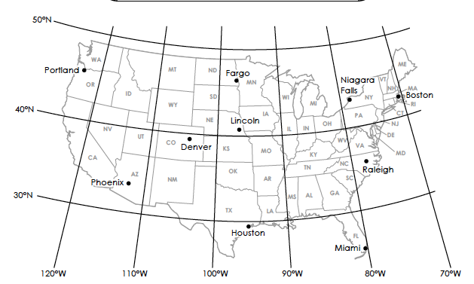

- 33°N latitude, 112°W longitude _________________________________________________________

- 35°N latitude, 78°W longitude _________________________________________________________

- 46°N latitude, 96°W longitude _________________________________________________________

- 45°N latitude, 122°W longitude _________________________________________________________

- 29°N latitude, 95°W longitude _________________________________________________________

- 43°N latitude, 79°W longitude _________________________________________________________

- 25°N latitude, 80°W longitude _________________________________________________________

Adapted from www.superteacherworksheets.com, Latitude and Longitude

