HSI: Mesopotamia
Document 1: Trade and Innovation
This Ancient Mesopotamia region included city-states. Ur was one of the most important city-states in Sumer and a center of trade. Sea-traders from Ur connected Mesopotamia with people as far away as South Asia. Sumerians used advanced mathematics and invented the first wheeled vehicles and codes of law. They also used a written language called cuneiform, which is the earliest known form of writing.

Document 2: City-States and Agriculture
Mesopotamia made up parts of the area known as the Fertile Crescent, which included a narrow strip of fertile land between the Tigris and Euphrates Rivers. About 9500 BC, Mesopotamians shifted from gathering food to growing food. In addition to farming, they domesticated animals, or used them for work and as a food source. Farming villages grew into bigger settlements and then cities. Later, these cities came together to create the world’s first city-states, or independent political units.

Document 3: Babylonian Code of Law
During the 1700s B.C., King Hammurabi created one of the first written codes of law in the world known as Hammurabi’s Code. King Hammurabi created the list of laws to (1) maintain order and (2) unify the various groups he conquered and controlled in Babylonia. Although Hammurabi’s Code included some horrific forms of punishment, it also included several modern legal practices. For example, when two people or groups had a disagreement, they were allowed to bring their case before a judge and provide evidence and witnesses to back up their claims.

HSI: Mesopotamia
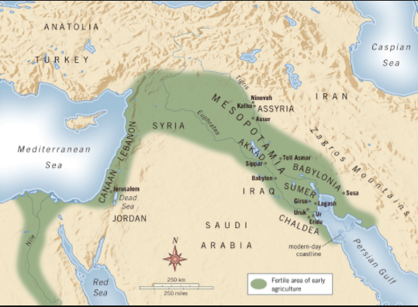

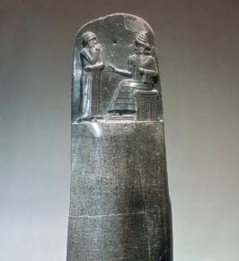
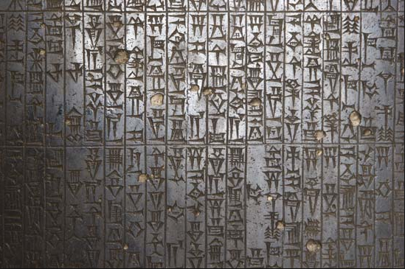

Excerpts adapted from “Mesopotamia.” National Geographic World Cultures and Geography. Washington, DC: 2015;
http://www.history.com/news/history-lists/8-things-you-may-not-know-about-hammurabis-code
Images—
Map of the Fertile Crescent: https://martinhumanities.com/category/mesopotamia/
Diorite stele and detailed view of stele inscribed with the Code of Hammurabi: https://www.britannica.com/topic/Code-of-Hammurabi

HSI: Ancient Egypt
Document 1: Mathematics
The Ancient Egyptians were mathematics experts and created advanced methods for solving problems. Egyptians used mathematics to create buildings, manage food supplies and compute the flood levels of the Nile River. Their mathematicians were so skilled that great Greek mathematicians traveled to Egypt to learn from them. Modern-day mathematics can be traced back to the ancient civilization. For example, the Rhind Mathematical Papyrus, the most famous mathematical document to have survived from Ancient Egypt, is the major source of knowledge of the mathematics of ancient Egypt. It contains 84 different mathematical problems - such as how to distribute 100 loaves of bread among a group of workers.

Document 2: Hieroglyphics
Around 3000 B.C., The Ancient Egyptians invented a writing system based on symbols called hieroglyphics. Hieroglyphics provide a look into Egypt’s past—particularly, in regards to religion, culture, and government in the ancient civilization. For example, the Rosetta Stone, a text written by a group of priests in Egypt in 196 B.C. to honor the Egyptian pharaoh, was partly written in Egyptian hieroglyphics. It lists all of the things that the pharaoh did for the priests and the people of Egypt.

Document 3: Egyptian Pyramids
The Egyptians built stone monuments called pyramids. The pyramids were built for two reasons—(1) as burial places, or tombs, for royalty and (2) kings and pharaohs to demonstrate their power by having large pyramids built in their honor. The largest pyramid built was the Great Pyramid of Khufu. Engineers and archaeologists are still amazed by Ancient Egyptian architecture and how the Egyptians built the pyramids without modern machines and technology. The pyramid form, in particular, still plays an important role in modern architecture, and can be seen above cemeteries, shopping centers, and other structures and locations.

` HSI: Ancient Egypt
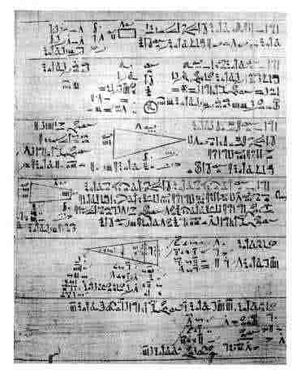
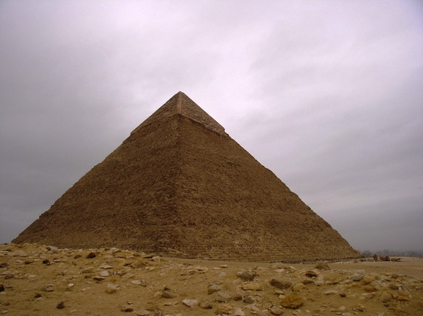
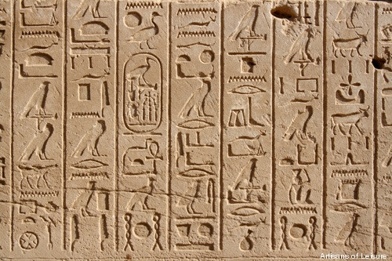

Excerpts adapted from “The Great Pyramids” and “Egypt’s Ancient Civilization.” National Geographic World Cultures and Geography. Washington, DC: 2015;
https://explorable.com/egyptian-mathematics
https://php.math.unifi.it/archimede/archimede_NEW_inglese/curve/curve_giusti/prima.php?id=1
http://www.bbc.co.uk/ahistoryoftheworld/objects/y1T3knf-T66RwWyEt_cZBw
http://www.ancientegypt.co.uk/writing/rosetta.html
Images—
Rhind Papyrus: http://www-groups.dcs.st-and.ac.uk/history/HistTopics/Egyptian_mathematics.html
Egyptian Hieroglyphics: https://www.quora.com/How-many-symbols-are-there-in-Egyptian-Hieroglyphs-writing
Great Pyramid of Khufu: https://www.khanacademy.org/humanities/ancient-art-civilizations/egypt-art/predynastic-old-kingdom/a/old-kingdom-pyramid-of-khufu

