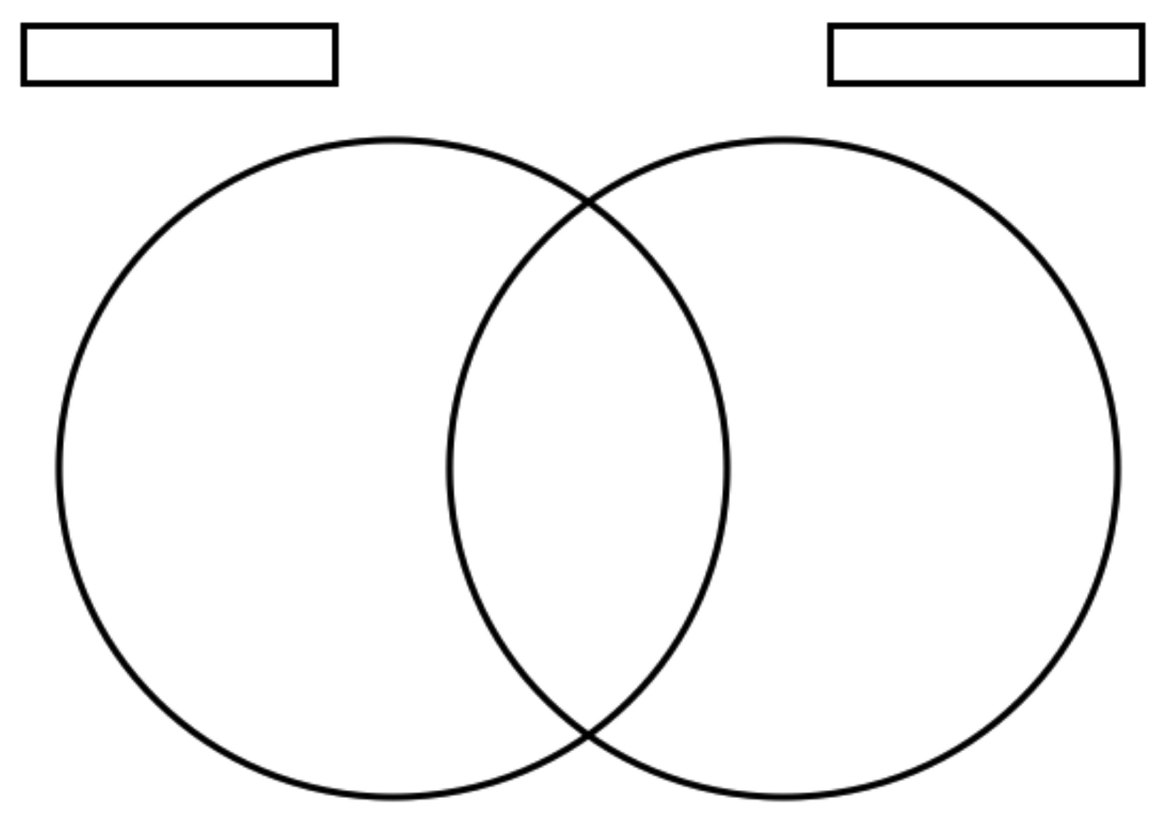
Venn Diagram – Sub-Saharan Africa: People & ESPN

