DOCUMENT 1
Many jobs, especially in call centers, banking, tech support, and manufacturing are being outsourced to the region of South and Southeast Asia due to lower wages, a large English-speaking population, and availability of technology.

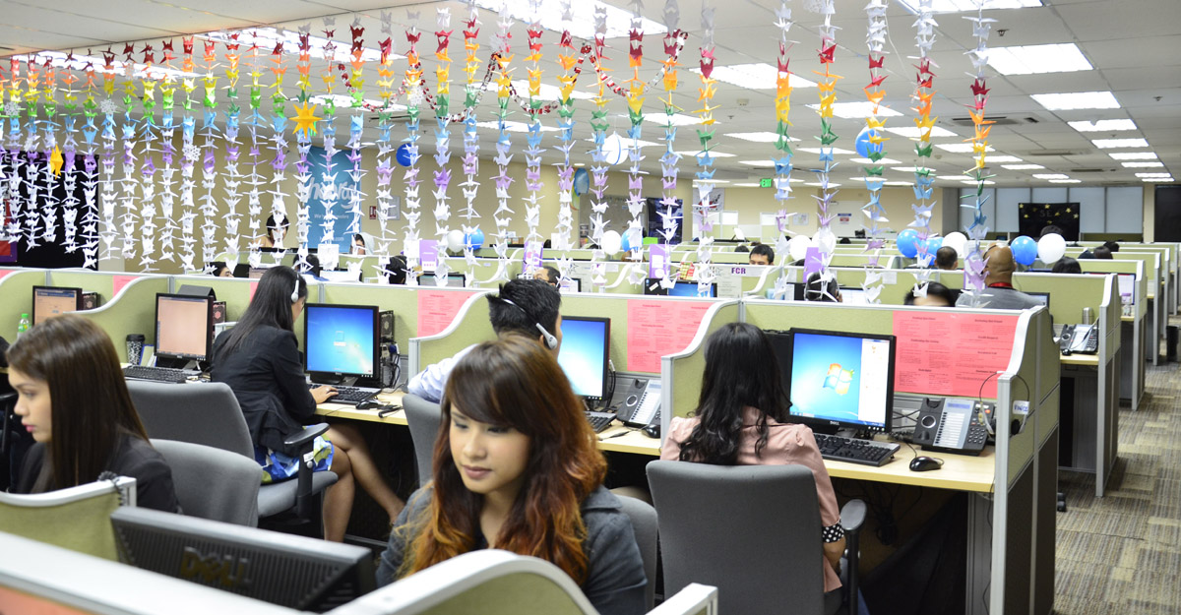
Image: An American-based company call center in the Philippines
List 3 things from the image that supports the statement above:
1.

2.

3.

Explain 2 ways people have adapted to the environment in the area:
1.

2.

Draw 1 conclusion about the role of technology in the area:

Source: forbes.com
DOCUMENT 2
Rural populations tend to create a more sparse settlement pattern and often are more dependent on agriculture, harvesting natural resources or ranching/herding as the primary economic activities.

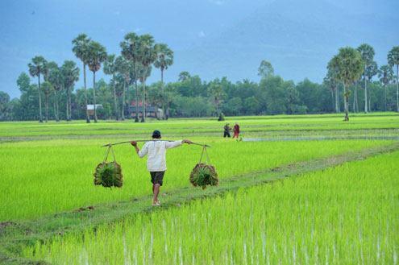
Image: Rice Farm in Cambodia
List 3 things from the image that supports the statement above:
1.

2.

3.

Explain 2 ways people have adapted to the environment in the area:
1.

2.

Draw 1 conclusion about the role of technology in the area:
1.

Source: asiafoundation.org

DOCUMENT 3
Urban populations represent denser population patterns and the lifestyle and economic activity is directly affected by available manufacturing and industry.

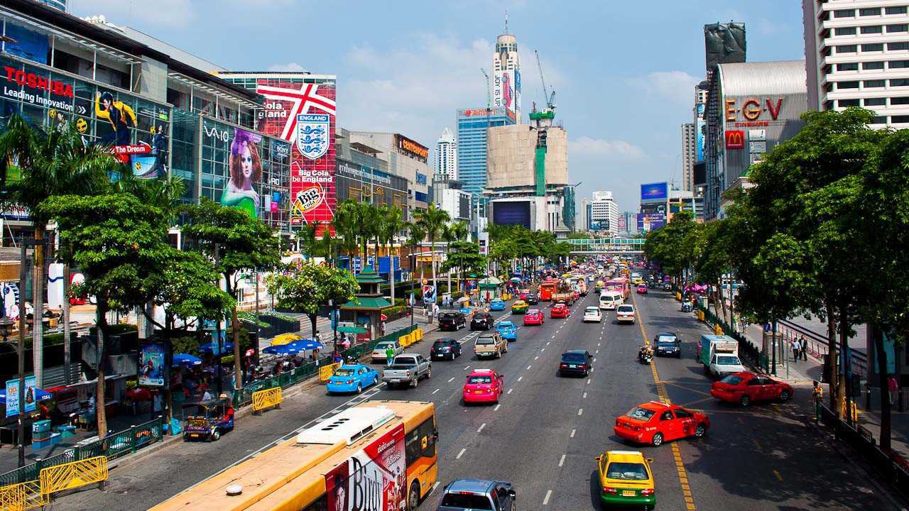
Image: A city in Thailand
List 3 things from the image that supports the statement above:
1.

2.

3.

Explain 2 ways people have adapted to the environment in the area:
1.

2.

Draw 1 conclusion about the role of technology in the area:

Source: crownetravels.com

