eNvironmental OPTICS 1

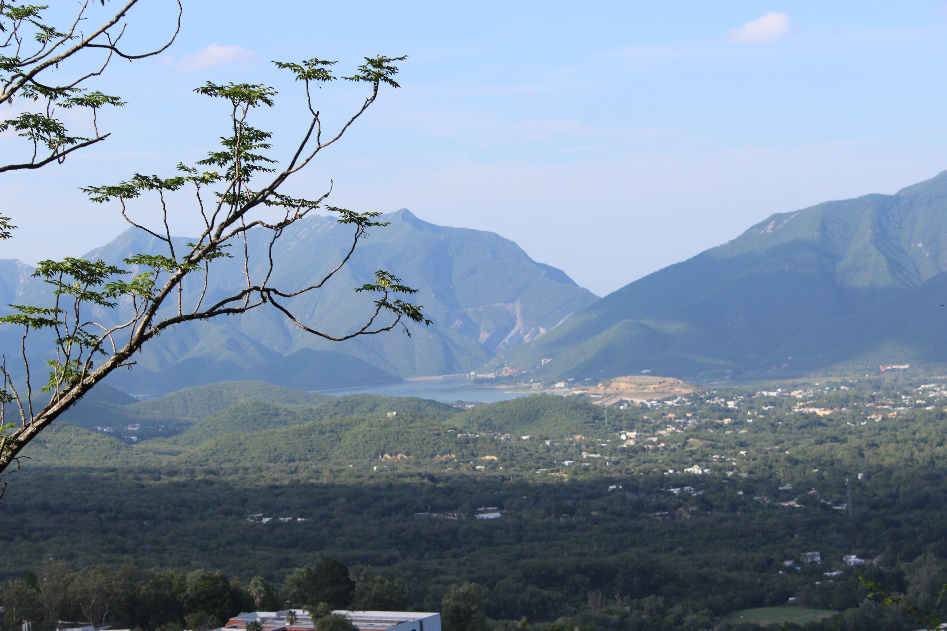
Photo by Adriana Bermejo (2013)

Objects in the photo? ________________________________________________________________________________
People/Participants in the photo?_______________________________________________________________________
Title/Time Period? ___________________________________________________________________________________
Inferences you can draw? Because I see I can infer the climate is
Conclusions? I can conclude that life in this place is because
Summary/ SoWhat? The two most important things in this visual are and because they give the message that
ANSWER ON YOUR OWN…
Do you think many people live in this area? What do you think are possible benefits and/or drawbacks of living in an area like this?
__________________________________________________________________________________________________
__________________________________________________________________________________________________

