**DOCUMENT A**

**Use the excerpt below to answer questions 1-4.**

|  |
| --- |
| **European Imperialism in Africa**    **Imperialism** is the domination (control) by one country of the political, economic, or cultural life of another country.  **The Old Imperialism** occurred between 1500 and 1800. Europeans established **colonies** in African coastal regions.  **The New Imperialism** occurred between 1870 and 1914. **Nationalism**—a strong sense of loyalty to one’s country—had produced strong, centrally governed nation-states. The Industrial Revolution—a period in the 1700s and 1800s in which workers in factories began to use machines to make goods—had made economies stronger as well. Imperialists needed raw materials to supply their factories. They needed foreign markets in which to sell their finished products. They also needed places to invest their profits (money made).  During this time, European industrialized nations became more forceful into expanding into other lands. The new imperialism was focused mainly in Africa—a continent rich in natural resources—where declining empires (kingdoms) and local wars left many states vulnerable (defenseless). In Africa, many states had been weakened by the slave trade.  Source adapted from *Imperialism in Africa*; ocs.cnyric.org |

1. In your own words, define the term ***imperialism***.
2. A ***colony*** is defined as an area controlled by a distant country. Based on the excerpt, what do you think motivated Europeans to establish colonies in Africa?
3. According to the excerpt, what factors or circumstances allowed Europeans to take control of African lands?
4. What do you think were some of the long-term effects of European imperialism in Africa?

**DOCUMENT B**

**Use the excerpt below to answer questions 1-3.**

|  |
| --- |
| **The Berlin Conference of 1884-1885 (“Scramble for Africa”)**  To keep the Europeans from fighting a war over the division of Africa a meeting was held in Berlin, Germany called the **Berlin Conference** where the nations of Europe peacefully divided Africa between themselves. For the next sixty years Africa, the Africans and the vast riches of Africa belonged to the Europeans as Africa was colonized (settled) and dominated (controlled) by Europe. All of Africa’s people and resources were exploited (misused)as for nearly a century Africa existed purely to benefit Europe.  During the conference, the leaders agreed to allow free trade among the colonies and established a plan for negotiating future European claims in Africa. Neither the Berlin Conference itself nor the plan for future negotiations (talks) provided any say for the peoples of Africa over the dividing of their homelands. By 1900, European states had claimed nearly 90 percent of African territory.  Excerpt adapted from *Berlin Conference of 1884-1885*; oxfordreference.com |

1. In your own words, explain the purpose of the Berlin Conference.
2. What long-term economic, social/cultural, and political effects do you think this event has had on the continent of Africa?
3. What long-term economic, social/cultural, and political effects do you think this event has had on the continent of Europe?

**DOCUMENT C**

**Use the map below to answer questions 1-3.**

**Map of Africa—1900s**

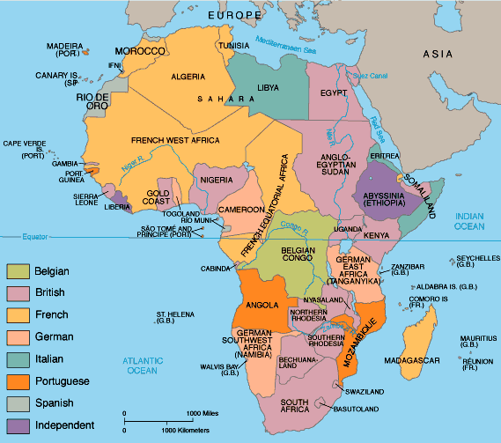

1. In your own words, describe what the map is showing.
2. Which two countries controlled the most land in Africa?
3. Do you think that the political divisions shown on the map created conflict between European powers? Why or why not?

**DOCUMENT D**

**Use the image below to answer questions 1-2.**



**Source:** The Rhodes Colossus: Striding from Cape Town to Cairo,” Dec. 10, 1892. Artist: Linley Sambourne

1. In your own words, describe what you see in the image above.
2. The image shows Cecil Rhodes, a ruler in British colonial Africa. Based on this image, how do you think Rhodes viewed Africa? Why?