**DOCUMENT A**

**Use the map and text below to answer questions 1-3**

**North Africa and Southwest Asia**



|  |
| --- |
| **The Geography of North Africa**  North Africa includes the countries of Morocco, Algeria, Tunisia, Libya, and Egypt. It is a very dry region. In fact, the Sahara desert covers most of North Africa. In the western part of the region, people live largely along the coast or in valleys in the Atlas Mountains, which get some rainfall. In Egypt, most of the population lives in a narrow area of land around the Nile River, which provides water. The rest of Egypt is covered by sparsely populated deserts and mountains.  The population of North Africa is increasing rapidly. Egypt has the largest population in the region. In fact, nearly as many people live in Egypt as in the rest of North Africa put together. Slightly more than half of all North Africans live in cities. Cairo, Egypt, is one of the largest cities in Africa. The rapid growth of cities has caused overcrowding and a lack of clean drinking water.  Source: *The Geography of North Africa*, Contemporary World Cultures |

1. What countries make up the region of North Africa?

1. What are the benefits and drawbacks of living in Egypt?
2. How does the physical geography of North Africa influence the decisions and lifestyle of people living within the region?

**DOCUMENT B**

**Use the map and text below to answer questions 1-3**

**North Africa and Southwest Asia**



|  |
| --- |
| Southwest Asia (also known as the Middle East) includes the countries ofJordan, Lebanon, Israel, Syria, Saudi Arabia, Yemen, Oman, United Arab Emirates (UAE), Qatar, Kuwait, Iraq, Iran, Afghanistan, and Turkey.The region is home to the Dead Sea, which is the saltiest and lowest body of water in the world and is surrounded by the Mediterranean Sea, Black Sea, Caspian Sea, Persian Gulf, and Red Sea. Farming is very difficult in Southwest Asia because of the harsh climate and lack of water and arable land; however, the region is rich with valuable resources such as oil and natural gas. |

1. What countries make up the region of Southwest Asia?

1. What are the benefits and drawbacks of living in Southwest Asia?
2. How does the physical geography of Southwest Asia influence the decisions and lifestyle of people living within the region?

**DOCUMENT C**

**Use the map below to answer questions 1-3.**

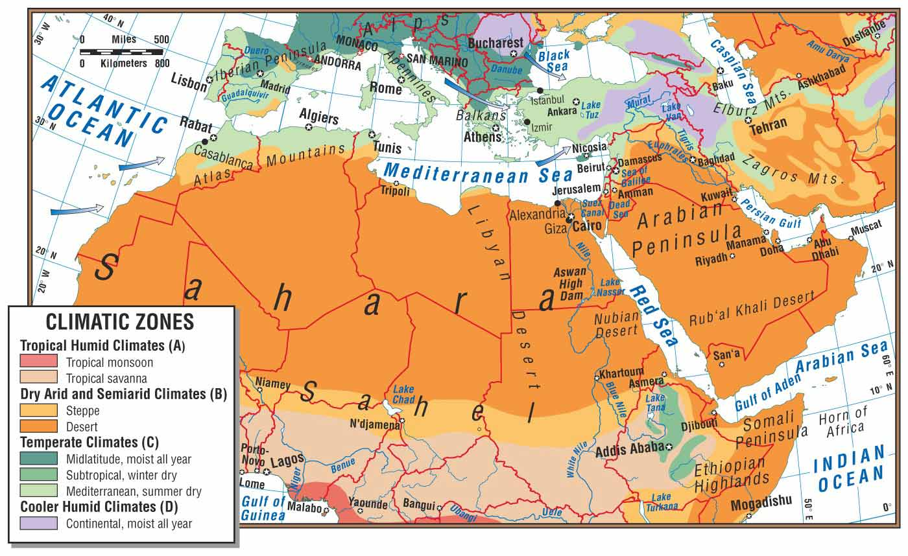

Source: lahistoriaonmapas.com

1. Which climatic zone dominates the region of North Africa and Southwest Asia?
2. What physical features and climate zones encourage migration settlement in the region (i.e. specific water forms)? Why?
3. What physical features discourage migration and settlement in the region? Why?

**DOCUMENT D**

**Use the image and text below to answer questions 1-4.**

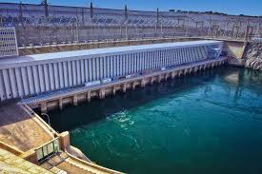

Source: Aswan High Dam; landimages.wordpress.com

|  |
| --- |
| North Africans have made major changes to their environments to make life easier. One important example is the Aswan High Dam, built on the Nile River in Egypt. It provides hydroelectricity and ended flooding. However, it also has negative environmental consequences. The region faces other environmental problems as well. Desertification, or the expansion of deserts, is a one serious problem and is often caused by overgrazing by livestock animals.  Source: *The Geography of North Africa*, Contemporary World Cultures |

1. What is the purpose of the Aswan High Dam?
2. What are some of the benefits of the Aswan High Dam?
3. What do you think are some of the negative consequences of the human modification?
4. How do you think desertification has affected settlement patterns in the region?

**DOCUMENT E**

**Use the image below to answer questions 1-3.**

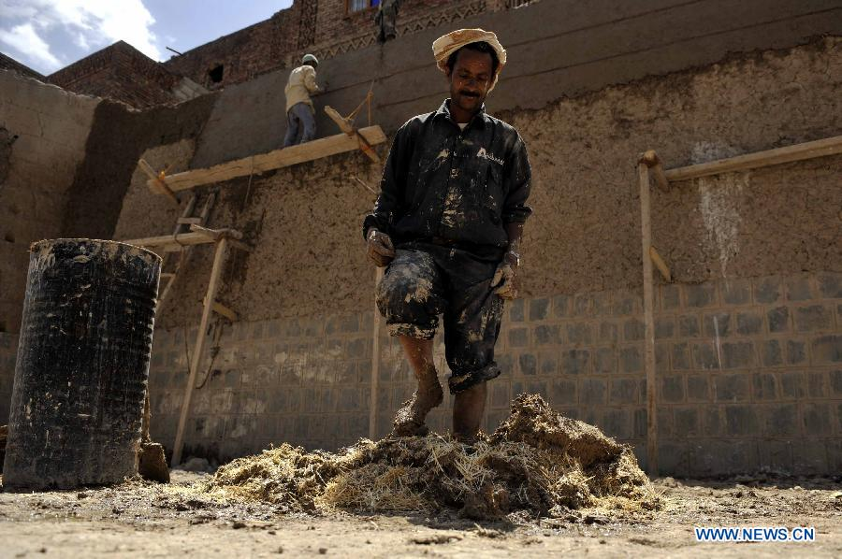

**Source:** Old City of Sanaa, Yemen; news.xinhuannet.com

1. What is happening in the picture?
2. What do you think are the benefits and drawbacks of living in this place?
3. How does the physical geography of this place influence the decisions and lifestyle of people living within the area?