Station 1: Western Region
The Rocky Mountains can be found in the west and is North America’s largest chain of mountains. The Rockies connect western areas of Canada to the southwestern portion of the United States and are part of a long series of mountain ranges.
The Sierra Madre mountain system is also a part of this long series of mountain ranges. The Sierra Madre stretch from the southwestern United States to Honduras. The Sierra Madre include many high volcanoes that stretch across Mexico south of the cities of Guadalajara and Mexico City.
In addition to mountains, the western region of North America includes deserts, forests, and rich deposits of oil and natural gas.

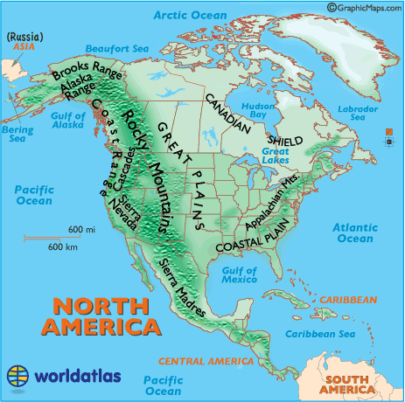

Reading adapted from http://nationalgeographic.org/encyclopedia/north-america-physical-geography/

Station 2: Great Plains
The Great Plains lie in the middle of the continent. Deep, rich soil covers large areas of the plains in Canada and the United States. Grain grown in this region, called the “Breadbasket of North America,” feeds a large part of the world. The Great Plains are also home to rich deposits of oil and natural gas.
The grassland or prairie regions of the Great Plains make up the largest biome in North America. Extreme weather stops the growth of large plants but is perfect for the natural grasses that cover most of the region.
These natural, or native, grasses vary in size from 7 feet in tallgrass prairies to only 8 or 10 inches in shortgrass prairies. Native animal species include bison, prairie dogs, and grasshoppers.

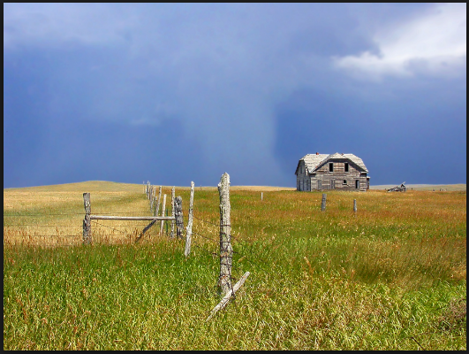
https://www.usgs.gov/media/images/agricultural-field-great-plains-region-montana

Reading adapted from http://nationalgeographic.org/encyclopedia/north-america-physical-geography/
Station 3: Canadian Shield
The Canadian Shield is a raised but somewhat flat plateau. It covers eastern, central, and northwestern Canada. The Canadian Shield includes a rocky landscape with several lakes.

The tundra is a biome common to the Canadian Shield. The tundra contains permafrost (soil that is frozen for two or more years). This permafrost keeps moisture near the soil’s surface, allowing vegetation growth even in the extreme, Arctic conditions of the tundra. During the summer, this top layer of soil melts only a few inches down, creating many shallow lakes, ponds, and marshes. Flowerless plants such as mosses take advantage of these shallow waters. In turn, they provide food for the caribou and musk ox that are typical of this area.

The region is filled with large deposits of nickel, gold, silver, and copper. There are also large forests in the region.
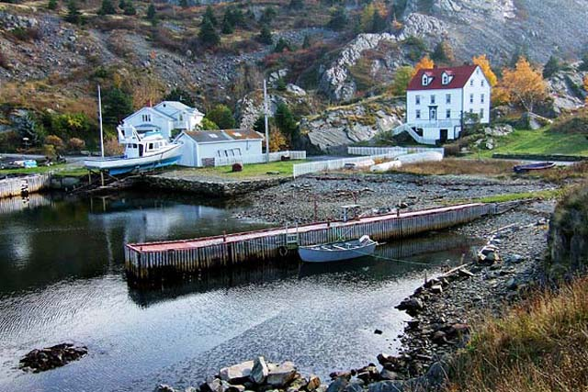
http://www.brigus.net/album/Brigus-in-the-Fall-.html

Reading adapted from http://nationalgeographic.org/encyclopedia/north-america-physical-geography/
Station 4: Eastern Region
This diverse region includes the Appalachian Mountains and the Coastal Plain (see map below). In the United States, the coastal plain can be found along the Atlantic Ocean and the Gulf of Mexico. The Coastal Plain includes cities such as Houston and Corpus Christi. Both cities are located along the Gulf of Mexico (Gulf Coastal Plain).
North America’s older mountain ranges, including the Appalachians, rise near the east coast of the United States and Canada. These areas have been mined for rich deposits of coal and other minerals for hundreds of years.
The coastal plains along the Atlantic extends from river, marsh, and wetland regions east of the mountains toward the sandy beaches of the Atlantic coast. Wetland areas are a biome of the eastern region and includes areas of land whose soil is soaked with permanent or seasonal moisture.

Map: Appalachian Mountains and Coastal Plains
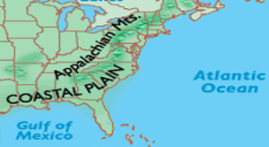
Graphicmaps.com
Map of Corpus Christi, Texas
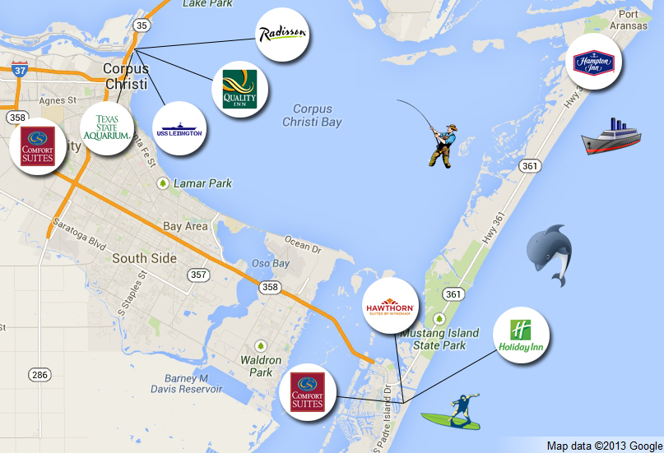http://corpuschristibeachhotels.com/

Reading adapted from http://nationalgeographic.org/encyclopedia/north-america-physical-geography/
Station 5: Caribbean Region
The Caribbean Region includes more than 7,000 islands, islets, reefs, and cays. The region’s islands and smaller islets are different in their landscape; some have somewhat flat and sandy land while others are rugged, mountainous, and volcanic. These beautiful and diverse islands attract many tourists from around the world.
The coral reefs and cays of the Caribbean Sea are among the most spectacular biomes in North America. Some coral reefs surround islands, such as the Bahamas, Antigua, and Barbados.
Coral reefs are made of millions of tiny animals—corals—that form a hard shell around their bodies. This hard surface provides a rich community for algae and plants such as seagrass and brightly colored tropical fish, as well as sharks, sea turtles, sea stars, and sea horses.

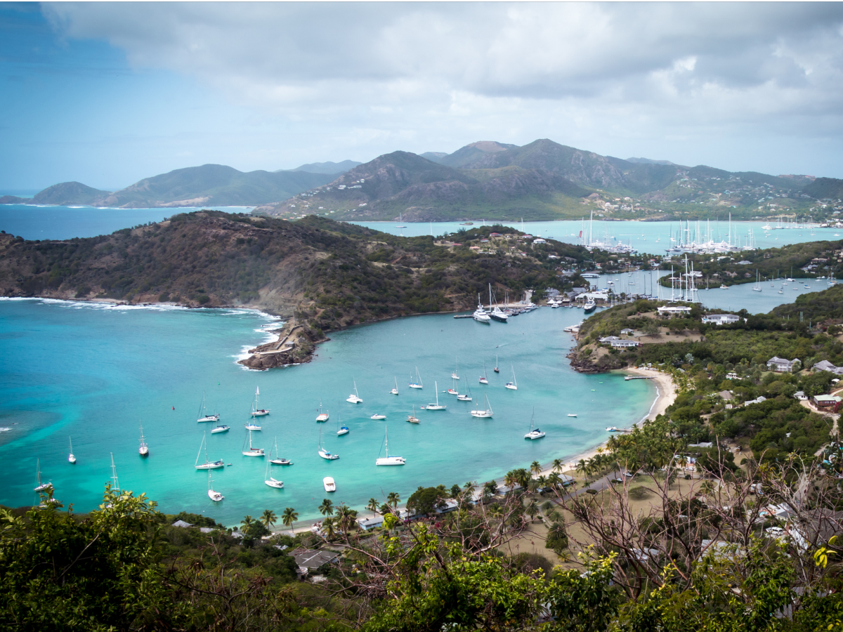
http://www.businessinsider.com/the-25-best-caribbean-islands-ranked-2016-2/#15-montserrat-11

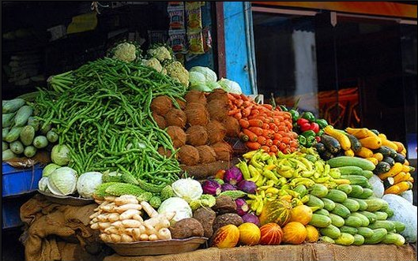
https://repeatingislands.com/2015/06/16/u-s-v-i-to-host-31st-west-indies-agricultural-economics-conference/

