Religion in the South and Southeast Asia Organizer
 | Hinduism | Buddhism  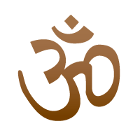 | Islam
Followers Worldwide
Origin

Name of Deity/Creator

Founder
Holy Book

Worship
Leaders
Place of Worship
Basic Beliefs/
Guidelines/
Rituals/
Celebrations

