CHRISTIANITY
How did Christianity begin?
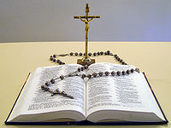
Christianity traces its beginning to the birth, adult ministry, death and resurrection of Jesus of Nazareth, known as Jesus Christ over 2000 years ago in the Middle East. Christians believe that Jesus Christ was the Son of God – fully human and fully divine – and that through believing in him and following his teachings they can inherit eternal life. In addition, Christians believe in the Trinity, or the three parts of God: God the Father or Creator, God the Son (Jesus) or Redeemer, and God the Holy Spirit or Sanctifier. The Holy Spirit is God's presence in the world.
Today there are about 2.2 billion Christians living all over the world. Most Christians live in countries within the Western Hemisphere such as the United States.
What is the sacred text of Christianity?
The sacred text of Christianity is the Holy Bible. The Christian Bible has two parts: the Old Testament which is essentially the Hebrew scriptures of Jesus' time; and the New Testament which contains writings about Jesus Christ and about the early church.

Why are there so many different kinds of Christians?
Today, Christianity is practiced by over two billion people. As with any large group, Christianity has experienced many different interpretations, disagreements and struggles for power over the centuries. These have led to the growth of many different branches of Christianity interpreting the life, death and resurrection of Jesus in different ways.
There are three basic branches of Christianity: Orthodox, Protestant and Roman Catholic. The Protestant branch includes: Methodist, Episcopal, Baptist, Anglican, Lutheran, and Pentecostal.
What are some of the holidays and festivals that Christians celebrate?
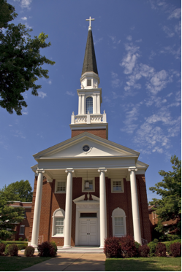
Christians worship in churches and cathedrals. It is customary to worship on Sunday, the Sabbath, and on other special festivals and celebrations such as:

- Christmas - often celebrated with nativity scenes, stories, pageants recalling the story of Jesus' humble birth in a stable surrounded by animals.
- Lent - the period leading up to Easter commemorating the 40 days Jesus spent in the desert fasting and praying. A time for personal reflection and improvement through prayer, fasting, and study.
- Easter - Jesus' resurrection from the dead. Eggs are a major symbol of Easter since they symbolize new life. Crosses are often covered with flowers to symbolize Jesus' victory over death.
Where do Christians worship and what are their leaders called?
Christians worship in churches and cathedrals. Worship leaders are called priests, ministers, pastors, reverends, and chaplains.

ISLAM
How did Islam begin?
The age of Islam began on the Arabian Peninsula in AD 622, when the prophet Mohammed fled to Medina from the holy city of Mecca in Saudi Arabia. Followers of Islam are called Muslims. Muslims believe that the last prophet of Allah (which means “God” in Arabic), Mohammad, was sent to preach the word of Allah. Muhammad’s main message is that there was no other God but Allah and that people should lead their lives in a way that was pleasing to Allah.
Islam spread quickly first throughout Saudi Arabia and surrounding countries and then throughout the world. There are about 1.6 billion Muslims in the world. The countries with the largest Muslim populations are Indonesia and India. In the Middle East, Turkey and Iran have the largest Muslim populations and in North Africa, Egypt has the most populous Muslim communities.
There are two basic groups of Islam: the Sunnis (about 80% of the world's Muslims) and the Shi'ites (about 20% of the world's Muslims). Although they share the same basic beliefs, they disagree on who was the rightful leader of Islam after Muhammad's death.
What is the sacred text of Islam?
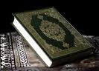
The sacred text of Islam is the Qu’ran (Koran). Many Muslims try to learn to read the Koran in its original language, Arabic. It is not uncommon for Muslims to memorize whole chapters of it. They read part of it every day.

What are the Five Pillars of Islam?
These are daily guidelines and rituals that Muslims must follow.
- Shahadah (declaration of faith)—to bear witness or testify that there is no god except one God (Allah) and Muhammad is His prophet or messenger.
- Salat (ritual prayer)—the five daily prayers are performed at dawn, noon, mid-afternoon, sunset and night. The prayers are offered in Arabic language and facing the direction of Mecca.
- Zakah (alms tax) –Giving 2.5% of one's wealth to the poor and needy.
- Sawm (fasting)—Muslims fast during the daylight hours in the ninth month of the Islamic lunar calendar called Ramadan. Ramadan is considered the holy month. Its purpose is to remind people of the goodness of what they have and to show equality with the poor.
- Hajj (pilgrimage)—Muslims believe in making a pilgrimage (journey) to Mecca, Saudi Arabia at least once in their lifetime. Mecca is a very sacred place to Muslims.

Where do Muslims worship and what are their leaders called?
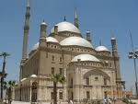
Muslims worship in mosques and their worship leaders are called Imams.

JUDAISM

How did Judaism begin?
Judaism began about 4000 years ago with the Hebrew people in the Middle East. Abraham, a Hebrew man, is considered the father of the Jewish faith because he promoted the central idea of the Jewish faith: that there is one God (Yahweh). At the time many people in the Middle East worshipped many gods (polytheism).
Abraham's son, Isaac had a son, Jacob, also called Israel. In this way the descendants of Abraham came to be known as the Israelites. According to the Jewish faith, God promised the Israelites he would care for them as long as they obeyed God's laws. While traveling, the Hebrews lived in Egypt where they were enslaved. Moses, a Hebrew, was chosen by God to lead the Hebrew people out of Egypt. It is said that God gave Moses the Law of the Jewish faith at Mt. Sinai in Saudi Arabia.
Today about 14 million Jewish people live all over the world. Approximately half of them live in the United States, one quarter live in Israel, and a quarter are still scattered around the world in countries in Europe, Russia, South America, Africa, Asia and other North American and Middle Eastern countries. Followers of Judaism are called Jews.

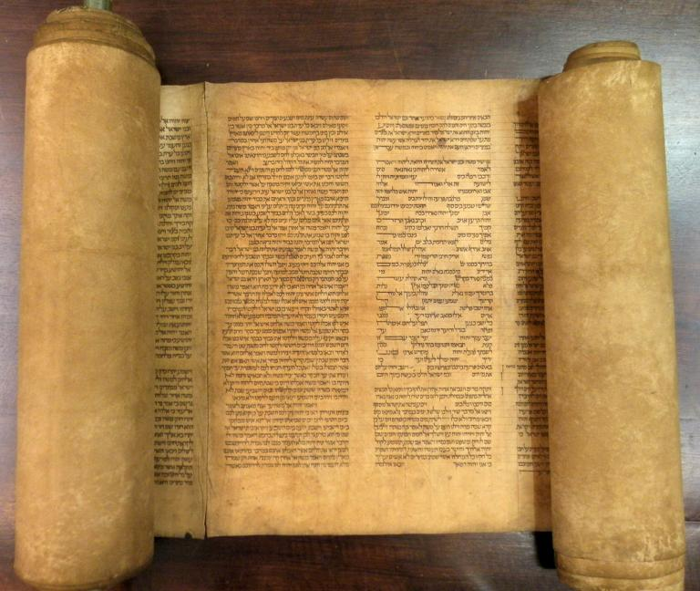
In 1948, the nation/country of Israel was created for the Jews by the United Nations.
What is the sacred text of Judaism?
The sacred book of the Jews is the Torah. The Torah is a collection of Jewish laws, customs, and beliefs and includes the first five books of the Old Testament (Genesis, Exodus, Leviticus, Numbers, Deuteronomy). The Ten Commandments form the basis of the Torah.

What are some of the holidays and festivals that the Jewish celebrate?
- Rosh Hashanah is the Jewish New Year festival which usually takes place in September or October.
- Hanukkah is the festival of lights. It is held in late November or December.
- Passover or Pesach is in the spring and marks the liberation of the Jews from slavery in Egypt, the giving of the Ten Commandments and the journey to Israel.

Where do Jewish people worship and what are their leaders called?
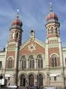
Jews worship in synagogues and their worship leaders are called rabbis.

Readings adapted from Our World Today, 2003

