Religion in the Middle East Graphic Organizer
 | Christianity | Islam  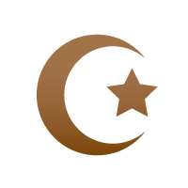 | Judaism  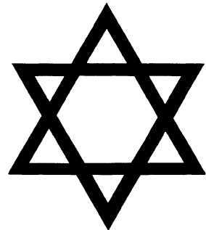
Followers Worldwide  (Based on 2012 estimates) | 2.2 Billion | 1.6 billion | 14 million
Name of Deity/Creator | God | God “Allah” | God “Yahweh"
Founder | Jesus | Mohammed | Abraham
Holy Book | Holy Bible | Qur’an | Torah
Worship  Leaders | Priests, ministers, pastors, chaplains, reverends | Imams | Rabbis
Place of Worship | Church / cathedral | Mosque | Synagogues
Basic Beliefs/  Guidelines/  Rituals/  Celebrations | Christmas – birth of Jesus  Lent – 40 days of fasting and praying in the desert before death  Easter – resurrection of Jesus | Five Pillars of Faith  - declare faith  - pray 5 times a day facing Mecca  - give to charity  - fasting during Ramadan  - pilgrimage to Mecca during lifetime | Rosh Hashanah - Jewish New Year  Hanukkah – Festival of Lights  Passover – celebrate freedom from Egypt and delivery of 10 commandments by Moses

