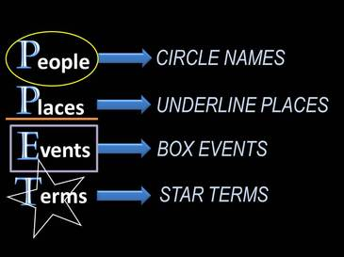
Summary—Write the main idea of the text

