The Political World Three Column Notes
Big Question: How does each political system function (work) differently in relationship to the concept (idea) of power?
Section Titles | Visual | Answers
Rule by one
1.

Rule by a few
2.

Rule by many
3.

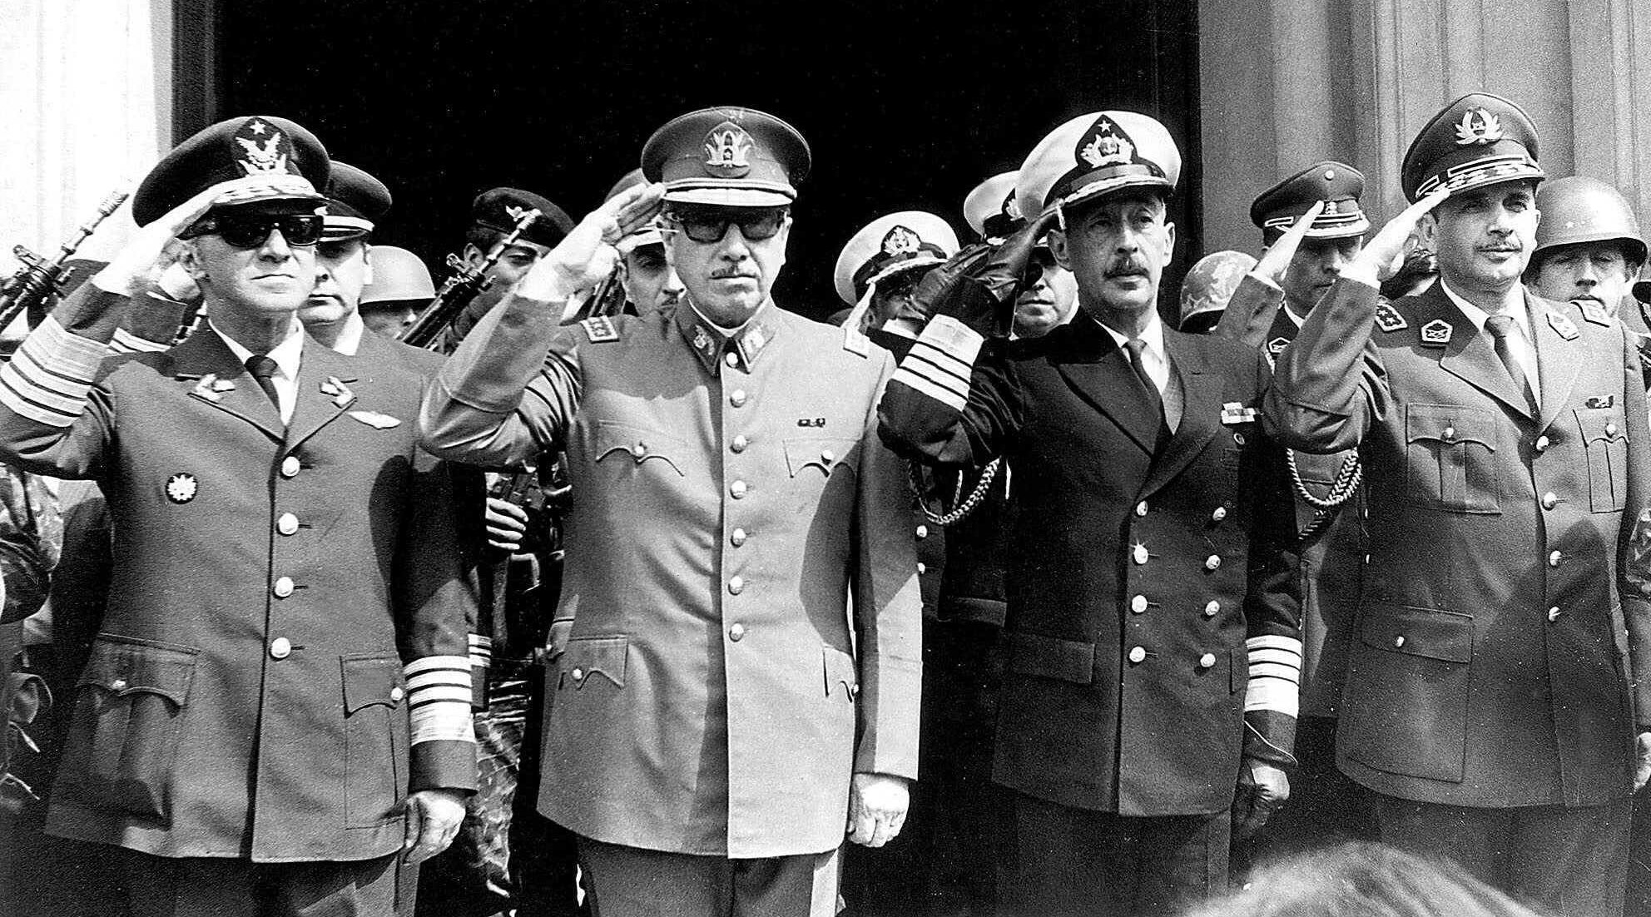
Source: latimesblogs.latimes.com

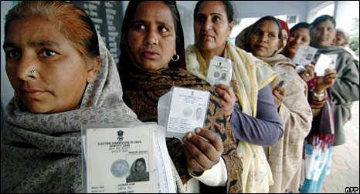
Source: news.bbc.co.uk

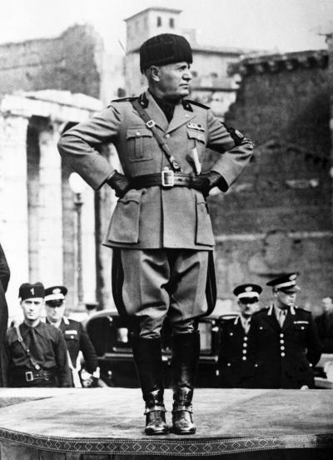
Source: nydailynews.com

