STATION 1
OPEC
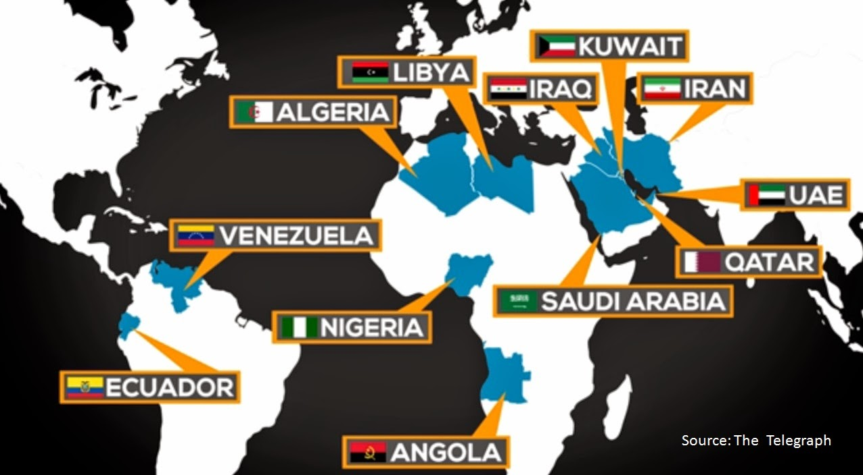
The Organization of Petroleum Exporting Countries, or OPEC, is an organization created to coordinate the petroleum (crude oil) policies (guidelines) of leading oil-exporting nations. It was founded on the idea that every nation/country has a right to develop its own natural resources. Today, 12 nations are members of OPEC. In order of production (oil barrels per day), they are: Saudi Arabia, Iran, Iraq, United Arab Emirates, Kuwait, Venezuela, Nigeria, Libya, Algeria, Angola, Qatar, and Ecuador.
OPEC was formed in Baghdad, Iraq on September 14, 1960. Today, OPEC headquarters are in Vienna, Austria.
STATION 2
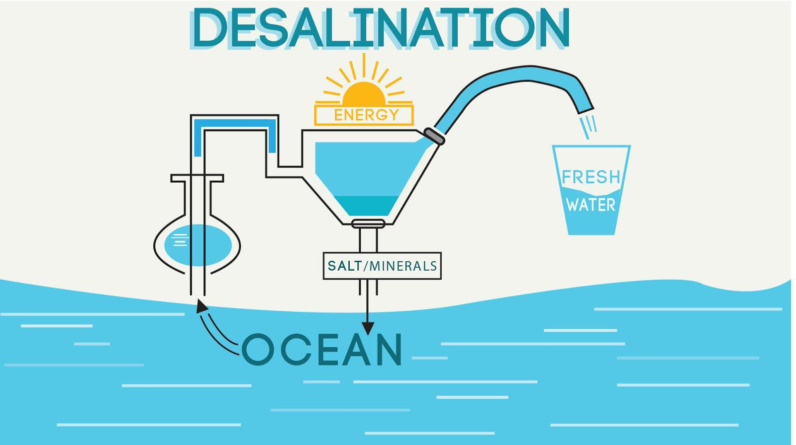
Source: wisemoneyisreal.com

Oil is essential for economies in the Middle East, and water is essential for its people. In northeastern Iraq and the mountains of Yemen, rainfall supports agriculture. The rest of the region, however, is very dry. Desalination plants are built in some Middle Eastern countries to remove salt from seawater in order to have enough water to meet their needs. While the plants produce water needed for the arid (dry) region, they can create problems for health and the environment. The seawater used most in desalination plants has high amounts of boron and bromide, and the process can also remove essential minerals like calcium. Also, the concentrated salt is often dumped back into oceans where the increased salinity (salt levels) affects the ocean's environment.
Source: thewaterproject.org
STATION 3
Desertification
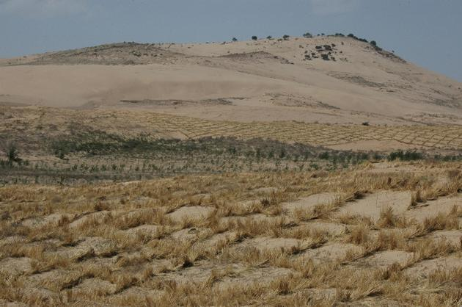
Source: ecomena.org

The Middle East has some of the largest oil reserves in the world, which produces most of the area's wealth. Even so, the region's climate and environment make living harsh. The Middle East requires water resources and suitable land for agriculture. Much of the land that is available for producing food is destroyed by increasing desertification and much of the water surrounding the region is not available for human consumption.
Desertification is a sweeping environmental problem, with vast effects in countries such as Syria, Jordan, Iraq, and Iran. Universal causes for a spread of arid (dry) environment are unsustainable (unmanageable) agriculture (farming) practices and overgrazing. Agriculture uses 85% of water in this region. It is common to misuse land by heavy irrigation in the Middle East. In the area droughts are more frequent, and contribute to the changing landscape. The overuse of water in agriculture is affecting the countries' already undersized water resources.
STATION 4
Global/Economic Interdependence
Global/Economic interdependence (definition)—One country depends on another country for something and that country may depend on another country, which eventually creates global interdependence. Importing and exporting of goods and services highly contributes to global interdependence.

The countries that are located on the Arabian Peninsula include Jordan, Iraq, Kuwait, Bahrain, Qatar, The United Arab Emirates, Oman, Yemen and Saudi Arabia, which are all located in Southwest Asia (or the Middle East). The Arabian Peninsula is surrounded by water on three sides, and the country of Iraq lies to the north of this peninsula. The Tigris and Euphrates rivers run through Iraq and provide fresh water to nation, but elsewhere the region is mostly desert.
The nations of this region have some of the world’s largest oil reserves. Petroleum/oil and natural gas are known as fossil fuels, because they are formed over millions of years from the remains of living things. They are nonrenewable resources.
Oil has made many nations on the Arabian Peninsula very wealthy, and much of the world (including the United States) depends on oil from this region. Countries in this region must use profits from selling oil to import food and other resources from other regions. When conflicts arise within these countries, they can affect the world’s supply of oil. Specifically, oil prices may rise during such conflicts, and the increase in cost affects people around the world. The region’s oil reserves will not last forever, however, so its economic future is uncertain.

STATION 5
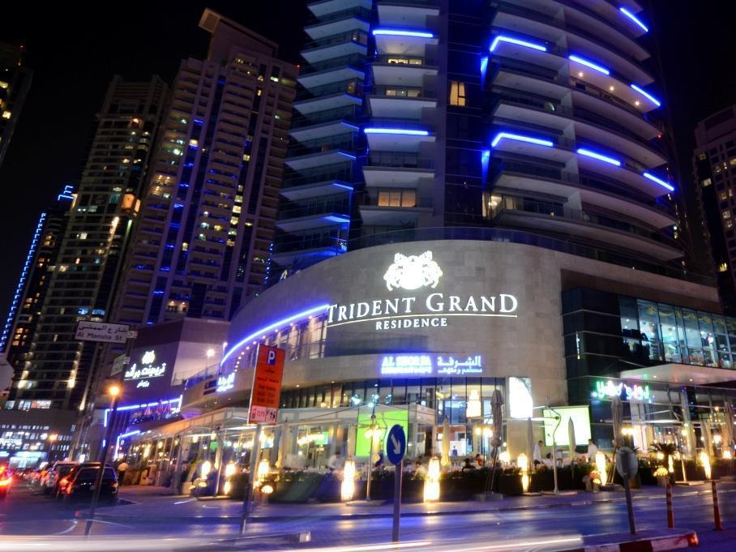
Source: Trident Grand Residence, Dubai, United Arab Emirates; chiangdoa.com
The United Arab Emirates (UAE), located on the Arabian Peninsula, is famous for its luxurious cities filled with lavish resorts, shopping, and attractions. The livelihoods of these extravagant emirates (states) might create the assumption that water scarcity is not a problem for these rich states. In reality, however, the UAE is confronted with a serious depletion of their available water resources.
Source: thewaterproject.org
STATION 6
SAUDI ARABIA’S TOP 10 IMPORTS

The following product groups represent the highest dollar value in Saudi Arabia’s import purchases during 2015. Also shown is the percentage share each product category represents in terms of overall imports into Saudi Arabia.

- Machines, engines, pumps: US$26.8 billion (15.8% of total Saudi imports)
- Vehicles: $25 billion (14.7%)
- Electronic equipment: $19.5 billion (11.5%)
- Iron or steel products: $5.8 billion (3.4%)
- Gems, precious metals: $5.8 billion (3.4%)
- Pharmaceuticals/Medicines: $5.6 billion (3.3%)
- Iron and steel: $4.7 billion (2.8%)
- Cereals: $3.9 billion (2.3%)
- Medical, technical equipment: $3.7 billion (2.2%)
- Plastics: $3.6 billion (2.1%)

Source: worldstopexports.com

