PLACARD 1
OPEC
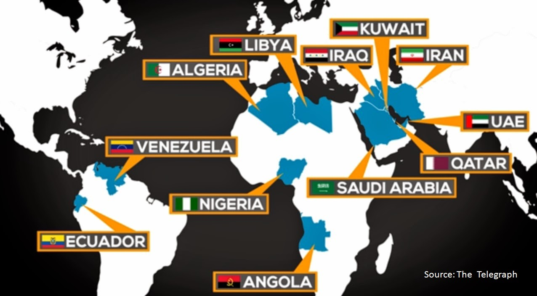
The Organization of Petroleum Exporting Countries, or OPEC, is an organization created to manage the petroleum policies of leading oil-exporting countries. OPEC countries in North Africa and Southwest Asia include: Libya, Algeria, Saudi Arabia, Iran, Iraq, United Arab Emirates, and Kuwait.

Excerpt adapted from OPEC Secretariat. I Need to Know: An Introduction to the Oil Industry and OPEC. Korneuburg, Austria: Ueberreuter Print GmbH, 2013. Print.
PLACARD 2
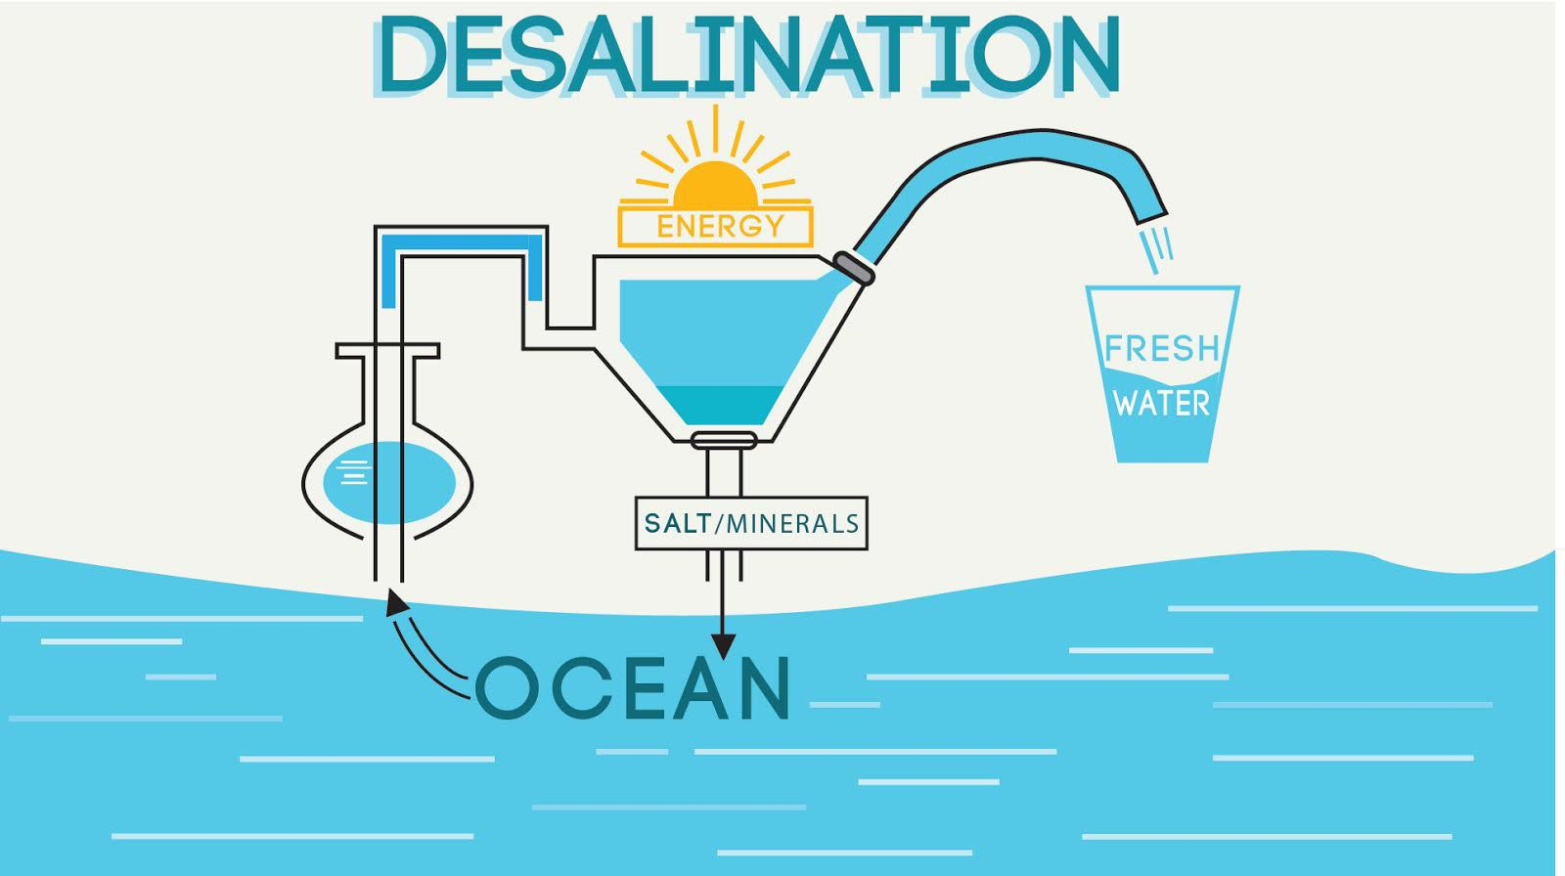
Source: wisemoneyisreal.com

Desalination plants are built in some Middle Eastern countries to remove salt from seawater in order to have enough water to meet their needs. While desalination produces water that is needed in the dry region, the expensive process can create problems for the environment. For example, the salt removed from seawater is often dumped back into oceans where the increased salt levels affects the ocean's environment.
Excerpt adapted from thewaterproject.org

PLACARD 3
Desertification
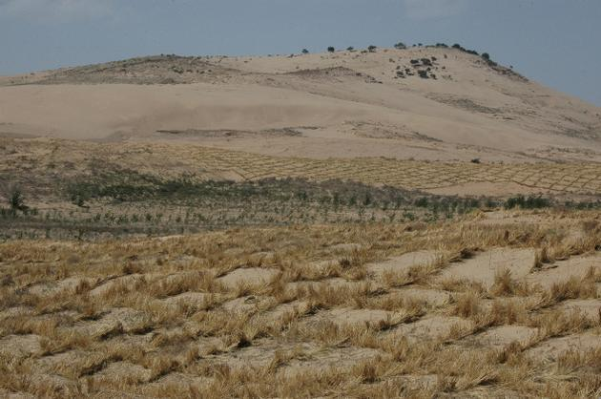
Source: ecomena.org

Desertification happens when fertile land becomes very dry and less productive land. In the Middle East, a great amount of land that is available for growing food is destroyed by desertification and much of the water surrounding the region is cannot be consumed. As a result, most people in the region never have enough water to meet their needs.
Poor agricultural, or farming, practices is one cause of desertification. For example, agriculture uses 85% of the freshwater that is available in this region.
PLACARD 4
Global/Economic Interdependence
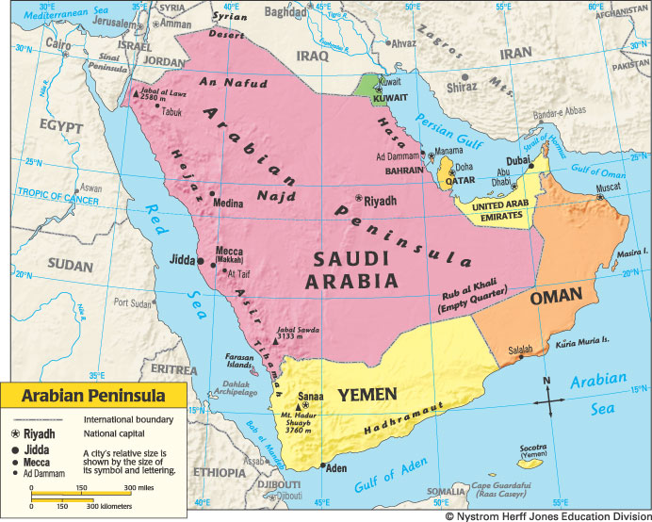
The countries that are located on the Arabian Peninsula have some of the world’s largest oil, or petroleum, reserves. Oil is known as a fossil fuel, because the substance formed over millions of years from the remains of living things. They are nonrenewable resources. Saudi Arabia is the top oil producing country on the Arabian Peninsula and in the world.

Oil has made many nations on the Arabian Peninsula very wealthy, and much of the world (including the United States) depends on oil from this region. Countries in this region must use profits from selling oil to import food and other scarce resources from other regions. When conflicts arise within these countries, they can affect the world’s supply of oil. Specifically, oil prices may rise during such conflicts, and the increase in cost affects people around the world.

