Types of Maps

In geography, maps are one of the most important tools researchers, cartographers, students and others can use to examine the entire Earth or a specific part of it.

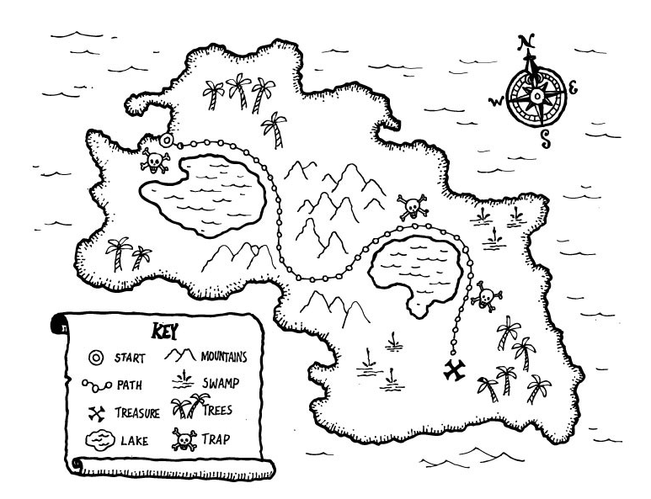
What Is a Map?
Maps are pictures of the Earth's surface. They can show landforms, political boundaries, water, the locations of cities, or in the case of thematic maps, show different but very specific topics such as the average rainfall distribution for an area or the distribution of a certain disease throughout a county.

The Different Types of Maps
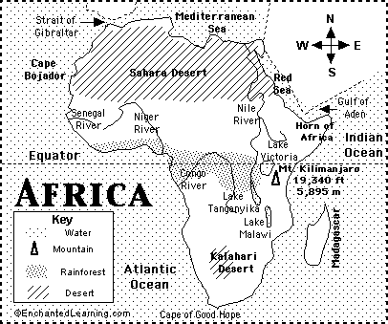
Physical Map: A physical map is one that shows the physical features of a place. They generally show things like mountains, rivers and lakes and water is always shown with blue. Mountains and elevation (height) changes are usually shown with different colors and shades to show relief. Normally on physical maps green shows lower elevations while browns show high elevations. An example of a physical map is one showing the state of Hawaii. Low elevation coastal regions are shown in dark green, while the higher elevations transition from orange to dark brown. Rivers are shown in blue.

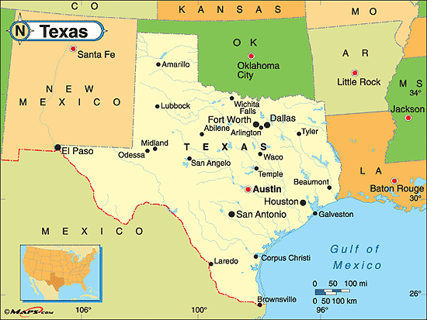
Political Map: A political map focuses on the state and national borders, of a place. They also include the locations of cities - both large and small, depending on the detail of the map. A common type of political map would be one showing the 50 U.S. states and their borders along with the United States' north and south international borders.

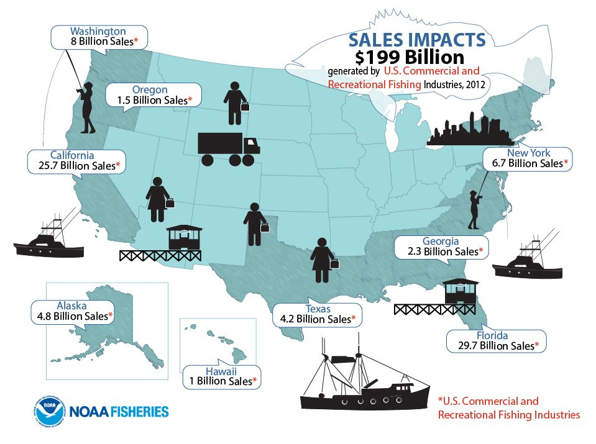
Thematic Map (Special Purpose): A thematic map is a map that focuses on a theme or special topic and are different from the other types of maps because they do not just show natural features like rivers, cities, political subdivisions, elevation and highways. If these items are on a thematic map, they are background information and are used as reference points to enhance the map's theme. Examples of thematic maps include maps showing population change, land use, land acquisitions, the type of economic activity or natural resources present in an area, and information about the climate of an area.
Reading adapted from “Types of Maps,” abouteducation.com
Images:
https://www.st.nmfs.noaa.gov/st5/publication/
http://enchantedlearning.com
http://onetouchweather.com/Texas.htm

PHYSICAL MAP | POLITICAL MAP | THEMATIC  (SPECIAL PURPOSE MAP)
Purpose | Purpose | Purpose
Characteristics | Characteristics | Characteristics

