The 4 C’s—Conflict in Syria
What began as a peaceful uprising or fight against Syria's President Bashar al-Assad in 2011 became a full-scale civil war that has left more than 250,000 people dead, devastated the country and caused global powers to get involved.

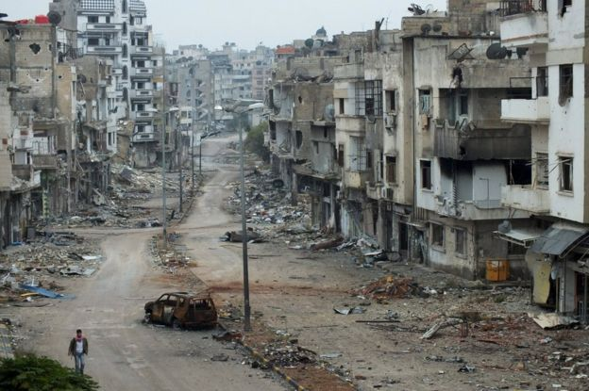
Why is there a war in Syria?
Long before the conflict began, many Syrians complained about high unemployment, widespread corruption, a lack of political freedom, and state control under President Bashar al-Assad, who succeeded his father, Hafez, in 2000.

In March 2011, protests for democracy began in the southern city of Deraa. The government's use of deadly force to crush the rebellion soon resulted in nationwide protests demanding the president step down from his position.

As the unrest spread, the enforcement intensified. Opposition (those who didn’t like the government) supporters began to take up arms (weapons), first to defend themselves and later to force government security forces from their areas.
The violence rapidly increased and the country started a civil war (a war between opposing groups of citizens of the same country) as hundreds of rebels (those against the government) formed to battle government forces for control of the country.

Basically, it has become more than just a battle between those for or against President Assad.

A key factor has been the involvement of other countries, including Iran, Russia, Saudi Arabia and the United States. Their military, financial and political support for the government and opposition has contributed directly to the fighting in Syria becoming stronger and lasting longer.

The US, for example, which says President Assad is responsible for widespread violence and must step down, has provided only limited military assistance to those fighting against the government, fearful that advanced weapons might end up in the hands of those who would cause further conflict and destruction. Since September 2014, the US has conducted military air strikes on the Islamic State (IS)—a terrorist group—in Syria, but it has avoided attacking the Syrian government.

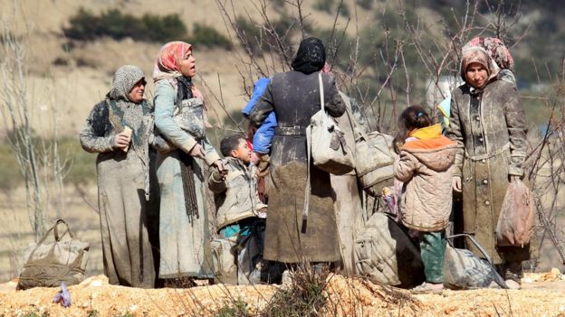
What impact has the war had?
More than 4.8 million people have left Syria, most of them women and children. Neighboring Lebanon, Jordan and Turkey have struggled to cope with one of the largest refugee (person who runs away from their country because of bad events) migrations in recent history.

About 10% of Syrian refugees have searched for safety in Europe, creating political divisions as countries argue over sharing the responsibility. A further 6.5 million people are internally displaced inside Syria.Reading adapted from Syria War: Why is there fighting in Syria?; bbc.com

The 4 C’s—Conflict in Syria
Context – What was the context (background) of the times, the situation, or the event?

Choices – What choices did the participants (such as the Syrian government and rebels) have at that time?

Course – What decision(s) did the participants (such as the Syrian government and rebels) make? What course did they take?

Consequences – What were the consequences or impact of the decision(s)? Did others get involved?
