eNvironmental OPTICS 1
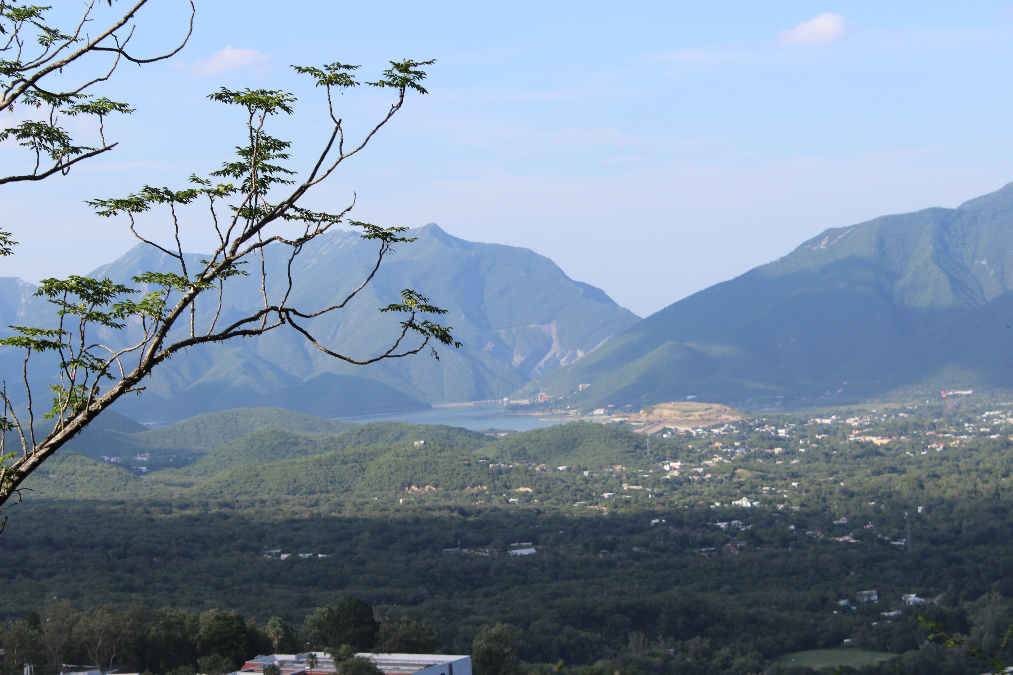
Photo Credit: Adriana Bermejo; Monterrey, Nuevo Leon, Mexico, Presa la Boca; 2013

Objects in the photo? ________________________________________________________________________________

People/Participants in the photo?_______________________________________________________________________

Title/Time Period? ___________________________________________________________________________________

Inferences you can draw? _____________________________________________________________________________

Conclusions? _______________________________________________________________________________________

Summary/So What?
__________________________________________________________________________________________________

__________________________________________________________________________________________________

ANSWER ON YOUR OWN…
Do you think many people live in this area? What do you think are possible benefits and/or drawbacks of living in an area like this?
__________________________________________________________________________________________________

__________________________________________________________________________________________________

