The Three Major Economic Systems
The survival of any society depends on its ability to provide food, clothing, and shelter for its people. All societies have something else in common. They have an economy, or economic system – an organized way of providing for the wants and needs of their people. They also decide WHAT, HOW, AND FOR WHOM goods and services will be produced. There are three major types of economic systems – traditional, command, and market. Most countries in the world can be identified with one of these systems.
Traditional Economies
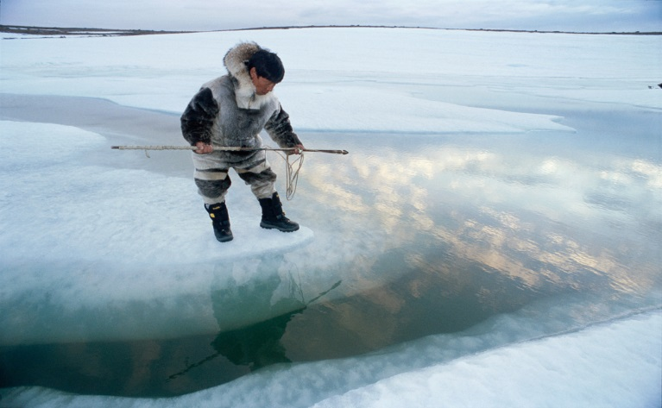
Why do so many Americans eat turkey on Thanksgiving? Why do most people shake hands when they meet, or leave tips in restaurants? These practices have generally been handed down from one generation to the next and have become tradition. In a traditional economy, individuals are not free to make decisions based on what they want or would like to have. Instead, their roles or jobs are based on what their elders and ancestors did in the past.
1 Inuit hunter hunting for seals
In a traditional economy, everyone knows their role or job, whether it's as a farmer, hunter or weaver. Individuals also understand what goods they are likely to receive and do not rebel, even if they are not satisfied. Traditional economies are helpless to changes in nature, especially the weather. For this reason, traditional economies limit population growth.
Examples. Many societies – such as the Inuits of Northern Canada – are examples of traditional economies. For generations, Inuit parents taught their children how to survive in a harsh climate, make tools, fish, and hunt. Their children, in turn, taught these skills to the next generation.

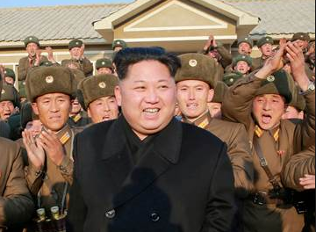
Command Economies
Other societies have a command economy, one in which a central authority makes most of the WHAT, HOW, and FOR WHOM decisions. Government has complete control over the economy and natural resources, and the people have little, if any, power over how the basic economic questions are answered.
2 North Korean leader Kim Jong Un
In a country with a command economy, basic education, health care, and other public services are available at little to no cost, and there are low levels of inequality and unemployment. Moreover, workers with different skills and responsibilities receive similar pay.
Examples. There are few command economies in the world today, but they still can be found in North Korea and Cuba. In North Korea, for example, the government led by dictator Kim Jung Un makes the major economic decisions. It determines the needs, goals, and economic activities for the entire country.

Market Economy
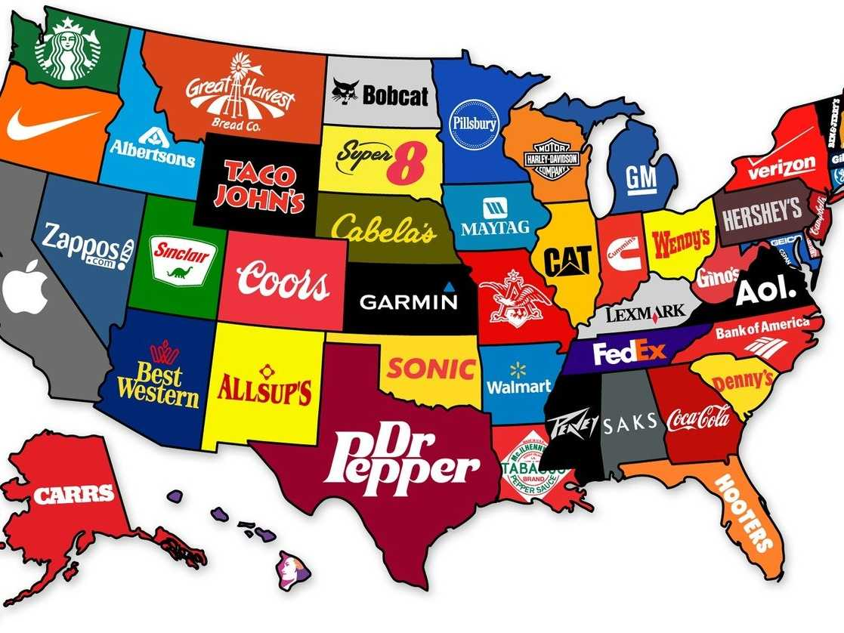
In a market economy, people and businesses answer the WHAT, HOW, and FOR WHOM questions. A market is an arrangement that allows buyers and sellers to come together in order to exchange a variety of goods and services. In a market economy, entrepreneurship is highly encouraged, the government has minimal involvement, and companies sell what the people want.
3 Popular brands in each US state
When a market economy is doing well, there is lots of buying and selling. During a “bad economy,” buying and selling slows down. One result of this phenomenon is a decrease in company profits and jobs due to low demand for products. Another result is an unequal distribution of income and large gap between rich and poor.
Examples
Many of the largest and most wealthy economies in the world, such as Canada and Japan, are based on the concept of a market economy. While there are also many differences among these countries, the common thread of the market connects them.

Reading adapted from “Economic Systems.” http://lisamodrow.weebly.com/uploads/2/7/3/5/27358777/economic_systems.pdf.
Images:
http://news.nationalgeographic.com/news/2012/04/120405-climate-change-waterborne-diseases-inuit/
http://www.nbcnews.com/news/north-korea/north-korea-s-hostage-diplomacy-kim-uses-detained-americans-leverage-n754841
http://www.businessinsider.com/the-most-famous-brand-in-every-state-2015-6

