Defining Regions

What are Regions?

Regions are areas or divisions that have definable characteristics. Regions are social constructs—meaning, they are perceived by people but do not exist in reality. People think of places as regions, because it is easier to make sense of the world by grouping areas that are similar to one another into larger categories. One thing that cannot be overlooked when talking about regions, however, is that their boundaries, or borders, are not always clear. A region comes to an end when many of the characteristics that have historically defined it no longer exist. The types of characteristics that help us identify regions include things such as economic system, political values, social norms, landscape, climate, ancestry, place in history, building styles, vegetation, wildlife, and on and on.

Types of Regions
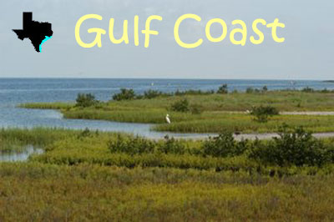
Regions can be defined in several different ways. Physical regions are areas that are based on location of landforms, climate, vegetation, and/or animal life. Some examples of physical regions in the Lone Star State (Texas) are:
- Geographic regions—Texas’s Gulf Coastal Plains extend from the Atlantic Ocean to beyond the Rio Grande River. Cities such as Corpus Christi, Galveston, and Houston lie within this region of the United States.
- Climate regions—the Atlantic Region of Canada has a fairly humid (moist) continental climate. A continental climate is a relatively dry climate with very hot summers and very cold winters.
- Vegetation regions - Evergreen forests have trees with leaves that stay green all year long. One of the places evergreen forests can be found is on the opposite side of the North American continent—in the Pacific Northwest, which includes the U.S. states of Washington and Oregon.
Human (cultural) regions are based on the activities of the people and can be defined in a variety of changing ways such as:
- Religious regions—As of 2015, over 1.7 billion or about 23.4% of the world population are Muslims, or follow in the Islamic faith. By the percentage of the total population in a region, 91.2% of people living in the Middle East and North Africa consider themselves Muslim.
- Economic regions – The term economic refers to the production, distribution, and use of income/money, wealth, and commodities. The Organization of the Petroleum Exporting Countries, or OPEC, is an organization of 13 countries that control 40 percent of oil production around the world and 73 percent of the world’s “proven” oil reserves. Since its creation in 1960, OPEC has been a major influence on global oil prices. The majority of the countries are located between Africa and the Middle East.
- Political regions – Political regions are areas that tend to be based on political/governmental divisions such as states; subnational units such as provinces, counties, townships, territories, etc. Political regions can be separated into voting locations – usually by county on a state level. Harris County, for example, is located in Texas. If you live in Harris County, your parents vote for Harris County representatives and vote on issues affecting the region. As residents of Harris County, they also vote on issues affecting the state of Texas.
- Metropolitan regions—Houston is a densely populated urban area with less-populated surrounding territories, sharing industry, infrastructure, and housing.

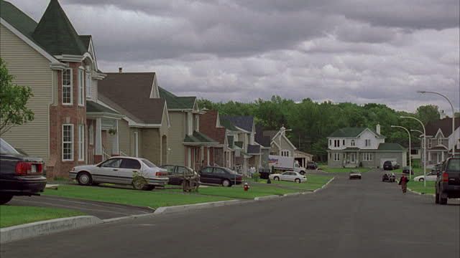
Change over Time
All regions change over time. People move, relationships shift, and regional characteristics shift, disappear, or transform. Borders change very often; cities annex, or extend into, nearby townships, counties split into new counties, and new countries come into existence as others disappear entirely. Changes in the environment frequently cause regional changes both in economics and population. Climate change is pushing deserts into former agricultural or farming regions and moving the types of trees that can grow in others. New highways, railways, and travel networks are created over time, bringing new areas into regions and often leading to suburban sprawl. (Suburban sprawl is the spreading of developments such as housing developments and shopping centers into suburban/residential or rural/country areas.)
Finally, and most importantly, people's views of regions change. Fifty years ago the Rust Belt (roughly northern Indiana, Ohio, Michigan, and western Pennsylvania) had what was considered as a strong economy. Today it is known for severe underemployment, loss of manufacturing, and serious economic problems. Who knows, though—given forthcoming environmental changes, it may wind up being known as a migration destination due to all of its water resources.
Reading adapted from Muehlenhaus, Ian. "Regional Geography: Types of Regions." World Geography: Understanding a Changing World. ABC-CLIO.

