My Home 1
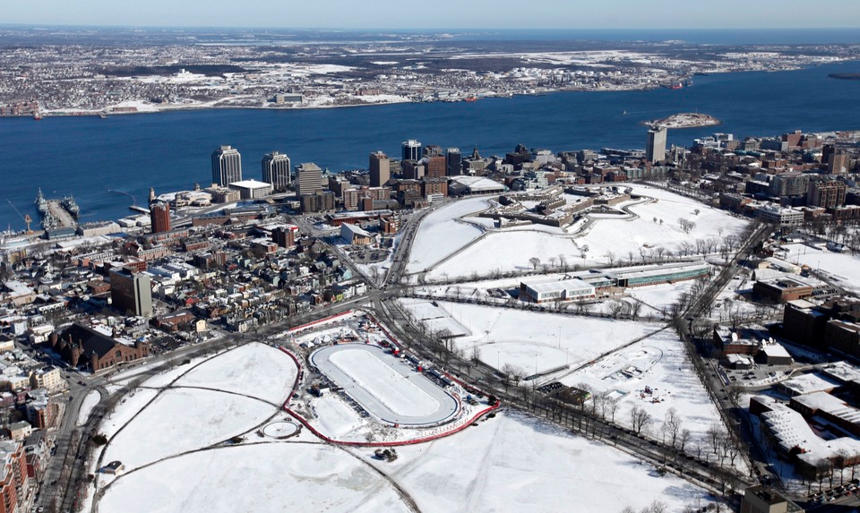
Pictured: Halifax, Nova Scotia, Canada, North America

Questions about you:
Where are you from? ________________________________________________________________________
What do you do for a living? __________________________________________________________________
Do many people live in your area? Why or why not? __________________________________________________________________________________________
__________________________________________________________________________________________
Journal Entry Questions:
What season is it? ___________________________________________________________________________
What do you see around you? _________________________________________________________________
__________________________________________________________________________________________
What is happening in this place? _______________________________________________________________
__________________________________________________________________________________________
Journal Entry (Use your responses above to create a journal entry)
__________________________________________________________________________________________
__________________________________________________________________________________________
__________________________________________________________________________________________
__________________________________________________________________________________________
__________________________________________________________________________________________
My Home 2
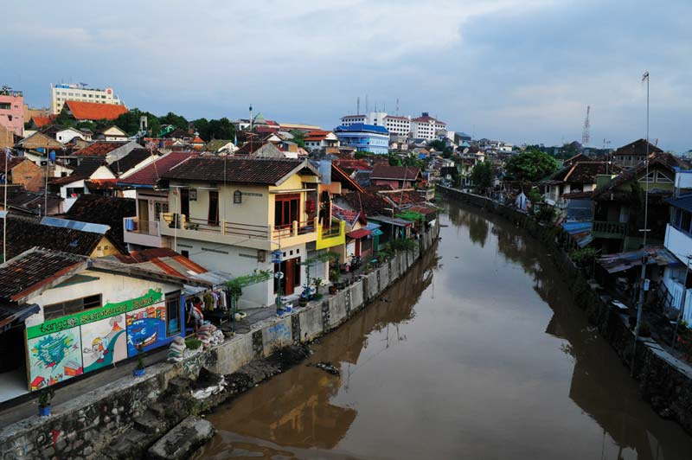
Pictured: Jakarta, Indonesia, Southeast Asia

Questions about you:
Where are you from? ________________________________________________________________________
What do you do for a living? __________________________________________________________________
Do many people live in your area? Why or why not? __________________________________________________________________________________________
__________________________________________________________________________________________
Journal Entry Questions:
What season is it? ___________________________________________________________________________
What do you see around you? _________________________________________________________________
__________________________________________________________________________________________
What is happening in this place? _______________________________________________________________
__________________________________________________________________________________________
Journal Entry (Use your responses above to create a journal entry)
__________________________________________________________________________________________
__________________________________________________________________________________________
__________________________________________________________________________________________
__________________________________________________________________________________________
__________________________________________________________________________________________

