Picture | Location  &  Description | Human/Cultural  Or  Physical
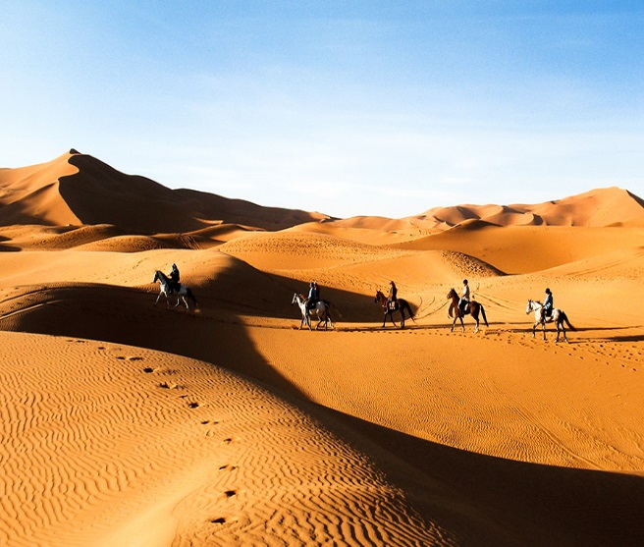 | - The Sahara Desert is located in North Africa and is the third largest desert in the world. It is very hot and temperatures can reach 136 Fahrenheit. It rarely rains in the Sahara. Total rainfall is less than three inches per year. | Physical
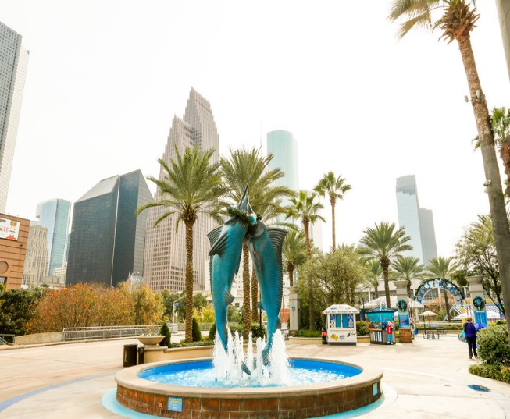 | Houston is the fourth most populous city in the nation and is the largest in the southern U.S. and Texas. It is considered by many as the Energy Capital of the world because of the amount of energy-based companies that call the city home. Houston is also home to the Texas Medical Center, the largest medical center in the world. There are many housing opportunities available in the city. | Human
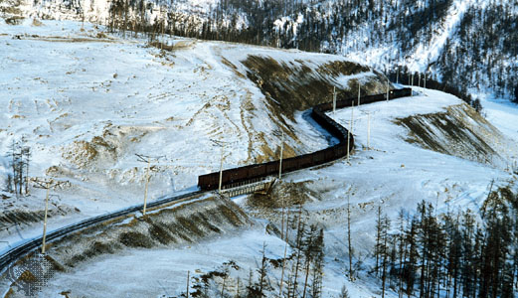 | Siberia covers 57% of Russia. Much of Siberia is covered in permafrost. Permafrost means that the land is always frozen. Siberia has very cold temperatures, with low winter temperatures reaching -20°C (-4°F). | Physical
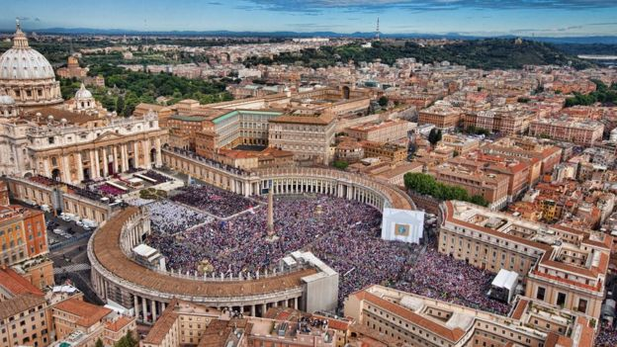 | The Vatican is the smallest independent state in the world and residence of the spiritual leadership of the Roman Catholic Church.  Its territory is surrounded by the Italian capital city Rome, and priests and nuns from many different countries make up almost all of the population. The Pope also lives there. | Human

Sources: https://kidskonnect.com/geography/sahara-desert/; https://www.equus-journeys.com/id/60020/horseback-trail-riding-morocco-atlas-horses-dunes-and-nomads-ficheproduit-47635.html/ch/voyage/47635?currency=EUR; https://www.apartments.com/downtown-houston-houston-tx/; http://www.houstontx.gov/abouthouston/houstonfacts.html; https://www.britannica.com/place/Siberia; http://todiscoverrussia.com/top-11-amazing-facts-about-siberia/; http://www.bbc.com/news/world-europe-17994868

