Document A

Use the photo to respond to the statements below.
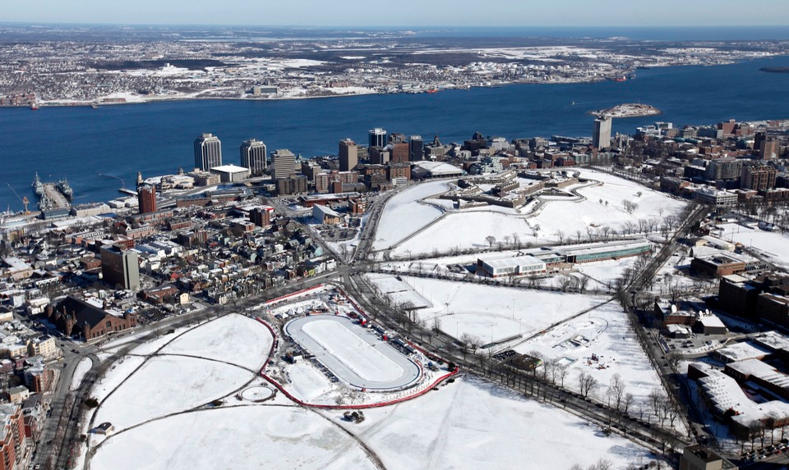
Pictured: Halifax, Nova Scotia, Canada; natureridgehomes.com

List 3 interesting things you notice in the photo:

Describe 2 ways the environment or situation would affect people living in the region shown:

List 1 way that you would classify or describe the region and why:

Document B

Use the map to respond to the statements below.
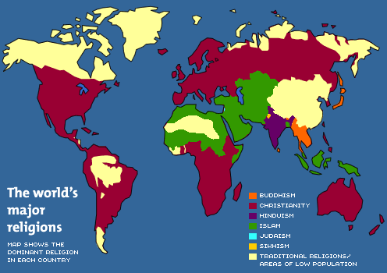

List 3 interesting things you notice on the map:

Describe 2 ways the environment or situation would affect people living in the region(s) shown:

List 1 way that you would classify or describe the region(s) and why:

Document C

Use the photo to respond to the statements below.
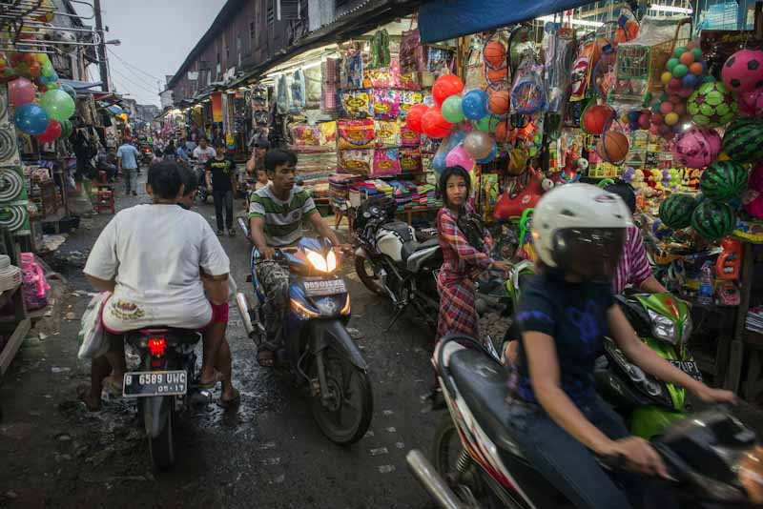
Pictured: Jakarta, Indonesia Pancogn Market; seattleglobalist.com

List 3 interesting things you notice in the photo:

Describe 2 ways the environment or situation would affect people living in the region shown:

List 1 way that you would classify or describe the region and why:

Document D

Use the map to respond to the statements below.
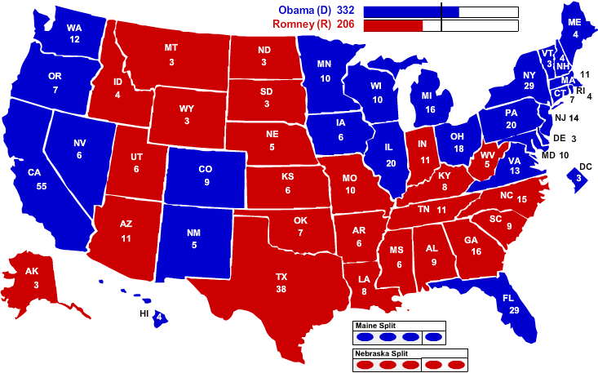
Source: 2012 Electoral Map: Barack Obama Wins; politicalmaps.org

List 3 interesting things you notice on the map:

Describe 2 ways the environment or situation would affect people living in the region(s) shown:

List 1 way that you would classify or describe the region(s) and why:

