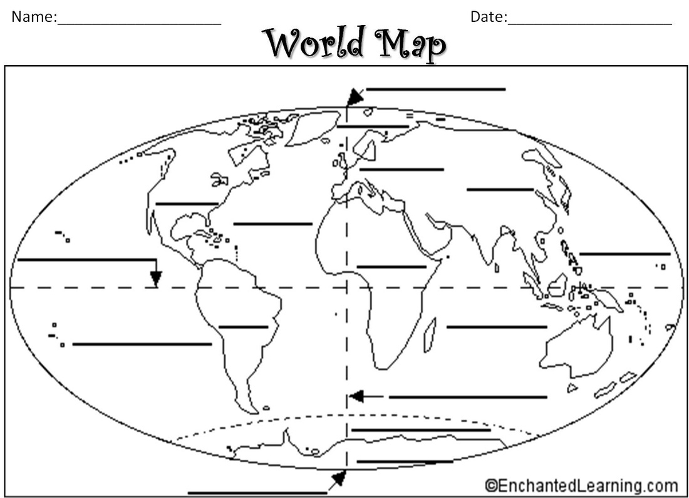
Continents—any of the world's main continuous expanses of land 5 Oceans (very large stretches of sea) of the World
Africa Pacific Ocean
Antarctica Atlantic Ocean
Asia Southern (Antarctic) Ocean
Australia Indian Ocean
Europe Arctic Ocean
North America
South America

