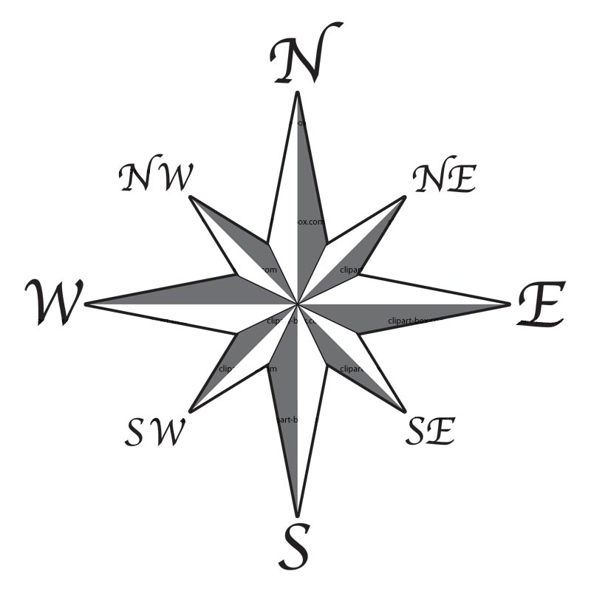
WORLD MAP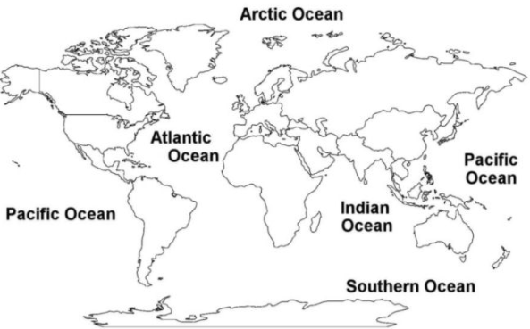
___________________
______________________
___________________________
_________________
_____________
___________________
___________________________
7 Continents Word Bank

Africa Antarctica Asia

Australia Europe North America

South America

