Category | 4 | 3 | 2 | 1
Basic elements (title, author, six completed panels) | Comic strip contains all elements in a creative, organized form. | Comic strip contains all elements. | Comic strip is missing one basic element. | Comic strip is missing two or more basic elements.
Panels/layout | All six panels are complete in a creative, organized format. | All six panels are complete with an appropriate cause-and-effect relationship. | Five panels are complete with an appropriate cause- and-effect relationship. | Four or fewer panels are complete with an appropriate cause-and-effect relationship.
Illustration | Strip contains six completed (colored), historically-based drawings in a creative, organized format. | Strip contains six completed (colored), historically-based drawings. | Strip contains five or fewer completed (colored), historically-based drawings. | Strip contains four or fewer completed (colored), historically-based drawings.
Grammar/ mechanics | There are no more than two errors. | There are no more than three errors. | There are no more than four errors. | There are five or more errors.

Comic Strip Rubric

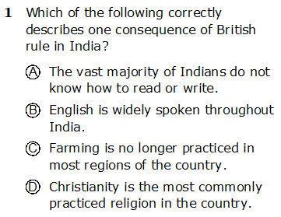
Exit Ticket

