Ancient Kingdoms of West Africa (pg. 40)
People – circle names
Places – underline places
Events – box events
Time/Terms – star dates and key words
Summary – summarize main points
Directions: Carefully analyze each document and respond to the question that follows.

Document 1: Ancient Ghana and the Gold-Salt Trade
Trade has played an important role in the economy of West Africa since very early times. As early as 300 CE, camel caravans carried salt from mines in the Sahara Desert to trading centers along the Niger River in present-day Mali. Their mission was to exchange the salt for the gold that was mined in forests near the headwaters of the Niger. West Africa's first kingdom, Ghana, became wealthy and powerful because it controlled the trade routes and commercial activities in its region.

Source: neh.gov
- Briefly explain the Ancient Kingdom of Ghana’s role in the gold-salt trade? How did this increase the kingdom’s power?

Document 2: Timbuktu (Mali)
Circle and label the parts of the map (TODALSIG)
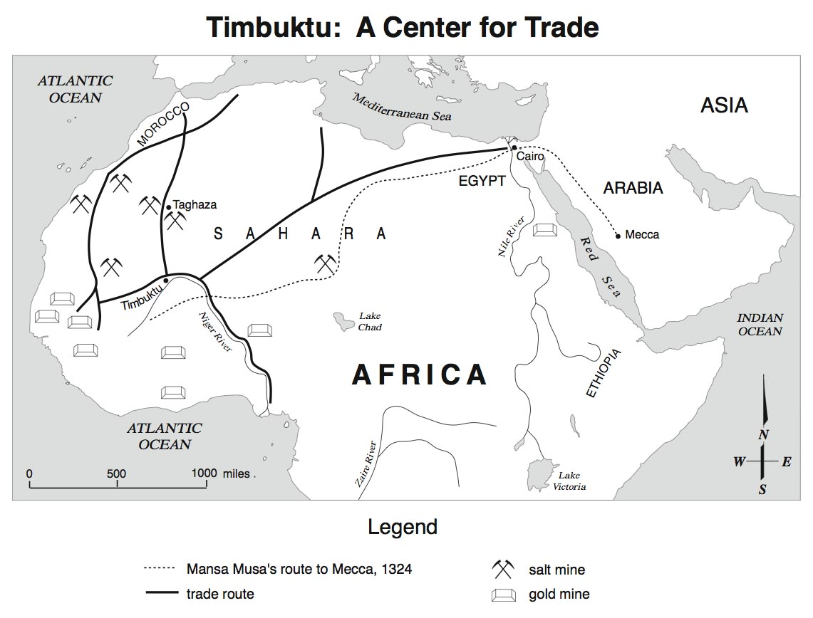
- According to the map, what products were traded on the trade routes?

- What other regions of the world benefitted from these trade routes? How did this promote cultural diffusion?

