Ancient Egypt and Mesopotamia Three Column Notes
Big Question: How did fertile river valleys contribute to the establishment of early urbanized societies in Ancient Egypt and Mesopotamia?
Section Titles | Visual | Answers
The Fertile Crescent  Farming and Trade in Ancient Egypt  Mesopotamia—The Land Between Rivers  Success on the Water  The Downfall of Ancient Egypt and Mesopotamia | What do you see?  List three things you see in the images. Try to find one you think others won’t find.

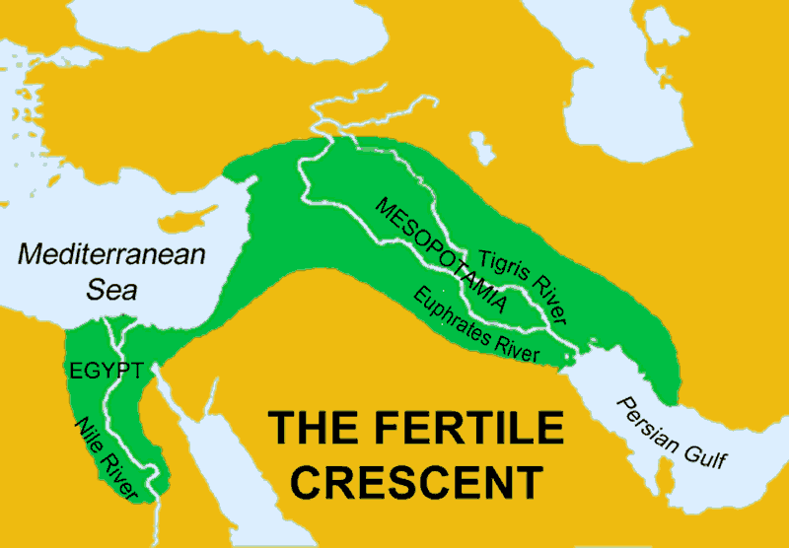
Source: mrdowling.com

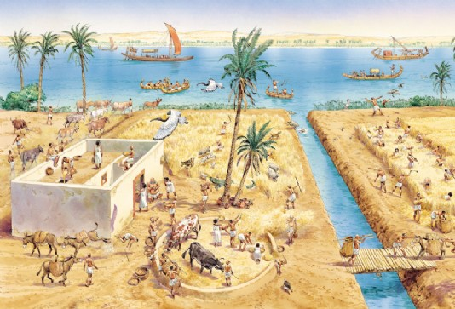
Source: q-files.com

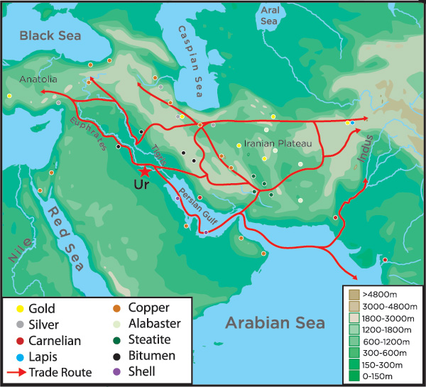
Source: www.penn.museum

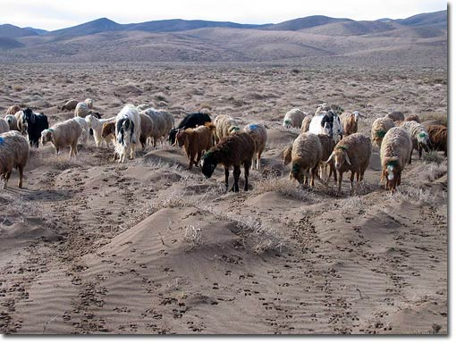
Source: peraculturenews.org

