Key Elements of Maps
Maps are graphic representations of places that use point, line, and area symbols, as well as color, to show how selected human and physical features are located, arranged, distributed, and related to one another. No single map can show everything, so the features shown on each map are selected to fit a particular purpose. It is impossible to accurately show the circular Earth on a flat surface without distorting (changing) shape, area, distance, or direction, so cartographers—or individuals that make maps—use different projections to preserve selected properties (shape, size, distance, direction), while others get distorted (changed).

A useful map should tell you what it is about (title), which direction north is (orientation), when the map was made or updated (date), who made the map (author), what the symbols mean (legend or key), how distances on the map relate to distances on the ground (scale), where to find selected places on the map (index), how to find places on the map (grid), and where the map's information comes from (sources or credits).

However, not all maps will show this information. The more information given, the better you will be able to evaluate the contents of the map, how credible the map is, and whether or not it is appropriate for a given purpose or audience.

TODALSIG
Panama

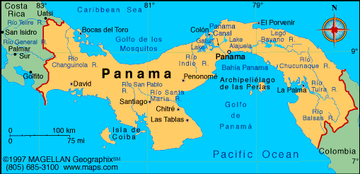

Title: Text explaining what the map is supposed to show: what is happening, where, and when.

Orientation: In most cases, the direction “north” is assumed to be at the top of a map. A north arrow is a symbol indicating the direction in which north lies; a compass rose is a symbol indicating the cardinal directions (North, South, East, West), and in some instances, intermediate directions (Northeast, Northwest, Southeast, Southwest).

Date: Text identifying when the map was made and/or updated.

Author: Text identifying the cartographer or organization responsible for making the map.

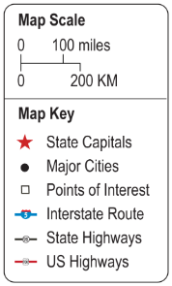
Legend or Key: A guide identifying what the map’s symbols and colors represent.

Scale: The relationship between distance on a map and actual distance on the earth. Scale may be represented by words (e.g., “one inch equals one mile”), a ratio or fraction (e.g., 1:63,360), or a divided bar. Bar scale is best to use when enlarging or reducing the size of a map, since the scale size will change with the map size. A map showing a small area in detail (such as a street map of a neighborhood) is a “large scale” map, while a map showing a large area without much detail (such as the world or a continent) is a “small scale” map (think about fractions here!).

Index: A listing of the places on the map and where to find them using grid coordinates—either latitude-longitude (77°53’W, 38°02’N) or letter-number (B4).
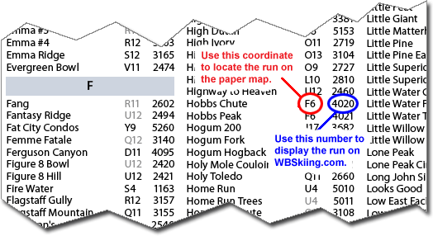

Grid: Intersecting lines (called a “coordinate system”) drawn on a map to pinpoint location. The grid can be a simple set of intersecting perpendicular (vertical) lines identifying rows and columns with letters and numbers (often used on a street map) or a set of intersecting lines identifying selected latitudes and longitudes.

Latitude and longitude are imaginary lines encircling (surrounding) the globe, intersecting (crossing) each other to form a grid that helps us pinpoint location—our "global address" or absolute location. They are measured in terms of the 360 degrees of a circle, sub-divided into minutes and seconds. For example, the White House in Washington, DC is located at 38°53'51"N, 77°02'11"W—that means it is 38 degrees, 53 minutes, 77 seconds north of the equator, and 77 degrees, 2 minutes, 11 seconds west of the Prime Meridian.

- Latitude lines (also called "parallels") run east-west, parallel to the Equator and measure distance north and south, from 0 degrees at the Equator to 90 degrees at the North and South Poles.
- Longitude lines (also called "meridians") run north-south and meet at the poles, measuring distance east and west of the Prime Meridian, from 0 degrees at the Prime Meridian running through Greenwich, England, to 180 degrees at the International Date Line (mostly in the Pacific Ocean).

Reading adapted from nationalgeographic.com Mapmaking Guide (6-8)

