Key Elements of Maps
Maps are graphic representations of places that use point, line, and area symbols, as well as color, to show how human and physical features are located and related to one another. No single map can show everything, so the features shown on each map are selected to fit a particular purpose. A useful map should tell you what it is about, which direction north is, when the map was made or updated, who made the map, what the symbols mean, how distances on the map relate to distances on the ground, where to find selected places on the map, how to find places on the map, and where the map's information comes from. However, not all maps will show this information. The more information given, the better you will be able to evaluate the contents of the map, how credible [trustworthy] the map is, and whether or not it should be used for a specific reason.

TODALSIG
There are several important elements that are included in most maps. The acronym TODALSIG—which lists the map elements in order of importance—can be used to help you remember each part. (Note: the acronym DOGTAILS is sometimes used to help us remember the key elements of a map easier.)

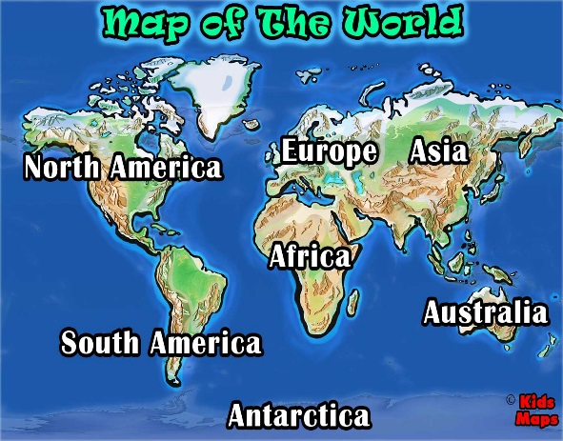
Title: Text explaining what the map is supposed to show: what is happening, where, and when.
Orientation: In most cases, the direction “north” is at the top of a map. A north arrow is a symbol indicating the direction in which north lies; a compass rose is a symbol that shows the cardinal directions (North, South, East, West), and in some maps, intermediate directions (Northeast, Northwest, Southeast, Southwest).
Date: When the map was made and/or updated.
Author: Text identifying the cartographer or organization responsible for making the map.
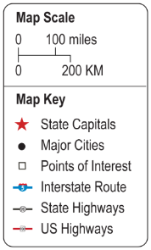
Legend or Key: A guide identifying what the map’s symbols and colors represent.
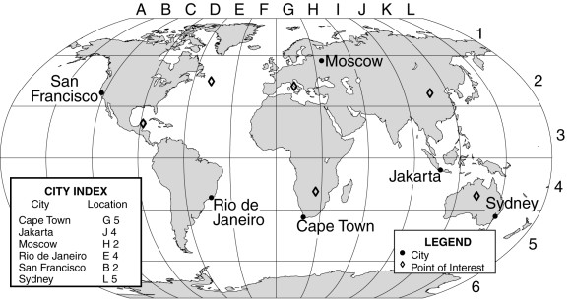
Scale: The relationship between distance on a map and actual distance on the earth.

Index: A listing of the places on the map and where to find them using grid coordinates—either latitude-longitude (77°53’W, 38°02’N) or letter-number (B4).
Grid: Latitude and longitude are imaginary lines encircling (surrounding) the globe, intersecting each other to form a grid that helps find our exact location—our "global address" or absolute location.
- Latitude lines (also called "parallels") run east-west, parallel to the Equator and measure distance north and south, from 0 degrees at the Equator to 90 degrees at the North and South Poles. The Equator divides the globe into Northern and Southern hemispheres.
- Longitude lines (also called "meridians") run north-south and meet at the poles, measuring distance east and west of the Prime Meridian, from 0 degrees at the Prime Meridian. The Prime Meridian divides the globe into Eastern and Western hemispheres.

Reading adapted from nationalgeographic.com Mapmaking Guide (6-8)

