Quiz Study Guide
Most questions are based on economic systems and political systems. Use this guide to study.
Economic systems | What to Produce? | How to Produce? | For whom to Produce?
traditional economy | based on custom; generations produce the same products; usually based on agriculture | products are produced the same as in the past | based on custom; producers traditionally barter
market economy  (free enterprise) | based on the demand of the consumer | based on innovation and competition | prices are set by producer; whoever can afford the product can purchase
command economy  (socialism) | based on government decision | based on government decision | based on government pricing or rations

Factors of Production | Definition | Examples - McDonalds
Natural Resources | materials from the earth that have value | lettuce, tomatoes, cows, land, potatoes
Labor | those who work to make the product | employees, cook, cashier
Capital | man-made materials used to produce | money, cash register, oven, grill, tables, chairs
Entrepreneur | the owner of the company | franchise owners
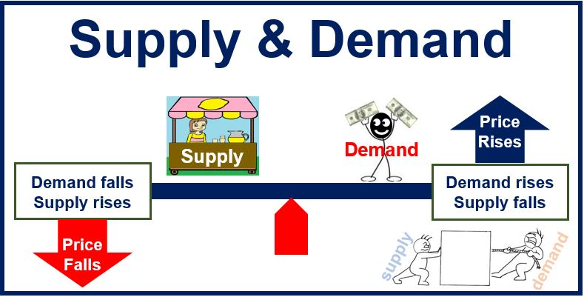

Limited Government | Unlimited Government
all authority figures must obey law, citizens have freedom and the right to vote for their leader, citizens have the power, there is a constitution so the government does not have too much power  Example:  Rule by one - democracy | there is no constitution to limit the power of the leader, leader does not have to obey laws, citizens are not free and have very few rights  Examples:  rule by few – oligarchy  rule by one – dictatorship, monarchy

