Zombie Apocalypse – The Search for Life
You have left your colony in order to search for survivors. You wish to take any survivors back with you the civilization. You find yourself in SW Asia and North Africa. You send word back to the colony about your travels. You send postcards that show and talk about your experience with the geography and if there are any survivors (explain why or why not they were able to survive in the environment), the ancient history, economic resources, religious sites you visit for refuge, and the current events in Syria.

The topics that are required for your project are:
- the geography of the region and your experience as you searched for civilization – were you
- the artifacts that you discover related to the Ancient Egyptians and Mesopotamians
- economic resources that are abundant in the region and how you will use these resources
- religious places that you visit for refuge and details about the religion (no Christianity)
- what you witness as you arrive to Syria searching for survivors

The postcards must be colored and in ink. NO WHITE SPACE!! FILL THE ENTIRE CARD!
The postcards must also be legible.
The postcards must include a greeting, inform the reader of your location, 2 details/characteristics of the place, your opinion about the topic, and a closing with your first and last name.
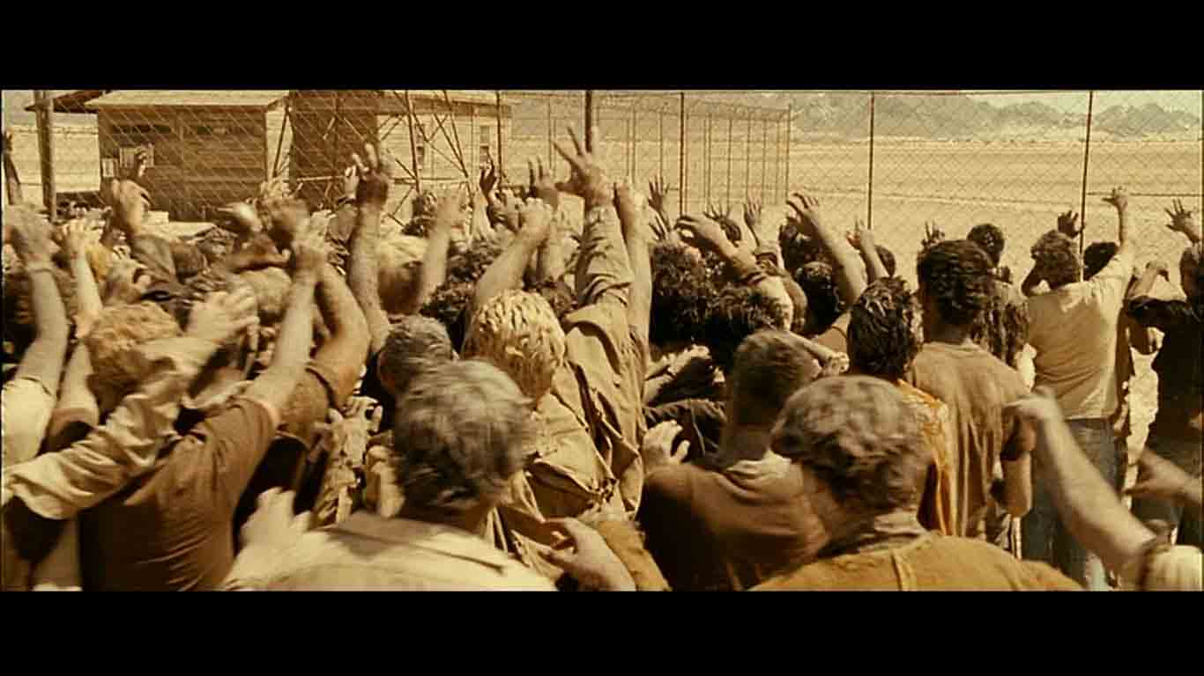
The source of you information must be written in the address portion of the postcard.
YOUR FINAL PRODUCT IS DUE:

