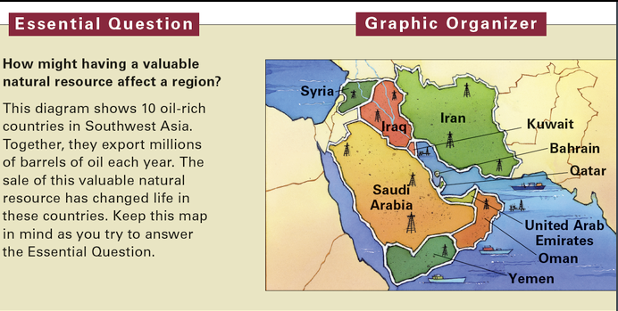
Oil in Southwest Asia
A lot can change in 50 years. Fifty years ago in the United States, there were no computers, no cell phones, and no Internet. Only a few American homes had color televisions. But some parts of the world, like Southwest Asia, have changed even more dramatically.
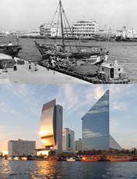
Look at the two photographs of the port city of Dubai. Dubai is one of seven states that make up the United Arab Emirates. Fifty years ago, it was a small town. Electricity had only recently been introduced. Today, Dubai is a modern city with one of the world’s largest human-made harbors.
Dubai, like much of Southwest Asia, has been transformed by oil. Southwest Asia has the world’s largest known oil reserves. This term refers to underground oil that has been discovered but remains unused. There are also large reserves of natural gas. Money from the sale of oil and natural gas has been used to pave roads and construct modern buildings in Southwest Asia. It has also provided medical care that helps people live longer.
Traders from all over the world still come to Southwest Asia today. But now, many arrive in huge tanker ships looking for only one product: oil.
Oil: Southwest Asia’s Hidden Treasure
On the surface, Southwest Asia doesn’t look very welcoming. Much of it is hot and dry. But hidden beneath the region’s deserts are vast reserves of oil and natural gas. More than half of the world’s proven crude oil reserves lie under Southwest Asia.

Worldwide demand is high for oil and natural gas. Developed countries depend on these fuels to meet most of their energy needs. A developed country is a wealthy country with an advanced economy. Developed countries have many industries and provide a comfortable way of life for most of their people. Developed countries have modern forms of transportation that run mainly on oil. Power plants burn oil and natural gas to generate electricity. Oil is also a raw material for plastics, medicines, and other goods. Some countries in Southwest Asia have grown rich meeting the world’s ever-growing demand for oil.

Although Southwest Asia has large oil reserves, it lacks other resources. Fresh water, for example, is in short supply across the region. Additionally, oil is a nonrenewable resource. There’s only a limited amount of it. Once it is used up, it can’t be replaced.
When the oil is gone, the world will have to turn to renewable resources. These are resources that will not run out or that can be replaced. Renewable energy resources include sunlight, wind, and geothermal energy, or heat from the center of Earth. Waterpower and trees are other renewable resources.
Oil Wealth and People’s Well-Being
Oil has made Saudi Arabia’s royal family very rich. Consider their 2002 vacation. King Fahd and 3,000 guests visited the town of Marbella in Spain. The royal family spent $185 million getting the Marbella palace ready for the vacation. After the king arrived, he had flowers delivered daily. Each day’s flowers cost about $1,500.
Not many people in Saudi Arabia live like the royal family. Just as some countries have more oil reserves than others, some people living in oil-rich countries have more wealth than others.
Oil Has Made Many People Better Off
In general, oil money has improved the lives of many people in Southwest Asia. In 2002, researchers from the United Nations studied changes in the region over the past 30 years. They found that life expectancy has increased by 15 years. They also found that the number of infants who die in their first year of life has dropped by two thirds.
Oil Has Not Improved Life for All
Oil money hasn’t ended poverty in Southwest Asia. For example, Yemen remains one of the 60 poorest countries in the world. Its population is about 80 percent of Saudi Arabia’s. But its oil reserves are only about 1 percent the size of those in Saudi Arabia. This means the amount of oil produced by Yemen each year has not been enough to pull its people out of poverty.
Other Southwest Asian countries have made a lot of money from oil. But they have not used that money to improve people’s lives. Iraq, for example, has the second-largest oil reserves in the region. But from 1979 to 2003, a dictator named Saddam Hussein controlled Iraq’s oil income. He spent most of Iraq’s oil money building an army, buying weapons, and fighting wars. Very little money went to make life better for ordinary Iraqis.

