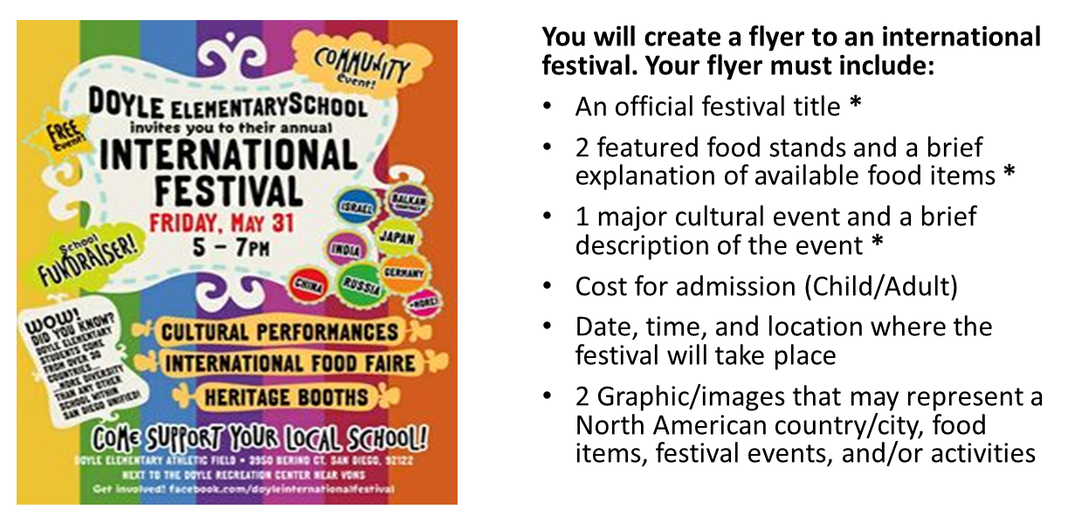
Grading Rubric
 | Excellent – 4 | Good – 3 | Fair – 2 | Poor – 1
Elements | Includes all required elements | Flyer is missing a minor element but major* elements are present | Flyer is missing a major element (*) | Flyer is incomplete – missing more than 1 major and minor element
Accuracy | All explanations and descriptions are accurate | 2 out of 3 explanations and descriptions are accurate | 1 out of 3 explanations and descriptions are accurate | 0 of the explanations and descriptions are accurate
Aesthetics  (Visual Appeal) | 100% colored | 75% colored | 50% colored | less than 50% colored; messy coloring
Grammar/Spelling | no more than 2 errors | 3-4 errors | 5 errors | more than 5 errors

Score: / 16
Comments:

