PHYSICAL PROCESSES
A physical process is
Internal process occur the earth. Examples include and
External processes occur the earth. Two types of external processes are
and

Guided Practice - Cause and Effect of Physical Processes
Cause/Action | Effect/Result | Specific Examples from Physical Map
This | Creates | xxx
wave action | beaches, coves, cliffs
glacier formation | valleys, hills
water flows | canyons, deltas, valleys
flooding | sedimentation, fertile plains
wind | erosion of rock formations, soil erosion, sand dunes, plains
volcanoes/ plate tectonics | mountains, rifts, igneous and metamorphic rocks
Which physical processes occur in Houston?
The physical processes that occur in Houston are
The effects of these processes include
Independent Practice – Analyzing Physical Processes
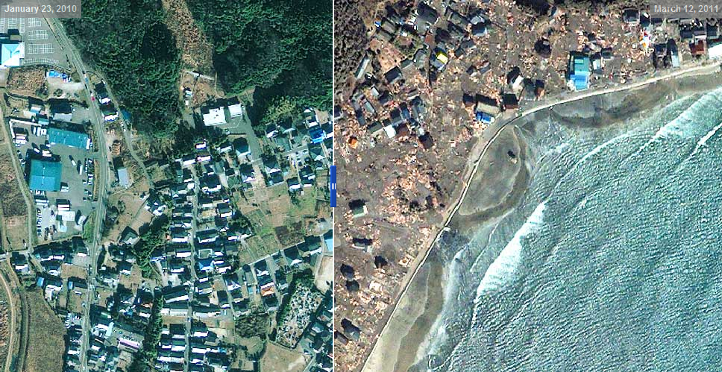
Physical Process?

This is an internal / external process because…

This process affects the economy because…

The effects on society include…

Effects on the political aspects of the place include…

Finally, the changes in the environment will include…

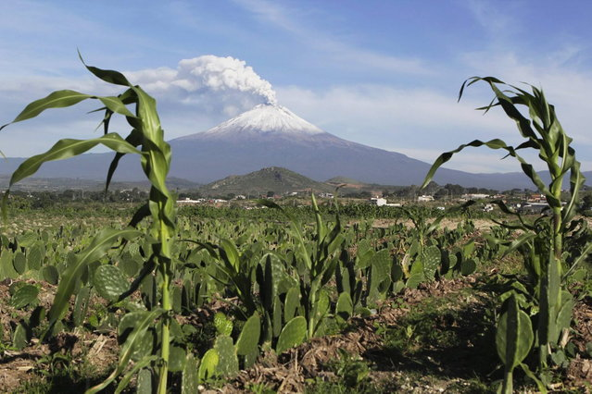
Physical Process?

This is an internal / external process because…

This process affects the economy because…

The effects on society include…

Effects on the political aspects of the place include…

Finally, the changes in the environment will include…
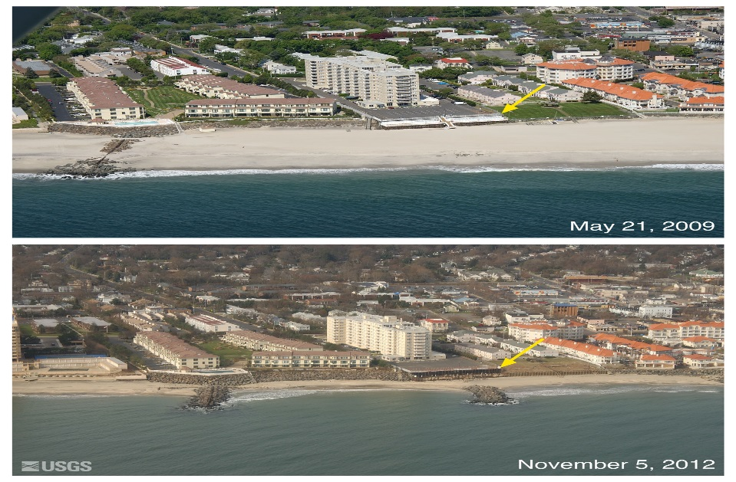

Physical Process?

This is an internal / external process because…

This process affects the economy because…

The effects on society include…

Effects on the political aspects of the place include…

Finally, the changes in the environment will include…
